|  |  |
| --- | --- |
|  | **MINISTRY OF EDUCATION AND TRAINING** |

**FPT UNIVERSITY**

|  |
| --- |
| Capstone Project Document |
| PET DATING |
| **VERSION 1.0** |
| |  |  | | --- | --- | |  | | | **Supervisor** | **Phan Duy Hùng** | | **Group Members** | **Lê Đức Chính – SE04365**  **Trịnh Bá Tân – SE04700**  **Lê Văn Sơn – SE04807**  **Dương Ngọc Duy – SE05121** | | **Capstone Project code** | **PD** | |

Ha Noi, May 20, 2019

Table of contents

List of Tables 6

List of Figures 6

List of Acronyms 11

**Acknowledgement** 12

**CHAPTER 1: INTRODUCTION** 14

1.1. Propose 14

1.2. Project Information 15

1.3. The People 15

1.4. Background 15

1.5. The Problem 16

1.6. Literature Review 16

1.7. The Proposal 18

1.7.1. The idea 18

1.7.2. The proposal 18

1.7.3. System functions 18

1.7.4. Business flow 19

**CHAPTER 2: SOFTWRE PROJECT MANAGEMENT PLAN (SPMP)** 21

2.1. Purpose 21

2.2. Software Process Model 21

2.2.1. About the SCRUM 21

2.2.2. Advantages and disadvantages of SCRUM 22

2.3. Project Organization 23

2.3.1. Organization structure 23

2.3.2. Roles and responsibilities 23

2.4. Tools And Techniques 25

2.5. Project Management Plan 26

2.5.1. Project schedule 26

2.5.2. Meeting minutes 27

2.5.3. Risk management plan 28

2.5.4. Communication plan 29

2.5.5. Coding convention 30

**CHAPTER 3: SOFTWARE REQUIREMENT SPECIFICATION** 30

3.1. Purpose 30

3.2. Functional Requirement 31

3.2.1. Use case diagram 31

3.2.2. Business rules 32

3.2.3. Use case list 32

3.2.4. Use case specification 34

3.3. Non-functional Requirement 80

3.3.1. Security 80

3.3.2. Availability 80

3.3.3. Usability 80

**CHAPTER 4: SOFTWARE DESIGN** 80

4.1. Purpose 80

4.2. Overview of System Architecture 81

4.2.1. Diagram 81

4.2.2. Component Explanation 81

4.3. Application Custom MVC Design 85

4.4. Database Design 86

4.4.1. Entity relationship diagram 86

4.4.2. Database diagram 89

4.5. Detailed Design 97

4.5.1. ReactComponent 97

4.5.2. Login 99

4.5.3. Logout 104

4.5.4. View User 105

4.5.5. Register User 109

4.5.6. Update User 113

4.5.7. View Pet 116

4.5.8. Create Pet 119

4.5.9. Update Pet 123

4.5.10. View Dating 125

4.5.11. Find mate 128

4.5.12. View Post 131

4.5.13. View Images Album 134

4.5.14. Create Post 137

4.5.15. Chatting 140

4.5.16. Search Others User 148

4.5.17. Manage Location 150

4.5.18. Manage Pet Breed 159

4.5.19. Manage Pet Species 167

4.5.20. Manage Report Reason 175

4.5.21. Manage Account 183

4.5.22. Verify Report 193

4.5.23. Login With Account 196

4.5.24. Reset Password 198

**CHAPTER 5: Software Testing Document** 200

5.1. Introduction 200

5.1.1. Purpose 200

5.1.2. Scope of testing 201

5.1.3. Range of testing 202

5.2. Test plan 203

5.2.1 Testing Tools and Environment 203

5.2.2. Resources and Responsibilities 204

5.2.3. Test Strategy 204

5.2.4. Features to be tested 208

5.3. Test case 209

5.3.1. UnitTest 209

5.3.2. System testing 209

5.3.3. Acceptance test 209

5.3.4. Defect Log 210

5.4. Test Report 211

5.4.1. Unit test 211

5.4.2. Integration and system tests 212

**CHAPTER 6: USER MANUAL** 212

6.1. Development and deployment guidelines 212

6.1.1. Development guideline 212

6.1.2. Deployment guideline 218

6.2. User guideline 224

6.2.1. Login, Logout 224

6.2.2. Create profile 226

6.2.3. Newsfeed 227

6.2.4. Create new post 228

6.2.5. Dating – Automation mode, Manual mode and Result 230

6.2.6. Chat 233

6.2.7. Search and view others user’s profile 235

6.2.8. View and update user profile 238

6.2.9. Create, view and update pet profile 241

# List of Tables

Table 1 - Advantages and disadvantages of SCRUM 22

Table 2 - Roles and responsibilities 25

Table 3 - Tools and techniques 26

Table 4 - Risk identification 29

Table 5 - Project report and meeting 29

Table 6 - Project communication 30

Table 7 - Coding Convention 30

Table 8 - Business rules 32

Table 9 - Actors description 33

Table 10 - Use case list 34

# List of Figures

Figure 1 - Lackky.com 12

Figure 2 - Thedogmates.com 13

Figure 3 - Roles in PD system 14

Figure 4 - Process of authorization on PD 15

Figure 5 - Process of review report on PD 15

Figure 6 - Process of dating on PD 15

Figure 7 - Process of user management process on PD 16

Figure 8 - Agile Model – SCRUM 16

Figure 9 - Organization structure 18

Figure 10 - Project Planning 21

Figure 11 - Use case diagram 24

Figure 12 - Use case diagram of Admin actor 27

Figure 13 - Use case diagram of Mod actor 36

Figure 14 - Use case diagram of User actor 41

Figure 15 - PetDating system architecture 59

Figure 16 - PetDating react native design 63

Figure 17 - Entity relationship diagram 64

Figure 18 - ERD description 66

Figure 19 - Database diagram 66

Figure 20 - ReactComponent class 73

Figure 21 - Login class diagram 74

Figure 22 - Login with Google sequence diagram 76

Figure 23 - Login with Facebook class diagram 77

Figure 24 - Logout class diagram 78

Figure 25 - Logout sequence diagram 79

Figure 26 - View user class diagram 80

Figure 27 - View user sequence diagram 82

Figure 28 - Register user class diagram 83

Figure 29 - Register user sequence diagram 85

Figure 30 - Update user class diagram 86

Figure 31 - Update user sequence diagram 88

Figure 32 - View pet class diagram 89

Figure 33 - View pet sequence diagram 91

Figure 34 - Create pet class diagram 92

Figure 35 - Create pet sequence diagram 94

Figure 36 - Update pet class diagram 95

Figure 37 - Update pet sequence diagram 97

Figure 38 - View dating class diagram 98

Figure 39 - View Dating sequence diagram 100

Figure 40 – Find mate class diagram 101

Figure 41 – Find mate sequence diagram 103

Figure 42 - View post class diagram 104

Figure 43 - View post sequence diagram 106

Figure 44 - View images album classs diagram 107

Figure 45 - View list images sequence diagram 109

Figure 46 - Create new post class diagram 110

Figure 47 - Create new post sequence diagram 112

Figure 48 - Conversation list class diagram 113

Figure 49 - Conversation list sequence diagram 114

Figure 50 - Send message class diagram 115

Figure 51 - Send message sequence diagram 117

Figure 52 - Receive message class diagram 118

Figure 53 - Receive message sequence diagram 119

Figure 54 - Searching class diagram 120

Figure 55 - Searching sequence diagram 121

Figure 56 - View location class diagram 122

Figure 57 - View location sequence diagram 123

Figure 58 - Update location class diagram 124

Figure 59 - Update location sequence diagram 126

Figure 60 - Create location class diagram 127

Figure 61 - Create location sequence diagram 129

Figure 62 - View pet breed class diagram 130

Figure 63 - View pet breed sequence diagram 131

Figure 64 - Update pet breed class diagram 132

Figure 65 - Update pet breed sequence diagram 134

Figure 66 - Create pet breed class diagram 135

Figure 67 - Create pet breeed sequence diagram 137

Figure 68 - View pet species class diagram 138

Figure 69 - View pet species sequence diagram 139

Figure 70 - Update pet species class diagram 140

Figure 71 - Update pet species sequence diagram 142

Figure 72 - Create pet species class diagram 143

Figure 73 - Create pet species sequence diagram 145

Figure 74 - View report reason class diagram 146

Figure 75 - View report reason sequence diagram 147

Figure 76 - Update report reason class diagram 148

Figure 77 - Update report reason diagram 150

Figure 78 - Create report reason class diagram 151

Figure 79 - Create report reason sequence diagram 153

Figure 80 - View account class diagram 154

Figure 81 - View account sequence diagram 155

Figure 82 - Update account class diagram 156

Figure 83 - Update account sequence diagram 158

Figure 84 - Create account class diagram 159

Figure 85 - Create account sequence diagram 161

Figure 86 - Change password class diagram 162

Figure 87 - Change password sequence diagram 163

Figure 88 - Verify report class diagram 164

Figure 89 - Verify report sequence diagram 165

Figure 90 - Login with account class diagram 166

Figure 91 - Login with account sequence diagram 167

Figure 92 - Reset password class diagram 168

Figure 93 - Reset password sequence diagram 169

Figure 94 - V-model 172

Figure 95 - Unit test with jest 176

Figure 96 - Defect logs with Github 177

Figure 97 - Integration and system test report 178

Figure 98 - Interface of Visual Studio Code 179

Figure 99 - Interface of Visual Studio Code 179

Figure 100 - Nodejs setup folder 180

Figure 101 - Nodejs setup folder after extracting 180

Figure 102 - Nodejs was installed succesfully 180

Figure 103 - XAMPP setup file 181

Figure 104 - XAMPP Control Panel interface 181

Figure 105 - Command for installing expo-cli 181

Figure 106 - expo-cli was installed succesfully 182

Figure 107 - Expo app on Google Play Store 182

Figure 108 - Expo Client app interface 183

Figure 109 - Create application interface on Hawk Host 184

Figure 110 - File Manager interface 184

Figure 111 - Create project interface 185

Figure 112 - Sign-in method set up interface for database 186

Figure 113 - Create database interface 187

Figure 114 - Realtime Database interface 187

Figure 115 - Storage bucket interface 188

Figure 116 - Login interface 189

Figure 117 - Logout option in Option tab 190

Figure 118 - Create user profile interface 191

Figure 119 - Newsfeed interface 192

Figure 120 - Choose images interface 193

Figure 121 - Create new post interface 194

Figure 122 - Find mate interface (Automation mode) 195

Figure 123 - Find mate interface (Manual mode) 196

Figure 124 - Find mate result 197

Figure 125 - List of conversation interface 198

Figure 126 - Chat interface 199

Figure 127 - Search and search result interface 200

Figure 128 - Others users profile interface 201

Figure 129 - Others users pet profile interface 202

Figure 130 - Option tab interface 203

Figure 131 - User profile interface 204

Figure 132 - Profile editing interface 205

Figure 133 - Pet profile editing interface 207

Figure 134 - Pet profile interface 208

Figure 135 - Pet profile editing interface 209

# List of Acronyms

|  |  |
| --- | --- |
| **Acronym** | **Definition** |
| App | Application |
| Admin | Administrator |
| Mod | Moderator |
| Web | Website |
| SRS | Software Requirements Specifiction |
| API | Application Program Interface |
| DB | Database |
| PD | PetDating |
| PB | Pet Breed |
| PS | Pet Species |
| MVC | Model-View-Controller |
| URL | Uniform Resource Interface |
| N/A | Not Available |
| OS | Operating System |
| CPU | Central Processing Unit |
| RAM | Random Access Memory |
| GPU | Graphical Processing Unit |

# **Acknowledgement**

We feel privileged and grateful in taking this opportunity to express our gratitute to the people who have contributed to the completion of this project.

First of all, we wish to express our deepest gratitude to our supervisor, Mr. Phan Duy Hung for his motivating mentorship and countless valuable guidance during the project. Under the instructions of Mr. Hung, the project team has always felt comfortable and confident. Apart from all the technologies and methodologies, Mr. Hung shared with us the philosophy of keeping the right attitude towards problems which we believe was the most important factor that led to the success of this project.  
 Besides, we would also like to thank the instructors at FPT University for all the classes. We hope you will find this project as a reflection of the knowledge and experiences you have given us during this period of four years.  
 Finally, we truly appreciate the random fellows on the Internet who has discussed with  
us. Without you, it would have likely been a real struggle to solve every tiny problem.

# **CHAPTER 1: INTRODUCTION**

* 1. Propose

This chapter provides an overview of the capstone project. It includes the project information, the background of the capstone project, the problem and our proposal to solve the problem.

* 1. Project Information

|  |  |
| --- | --- |
| Project Information | |
| Project name | Pet Dating |
| Project code | PD |
| Group name | Orange Wave |
| Product type | Mobile Application |
| Timeline |  |

* 1. The People

Supervisor:

|  |  |  |  |
| --- | --- | --- | --- |
| Full name | Phone | E-Mail | Title |
| Phan Duy Hùng |  | HungPD2@fe.edu.vn | Supervisor |

Team members:

|  |  |  |  |  |
| --- | --- | --- | --- | --- |
| Full name | Student ID | Phone | E-Mail | Title |
| Lê Đức Chính | SE04365 | 0395052756 | Chinhldse04365@fpt.edu.vn | Leader |
| Trịnh Bá Tân | SE04700 | 0347766759 | Tantbse04700@fpt.edu.vn | Member |
| Lê Văn Sơn | SE04807 | 0975637302 | Sonlvse04807@fpt.edu.vn | Member |
| Dương Ngọc Duy | SE05121 | 0989188497 | Duydnse05121@fpt.edu.vn | Member |

* 1. Background

Nowadays, pets play an important role in everyday life of Vietnamese people. Many people treat their pets as an irreplaceable member in the family. According to the survey of Q&ME, among the Vietnamese people that have pet, sixty three percent of them have been lived with their dog for more than three years and fourty percent of them that often wear clothes for their pet. Many people remember and celebrate birthdays for these little friends. With higher income an condition of living in recent years, pets raising is not only for some purpose like protecting house, catching rats,.. but people also do it because they want to have one more habit, one more friend.

* 1. The Problem

Everybody cares about the life of pet such as food, clothes, morale and mates. In Vietnam, people have trouble finding mate for your pet. A few groups about pet on Facebook is usually where people meet with others that have the same interest, Facebook has a large number of users and easy to connect, easy to join, but it also lack of specific features that focus in users that have pets. Some others systems in Vietnam are not really popular or no longer be developed and supported. In conclusion, there are not really any online place or community for people that have pets in Vietnam right now.

* 1. Literature Review

We consulted some websites/application about pet before give our proposal. Each website/application has a lot of advantages but still has some limitations.

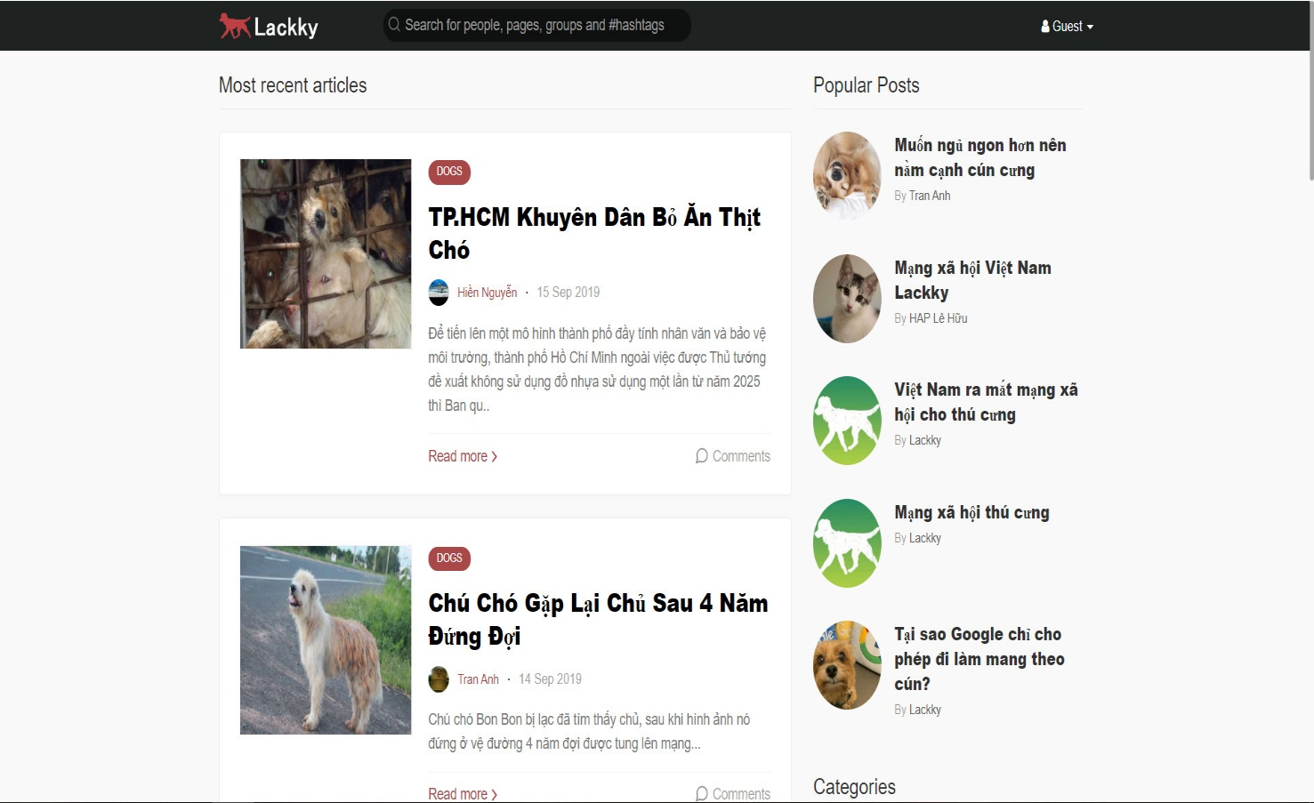

Figure 1 - Lackky.com

|  |  |
| --- | --- |
| **Advantages** | **Disadvantages** |
| * Provide news and more information about pets. | * Not support finding mates. * Only news, no communication between users |

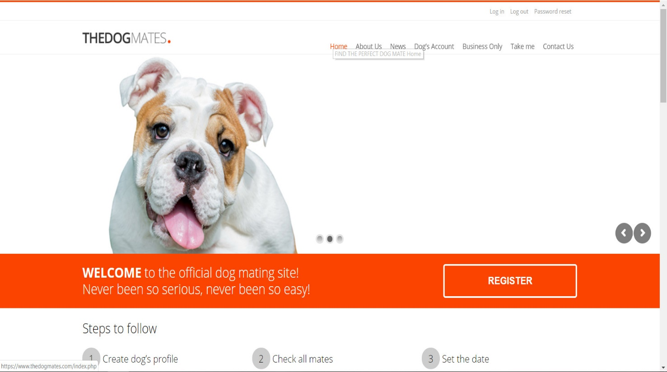

Figure 2 - Thedogmates.com

|  |  |
| --- | --- |
| **Advantages** | **Disadvantages** |
| * Have multiple kind of dogs. * Vote for dog | * Not popular in Viet Nam. * Complex in registration and approval. * Serve only for dog. |

* 1. The Proposal
     1. The idea

We want to build a mobile application where everyone can join to the worlds of pets. Major of application is finding the mates for their pets based on automation mode or manual mode. In the app, people maybe complete the user’s profile; pet’s profile; upload images; post status. In addition, everyone can connect and chat about pets. It helps making pets dating becomes easy, safe and enhance the community. Our idea has two part: mobile application for user and website for manager.

* + 1. The proposal

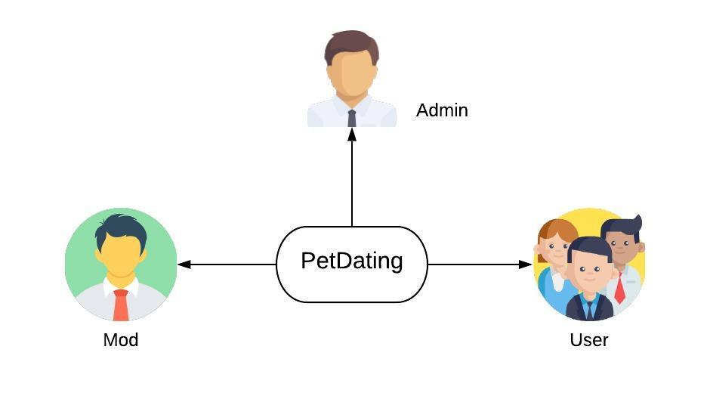

Figure 3 - Roles in PD system

* + 1. System functions

There are three roles and responsibilities of each role on PetDating:

|  |  |
| --- | --- |
| **Role** | **Responsibilities** |
| Admin | People who manage the PD system and has all authority on system |
| Mod | Somebody who manage the PD system. But with less authority than administrator |
| Users | People who join and use PD application |

The system has the following roles and main functions:

* Admin:

+ Login and Logout to website.

+ Authorize to moderator.

* Mod:

+ Login and Logout to website.

+ Review reports from user.

* Users

+ Login and Logout to mobile application.

+ Allow users to join PD, view user profile and modify your profile.

+ Allow users to create, modify your pet profile and view the pet profile. The pet profile defines the name, sex, age, … of pets.

+ Allow users to upload images, post status and set privacy such as private or public.

+ Users can use dating function to find mates for pets. There are two types of finding mates:

* + Find mates by automation: Application suggests pets base on your pet that the pet has selected.
  + Find mates by manual: Application suggests pets base on your choose.

+ Users can use chatting system to connect to other users.

+ Allow users to like or report the posts.

+ Allow users to feedback about system.

* + 1. Business flow
* **Authorization process**

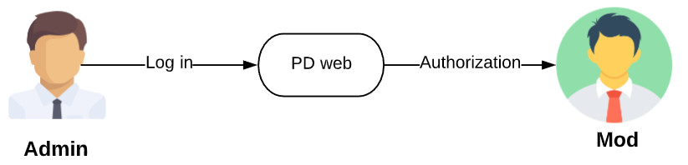

Figure 4 - Process of authorization on PD

* **Review report process**

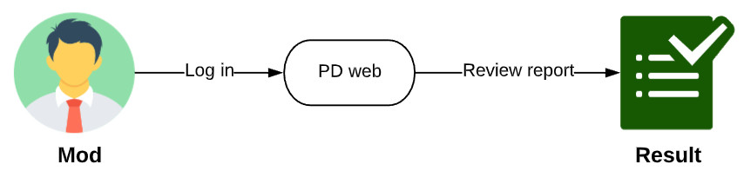

Figure 5 - Process of review report on PD

* **Dating process**

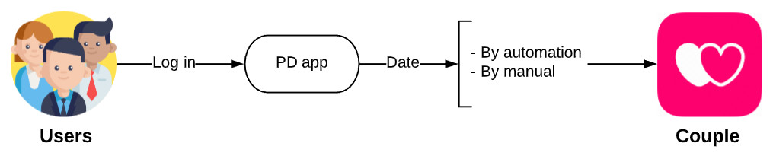

Figure 6 - Process of dating on PD

* **User management process**

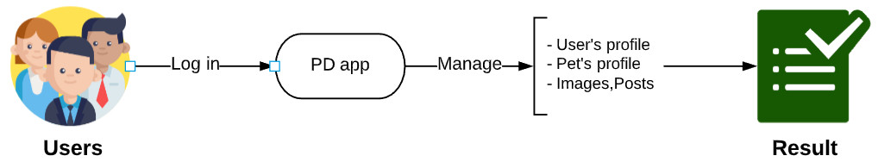

Figure 7 - Process of user management process on PD

# **CHAPTER 2: SOFTWRE PROJECT MANAGEMENT PLAN (SPMP)**



## Purpose

Project plan describes the software process model, team organization and management plan of the project. All team members must follow this section as a guideline to complete assigned tasks and deadline.

## Software Process Model

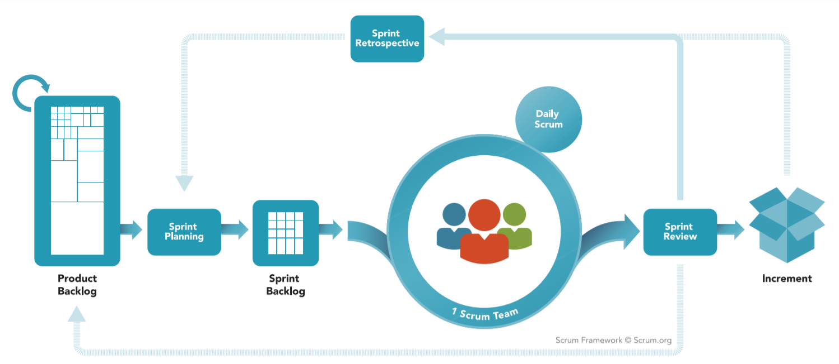

Figure 8 - Agile Model – SCRUM



### About the SCRUM

SCRUM is Agile software development life cycle (SDLC) models. Scrum is a framework within which people can address complex adaptive problems, while productively and creatively delivering products of the highest possible value. And it is a simple framework for effective team collaboration on complex products.

* **Product Backlog**: is an ordered list of everything that is known to be needed in the product. It is the single source of requirements for any changes to be made to the product.
* **Sprint Planning**: The work to be performed in the Sprint is planned at the Sprint Planning. This plan is created by the collaborative work of the entire Scrum Team.
* **Sprint Backlog**: is the set of Product Backlog items selected for the Sprint, plus a plan for delivering the product Increment and realizing the Sprint Goal. The Sprint Backlog is a forecast by the Development Team about what functionality will be in the next Increment and the work needed to deliver that functionality into a “Done” Increment.
* **Sprint**: The heart of Scrum is a Sprint, a time-box of one month or less during which a “Done”, useable, and potentially releasable product Increment is created. Sprints have consistent durations throughout a development effort. A new Sprint starts immediately after the conclusion of the previous Sprint.

*Reference: “The Scrum Guide - The Definitive Guide to Scrum: The Rules of the Game” – Developed and sustained by Scrum creator: Ken Schwaber and Jeff Sutherland – November 2017.*

### Advantages and disadvantages of SCRUM

|  |  |
| --- | --- |
| **Advantages** | **Disadvantages** |
| * Works well for fast-moving development projects. * The team gets clear visibility through scrum meetings. * Removing mistakes or rectifying them is considerably easy. * It is iterative in nature and needs continuous feedback from the user for the betterment of the process. | * Scrum often leads to scope creep, due to the lack of a definite end-date. * The chances of project failure are high if individuals aren't very committed or cooperative. * If any team member leaves in the middle of a project, it can have a huge negative impact on the project. * Daily meetings sometimes frustrate team members |

Table 1 - Advantages and disadvantages of SCRUM

## Project Organization



### Organization structure

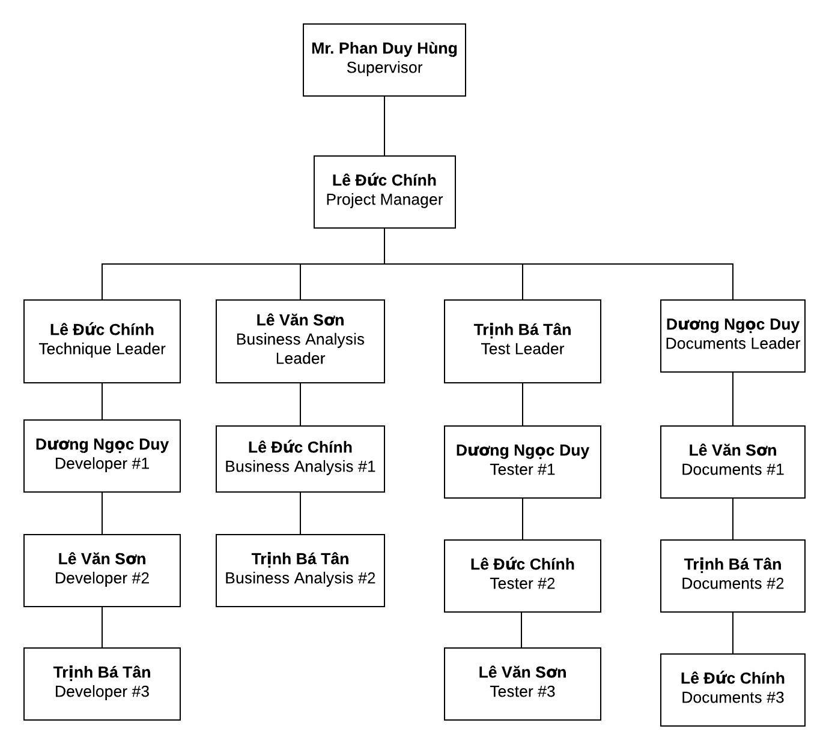

Figure 9 - Organization structure

### Roles and responsibilities

|  |  |  |
| --- | --- | --- |
| **Role** | **Responsibilities** | **Full Name** |
| **Project Manager** | | |
| Project Manager | * Guide team toward the goal of successfully passing the final capstone project. * Develop schedule and assigning task with responsibilities for each member. * Communicate with all teams to keep them focusing on the final goal. * Propose ideas or issues of the team to supervisor, university. | Lê Đức Chính |
| **Business analyst team** | | |
| BA leader | * Elicit and analyze requirement. * Define scope and create SRS template. * Design entity relationship diagram. | Lê Văn Sơn |
| BA #1 | * Define business process flow and object state. | Lê Đức Chính |
| BA #2 | * Capture and specific describe use case. | Trịnh Bá Tân |
| **Developer** | | |
| Technical leader | * Define high level architecture base on SRS. * Implement configuration and server. * Design and code dating function. * Develop client functions in console system. * Design and review database. * Design mockup for application. | Lê Đức Chính |
| Dev #1 | * Lead chatting function. * Design a part of database. * Design and code chatting function. * Code others screen. * Design mockup for application. | Dương Ngọc Duy |
| Dev #2 | * Design and code dating function. * Code others screen. * Design mockup for application. | Lê Văn Sơn |
| Dev #3 | * Design and code chatting function. * Code others screen. * Design mockup for application. | Trịnh Bá Tân |
| **Tester** | | |
| Test leader | * Create template testing documents. * Define test strategy, create test plan and defect log temple. | Trịnh Bá Tân |
| Test #1 | * Implement test case and log defect. | Dương Ngọc Duy |
| Test #2 | * Implement test case and log defect. | Lê Đức Chính |
| Test #3 | * Implement test case and log defect. | Lê Văn Sơn |
| **Documentation** | | |
| Docs leader | * Prepare all the documentation relating to the project. * Give format in documentation. | Dương Ngọc Duy |
| Docs #1 | * Check spelling errors and grammar errors. | Lê Văn Sơn |
| Docs #2 | * Check spelling errors and grammar errors. | Trịnh Bá Tân |
| Docs #3 | * Check spelling errors and grammar errors. | Lê Đức Chính |

Table 2 - Roles and responsibilities



## Tools And Techniques

|  |  |  |
| --- | --- | --- |
| **Tool and techniques** | **Version** | **Description** |
| Visual Studio Code | Lastest | Text editor for coding, testing |
| GitKraken | Lastest | Git GUI for controlling source code and version easily |
| XAMPP | Lastest | MySQL environment for developing and testing in localhost |
| NodeJS | 10.16.3 LTS | Environment for application |
| Expo-cli | 3.9.1 | Environment for developing React Native app with Expo |
| Expo SDK | 35 | Environment provides access to device  and system functionality |
| Expo Client | Lastest | App on android for running and testing React Native app on real devices |
| Google Drive | Online | Documents, resources storage |
| Lucidchart | Online | Diagram, UML, chart creation tool |
| Draw.io | Online | Diagram, UML, chart creation tool |
| Microsoft Project | 2019 | Plan management and schedule |
| Microsoft Office | 2019 | Documentation tool includes: Words, Excel, PP, … |
| Trello | Online | Control task, backlog |
| Facebook | Online | Communication tool |
| Skype | Lastest | Communication tool |
| Google Meet | Online | Video conferencing, presentation |
| Hawk Host | Online | Online hosting service |
| Google Firebase Storage | Online | Cloud storage for Firebase |
| Google Firebase Realtime Database | Online | Database for performing realtime function |

Table 3 - Tools and techniques



## Project Management Plan



### Project schedule

The tasks list detail is described in file: **“Plan.mpp”**

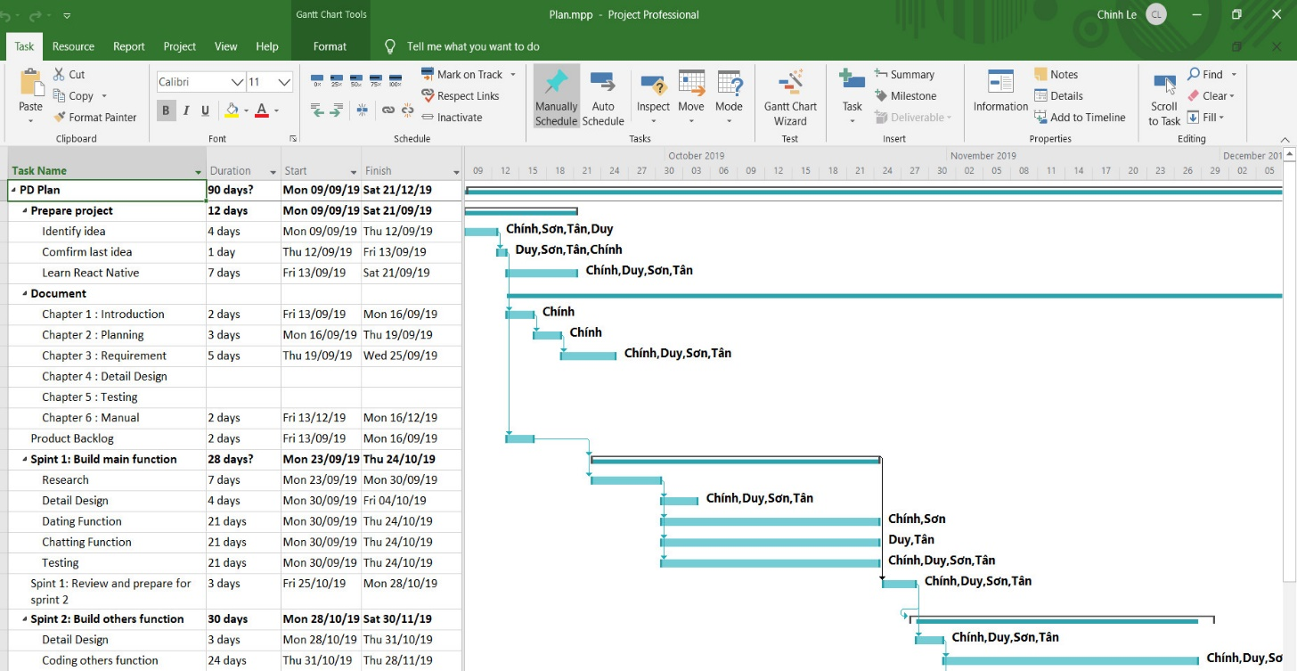

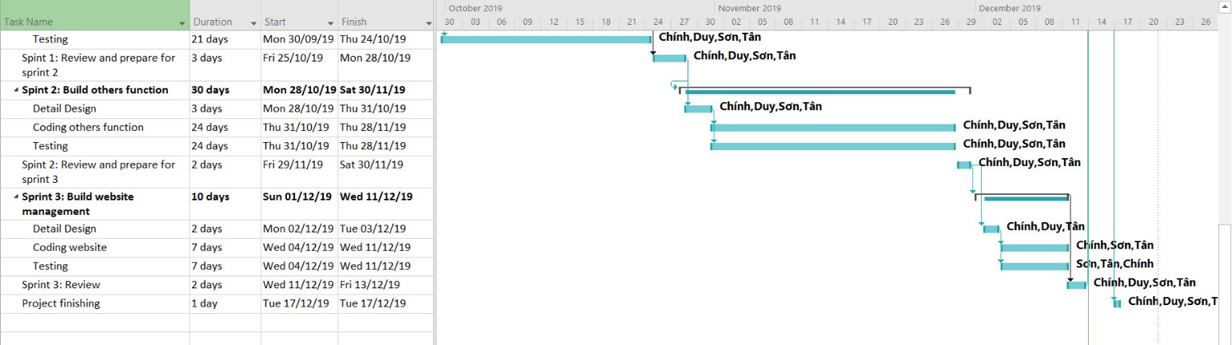

Figure 10 - Project Planning

### Meeting minutes

|  |  |  |  |  |
| --- | --- | --- | --- | --- |
| **Project Name/Code** | PetDating | **Date of meeting** | |  |
| **Conductor** | Lê Đức Chính | **Location** | |  |
| **Topic of meeting** |  | | | |
|  |  | | | |
| **Attendees:** | | | | |
| **Name** | **Role** | | **Attendance** | |
| Phan Duy Hùng | Supervisor | | Present | |
| Lê Đức Chính | PM | | Present | |
| Trịnh Bá Tân | Team member | | Present | |
| Lê Văn Sơn | Team member | | Present | |
| Dương Ngọc Duy | Team member | | Present | |
|  | | | | |
| **Meeting objective:** | | | | |
|  | | | | |

### Risk management plan

**\*Risk identification**

|  |  |  |  |  |
| --- | --- | --- | --- | --- |
| **No** | **Risk description** | **Contingency/Mitigation plan** | **Probability** | **Impact** |
| 1 | Scope of project was defined poorly that cause ambiguous for team members | Meeting with BA expert | Medium | High |
| 2 | Requirements changes during project time | Meeting and redefine objective with each team member. | Medium | High |
| 3 | Failure in estimating sprint time, inadequate change | Doing overnight work to keep process continuing | High | Medium |
| 4 | Confliction among team members | - Transfer problems to whole team to resolve it.  - Create happy and friendly environment among team members. | Low | Medium |
| 5 | Library or third-party features used in project is no longer supported | Choose alternative library or coding from scratch | Low | High |
| 6 | Illness or absence of team members | Ensure that the absence of a member will not affect the plan and schedule. Always have plans to deal with this problem | Low | Low |

Table 4 - Risk identification

**\*Probability - Impact matrix**

|  |  |  |  |  |
| --- | --- | --- | --- | --- |
| Probability | High |  | R3 |  |
| Medium |  |  | R1, R2 |
| Low | R6 | R4 | R5 |
|  |  | Low | Medium | High |
|  |  | Impact | | |

### Communication plan

Project report and meeting:

|  |  |  |  |  |
| --- | --- | --- | --- | --- |
| **No** | **Activity** | **Stakeholder** | **Time** | **Description** |
| 1 | Weekly report | * Team member * Supervisor | Friday | * Report in meeting minutes * Review status based on weekly report * Plan for the next week |
| 2 | Daily report | Project manager | Daily | * Report issue and planning * Support to solve issues |
| 3 | Ad-hoc report | Team members | Event-based | * Report and talking face to face |

Table 5 - Project report and meeting

Project communication:

|  |  |  |
| --- | --- | --- |
| **No** | **Style** | **Description** |
| 1 | Weekly meeting schedule | Spend one day in a week for meeting to review and update solution for problems. |
| 2 | Unscheduled meeting | If any member has problems that he wants to solved immediately, we will have a chat box. |
| 3 | Communication channel | Our main communication is physical meeting, chat box, Facebook messenger. |

Table 6 - Project communication

### Coding convention

The following coding conventions are used to code the project to help improve readabilities, maintenance abilities, and code more easily.

|  |  |  |
| --- | --- | --- |
| **#** | **Style** | **Implementation component** |
| 1 | NodeJS coding convention | Service API |
| 2 | React coding convention | React native convention |
| 3 | RESTful API | REST convention |

Table 7 - Coding Convention

**CHAPTER 3: SOFTWARE REQUIREMENT SPECIFICATION**

3. 1. Purpose

This chapter outlines functional and non-functional requirements of our system. It also provides some format constraints in common requirements and project success criteria. The content of this chapter is used as the basis for the work in the subsequent chapters.

* 1. Functional Requirement

3. 2. 1. Use case diagram

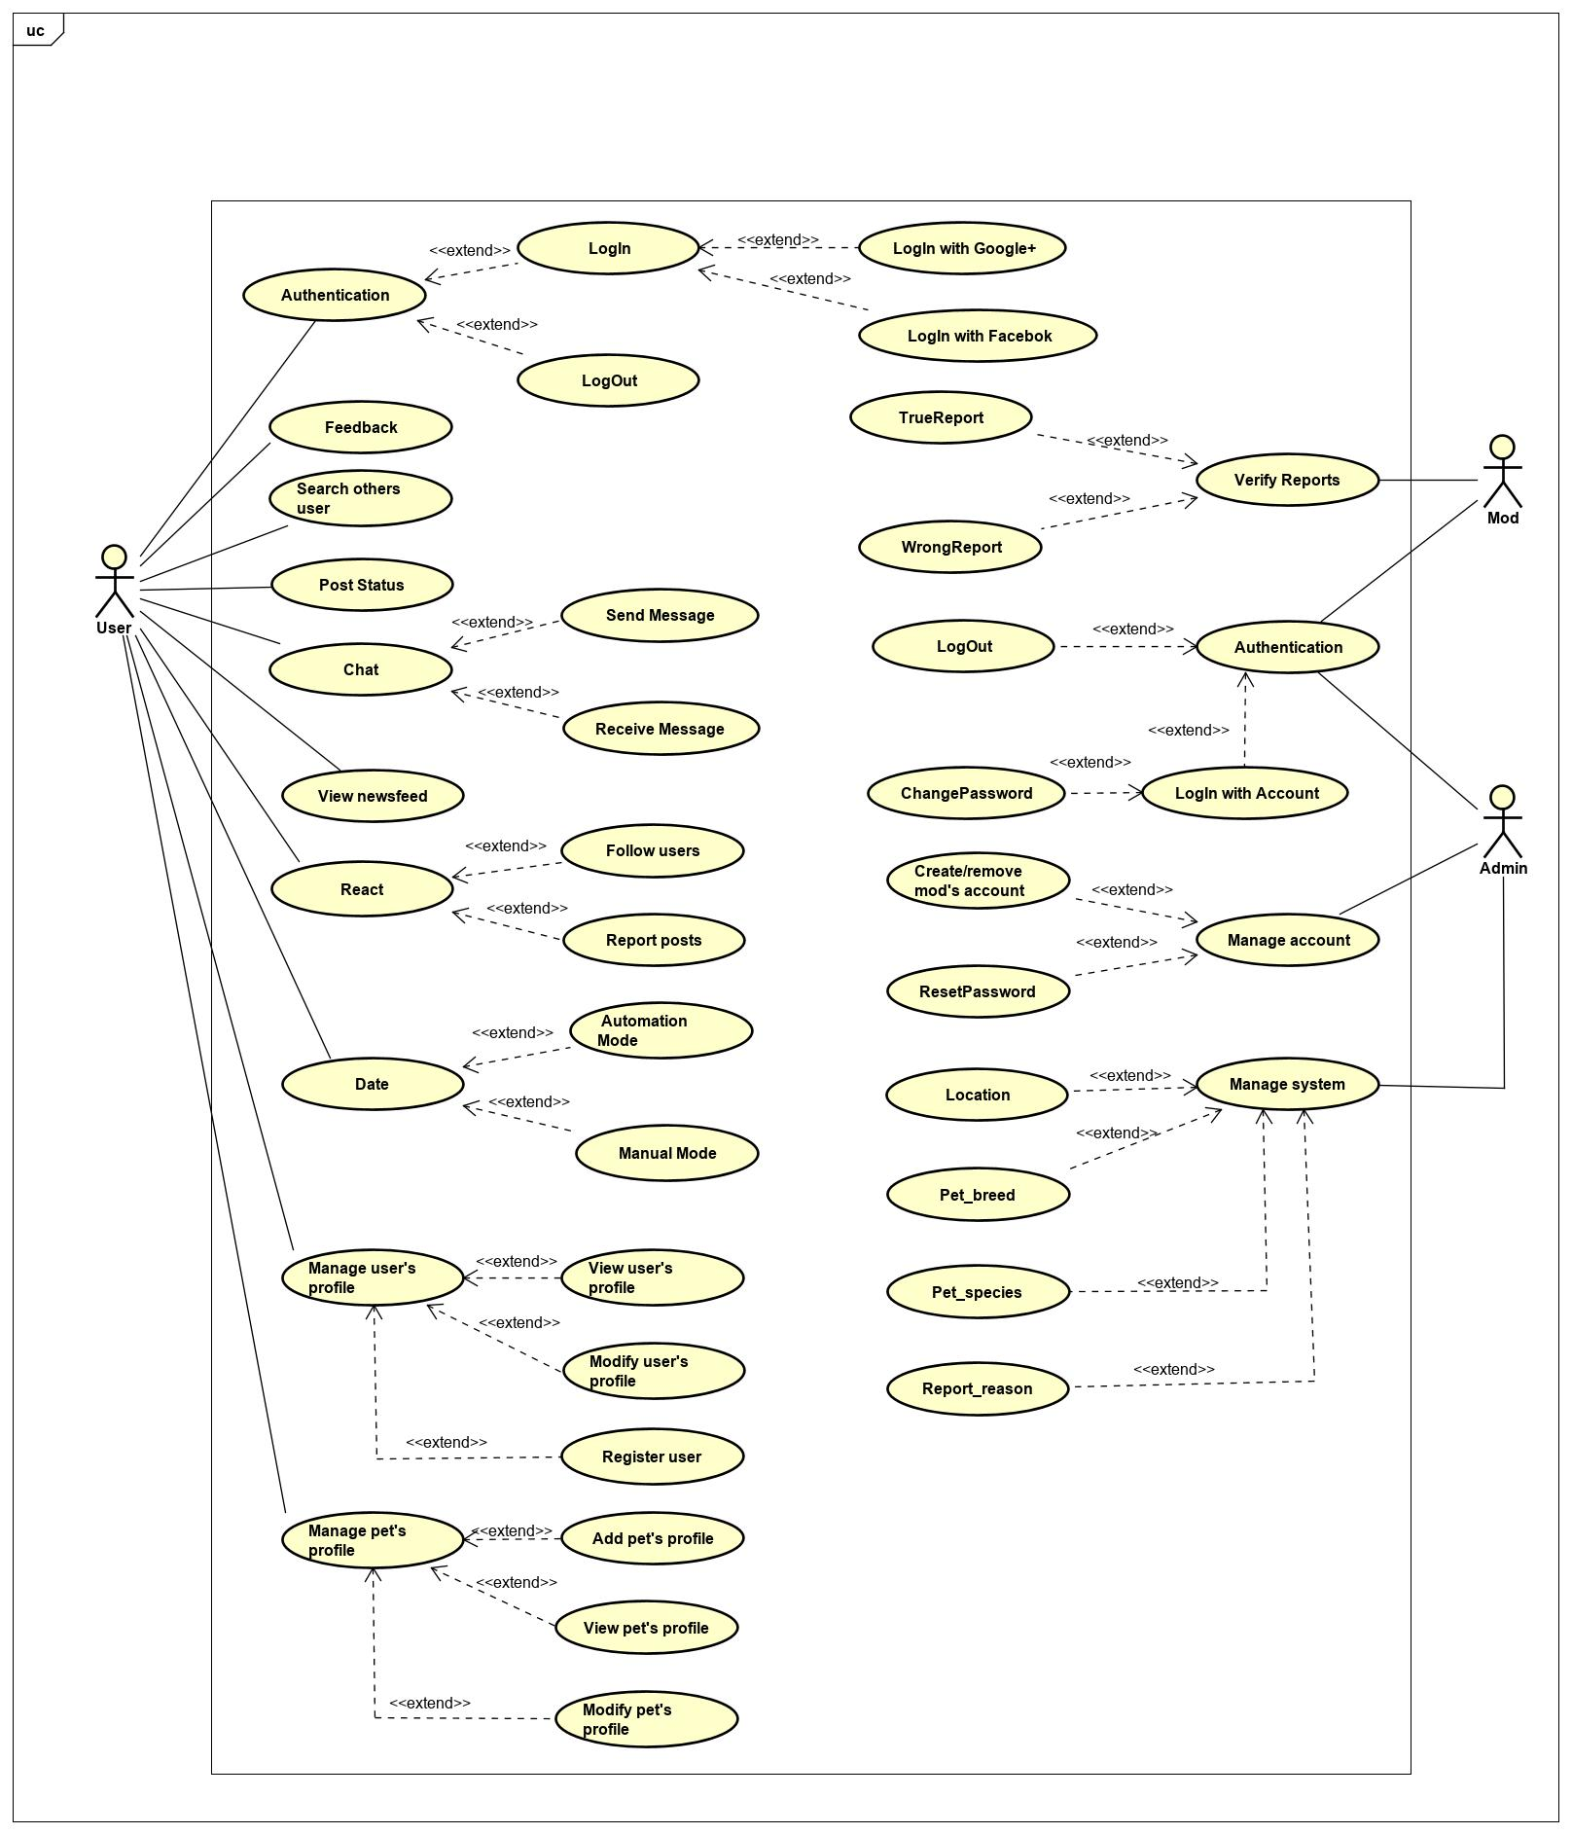

Figure 11 - Use case diagram

* + 1. Business rules

|  |  |
| --- | --- |
| **ID** | **Description** |
| 1 | Google+ account or Facebook account must be valided. |
| 2 | Mod’s password is automation generated in first time. |
| 3 | Admin’s password (or Mod’s password) must not be stored as plain text. Instead it must be hashed using a secure hash algorithm. |
| 4 | Admin/Mod must provide their account's email address and password when logging into the website. |
| 5 | Only Admin account can create/remove mod’s account. |
| 6 | Only Admin account can reset password of mod’s account. |
| 7 | The field must be filled by characters consist of alphabet and numbers. |
| 8 | The field must be filled by characters consist of alphabet. |
| 9 | The field must be not empty. |
| 10 | The characters of field is greater than 10. |
| 11 | The characters of field is greater than 3. |
| 12 | The characters of field is greater than 5. |
| 13 | The maximum characters of field is 30. |
| 14 | The maximum characters of field is 20. |
| 15 | Image file type must be image type. |

Table 8 - Business rules

* + 1. Use case list

|  |  |
| --- | --- |
| **Actors** | **Description** |
| User | Everyone who has an account on the PetDating system and used it. |
| Admin | People who has responsibilities about mod’s account. |
| Moderator | A group of people who review reports from User. |

Table 9 - Actors description

|  |  |  |
| --- | --- | --- |
| **ID** | **Actor** | **Name** |
| AD-UC-1.0 | Admin | Login with account |
| AD-UC-2.0 | Logout |
| AD-UC-3.0 | Change password |
| AD-UC-4.0 | Create mod’s account |
| AD-UC-5.0 | Remove mod’s account |
| AD-UC-6.0 | Reset password |
| AD-UC-7.0 | Manage location |
| AD-UC-8.0 | Manage pet_breed |
| AD-UC-9.0 | Manage pet_species |
| AD-UC-10.0 | Manage report_reason |
| MD-UC-1.0 | Moderator | Login with account |
| MD-UC-2.0 | Logout |
| MD-UC-3.0 | Change passwrod |
| MD-UC-4.0 | Verify true report |
| MD-UC-5.0 | Verify wrong report |
| US-UC-1.0 | User | Login with Goole/Facebook |
| US-UC-2.0 | Logout |
| US-UC-3.0 | Feedback |
| US-UC-4.0 | Search others user |
| US-UC-5.0 | Send message |
| US-UC-6.0 | Receive message |
| US-UC-7.0 | View newsfeed |
| US-UC-8.0 | Follow user |
| US-UC-9.0 | Report posts |
| US-UC-10.0 | Automation Mode |
| US-UC-11.0 | Manual Mode |
| US-UC-12.0 | View user’s profile |
| US-UC-13.0 | Modify user’s profile |
| US-UC-14.0 | Register user |
| US-UC-15.0 | Add pet’s profile |
| US-UC-16.0 | View pet’s profile |
| US-UC-17.0 | Modify pet’s profile |
| US-UC-18.0 | Post status |

Table 10 - Use case list

* + 1. Use case specification
       1. **Admin**

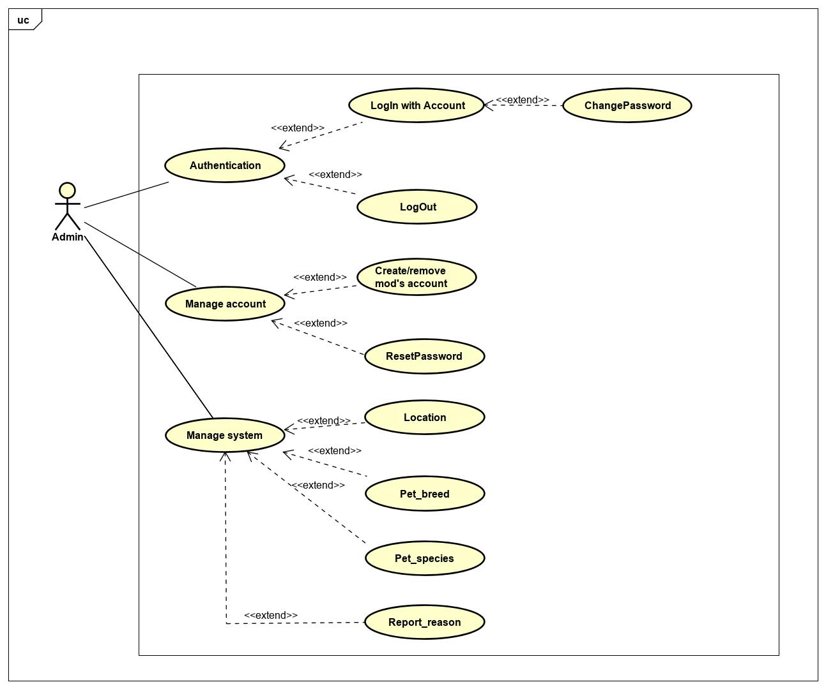

Figure 12 - Use case diagram of Admin actor

* + - * 1. Authentication

**\*Login with account**

|  |  |  |  |
| --- | --- | --- | --- |
| **USECASE AD-UC-1.0** **SPECIFICATION** | | | |
| **Use case ID** | AD-UC-1.0 | **Use case version** | V1.0 |
| **Use case name** | Login with account | | |
| **Author** | Le Duc Chinh | | |
| **Date** | 25/09/2019 | **Priority** | High |
| **Primary actor** | Admin | **Secondary actor** | N/A |
| **Description** | Allows admin login to PD system in website. | | |
| **Pre-condition** | Admin has an account and the account is still working. | | |
| **Post-condition** | When the normal flow completes successfully, the login status is set to true, and the access token is saved on the website. | | |
| **Trigger** |  | | |
| **Main flow:**   |  |  |  | | --- | --- | --- | | **No.** | **Actor events** | **System respond** | | **1.** | Admin goes to login page |  | | **2.** |  | Website displays the details, which includes the following:  Title: Đăng nhập vào hệ thống PD  TextInput: Tài khoản  TextInput: Mật khẩu  Button: Đăng nhập | | **3.** | Admin fills account and password then clicks “Đăng nhập” button. |  | | **4.** |  | System generates cookies and save them. | | **5.** |  | Website navigates to homepage. |   **Alternative Flows: Admin logged and not yet log out.**   |  |  |  | | --- | --- | --- | | **No.** | **Actor events** | **System respond** | | **1.** | Admin goes to homepage |  | | **2.** |  | Website checks cookies then navigates to login page if not exist cookies. |   **Extension Flows: N/A**  **Exception:**  **AD1.0-E1 – Cannot connect with Account API**  System displays error message.  **AD1.0-E2 – Wrong account or password**  System displays error message and requests login again.    **Business Rules: B3, B4** | | | |
|  | | | |

**\*Logout**

|  |  |  |  |
| --- | --- | --- | --- |
| **USECASE AD-UC-2.0** **SPECIFICATION** | | | |
| **Use case ID** | AD-UC-2.0 | **Use case version** | V1.0 |
| **Use case name** | LogOut | | |
| **Author** | Le Duc Chinh | | |
| **Date** | 25/09/2019 | **Priority** | High |
| **Primary actor** | Admin | **Secondary actor** | N/A |
| **Description** | Log out the PD System. | | |
| **Pre-condition** | Has logged into PD system. | | |
| **Post-condition** | When the normal flow completes successfully, the login status is set to false, and the access token is cleared. | | |
| **Trigger** |  | | |
| **Main flow:**   |  |  |  | | --- | --- | --- | | **No.** | **Actor events** | **System respond** | | **1.** | Clicks icon “Account” on top right of website. |  | | **2.** |  | Website displays “Account Management” pop-up | | **3.** | Admin/Mod clicks “Đăng xuất” on top right of website. |  | | **4.** |  | Website navigates to Login page. |   **Alternative Flows: N/A**  **Extension Flows:**  **Exception: N/A**  **Business Rules: N/A** | | | |
|  | | | |

**\*Change Password**

|  |  |  |  |
| --- | --- | --- | --- |
| **USECASE AD-UC-3.0** **SPECIFICATION** | | | |
| **Use case ID** | AD-UC-3.0 | **Use case version** | V1.0 |
| **Use case name** | Change Password | | |
| **Author** | Le Duc Chinh | | |
| **Date** | 25/09/2019 | **Priority** | High |
| **Primary actor** | Admin | **Secondary actor** | N/A |
| **Description** | Allows admin to change their password. | | |
| **Pre-condition** | Admin logged in to system. | | |
| **Post-condition** | Password has been changed. | | |
| **Trigger** |  | | |
| **Main flow:**   |  |  |  | | --- | --- | --- | | **No.** | **Actor events** | **System respond** | | **1.** | Clicks icon “Account” on top right of website. |  | | **2.** |  | Website displays “Account Management” pop-up | | **3.** | Clicks “Đổi mật khẩu” |  | | **4.** |  | Website directs to “Đổi mật khẩu” interface | | **5.** | Fills all require field and presses the “Xác nhận” button |  | | **6.** |  | Shows sucess message |   **Alternative Flows: N/A**  **Extension Flows: N/A**  **Exception: N/A**  **Business Rules: N/A** | | | |
|  | | | |

* + - * 1. Manage account

**\*Create mod’s account**

|  |  |  |  |
| --- | --- | --- | --- |
| **USECASE AD-UC-4.0** **SPECIFICATION** | | | |
| **Use case ID** | AD-UC-4.0 | **Use case version** | V1.0 |
| **Use case name** | Create mod’s account | | |
| **Author** | Le Duc Chinh | | |
| **Date** | 26/09/2019 | **Priority** | Medium |
| **Primary actor** | Admin | **Secondary actor** | N/A |
| **Description** | Administrator creates account for moderator. | | |
| **Pre-condition** | Admin has logged into system by admin account. | | |
| **Post-condition** | N/A | | |
| **Trigger** |  | | |
| **Main flow:**   |  |  |  | | --- | --- | --- | | **No.** | **Actor events** | **System respond** | | **1.** | Clicks icon “Account” on top right of website. |  | | **2.** |  | Website displays “Account Management” pop-up | | **3.** | Clicks “Thêm mới quản trị” |  | | **4.** |  | Website directs to “Thêm mới quản trị” interface | | **5.** | Fills all require field and presses the “Xác nhận” button |  | | **6.** |  | Shows sucess message |   **Alternative Flows: N/A**  **Extension Flows: N/A**  **Exception:**  **AD4.0-E1 – Cannot communicate with API server**  System displays error message.  **Business Rules: B2, B5** | | | |
|  | | | |

**\*Remove mod’s account**

|  |  |  |  |
| --- | --- | --- | --- |
| **USECASE AD-UC-5.0** **SPECIFICATION** | | | |
| **Use case ID** | AD-UC-4.0 | **Use case version** | V1.0 |
| **Use case name** | Remove mod’s account | | |
| **Author** | Le Duc Chinh | | |
| **Date** | 26/09/2019 | **Priority** | Medium |
| **Primary actor** | Admin | **Secondary actor** | N/A |
| **Description** | Administrator removes account of moderator. | | |
| **Pre-condition** | Admin has logged into system by admin account. | | |
| **Post-condition** | N/A | | |
| **Trigger** |  | | |
| **Main flow:**   |  |  |  | | --- | --- | --- | | **No.** | **Actor events** | **System respond** | | **1.** | Admin clicks “Quản lí tài khoản” |  | | **2.** |  | Website show “Quản lí tài khoản” page | | **3.** | Admin clicks “edit” icon. Then switch “Hoạt động” to “Không hoạt động” and click “Lưu” |  | | **4.** |  | Website reload and the status of mod is “Không hoạt động” |   **Alternative Flows: N/A**  **Extension Flows: N/A**  **Exception:**  **AD5.0-E1 – Cannot communicate with API server**  System displays error message.  **Business Rules: B5** | | | |
|  | | | |

**\*Reset Password**

|  |  |  |  |
| --- | --- | --- | --- |
| **USECASE AD-UC-6.0** **SPECIFICATION** | | | |
| **Use case ID** | AD-UC-6.0 | **Use case version** | V1.0 |
| **Use case name** | Reset Password | | |
| **Author** | Le Duc Chinh | | |
| **Date** | 26/09/2019 | **Priority** | Medium |
| **Primary actor** | Admin | **Secondary actor** | N/A |
| **Description** | Administrator resets password for moderator’s request. | | |
| **Pre-condition** | Admin has logged into system by admin account. | | |
| **Post-condition** | Password has been changed to default. | | |
| **Trigger** |  | | |
| **Main flow:**   |  |  |  | | --- | --- | --- | | **No.** | **Actor events** | **System respond** | | **1.** | Admin clicks “Quản lý tài khoản” on left-menu |  | | **2.** |  | Website navigates to “Quản lý tài khoản” page | | **3.** | Admin click icon “Reset” on right of accoutName |  | | **4.** |  | Website shows modal reset | | **5.** | Admin clicks “Đồng ý” |  | | **6.** |  | Website reloaded and password’s reset |   **Alternative Flows: N/A**  **Extension Flows: N/A**  **Exception:**  **AD6.0-E1 – Cannot communicate with API server**  System displays error message.  **Business Rules: B6** | | | |
|  | | | |

* + - * 1. Manage system

**\*Manage location**

|  |  |  |  |
| --- | --- | --- | --- |
| **USECASE AD-UC-7.0** **SPECIFICATION** | | | |
| **Use case ID** | AD-UC-7.0 | **Use case version** | V1.0 |
| **Use case name** | Manage location | | |
| **Author** | Le Duc Chinh | | |
| **Date** | 26/09/2019 | **Priority** | Medium |
| **Primary actor** | Admin | **Secondary actor** | N/A |
| **Description** | Administrator manages location. | | |
| **Pre-condition** | Admin has logged into system by admin account. | | |
| **Post-condition** | Location was changed in database | | |
| **Trigger** |  | | |
| **Main flow:**   |  |  |  | | --- | --- | --- | | **No.** | **Actor events** | **System respond** | | **1.** | Admin clicks “Quản lý vị trí” on left-menu |  | | **2.** |  | Website navigates to “location page” | | **3.** | Admin can inserts new location, updates location |  |   **Alternative Flows: N/A**  **Extension Flows: N/A**  **Exception:**  **AD7.0-E1 – Cannot communicate with API server**  System displays error message.  **Business Rules: B9** | | | |
|  | | | |

**\*Manage pet_breed**

|  |  |  |  |
| --- | --- | --- | --- |
| **USECASE AD-UC-8.0** **SPECIFICATION** | | | |
| **Use case ID** | AD-UC-8.0 | **Use case version** | V1.0 |
| **Use case name** | Manage pet_breed | | |
| **Author** | Le Duc Chinh | | |
| **Date** | 26/09/2019 | **Priority** | Medium |
| **Primary actor** | Admin | **Secondary actor** | N/A |
| **Description** | Administrator manages breed of pet. | | |
| **Pre-condition** | Admin has logged into system by admin account. | | |
| **Post-condition** | Breed of pet was changed in database | | |
| **Trigger** |  | | |
| **Main flow:**   |  |  |  | | --- | --- | --- | | **No.** | **Actor events** | **System respond** | | **1.** | Admin clicks “Quản lý Loài” on left-menu |  | | **2.** |  | Website navigates to “breed page” | | **3.** | Admin can inserts new breed, updates breed |  |   **Alternative Flows: N/A**  **Extension Flows: N/A**  **Exception:**  **AD8.0-E1 – Cannot communicate with API server**  System displays error message.  **Business Rules: B9** | | | |
|  | | | |

**\*Manage pet_species**

|  |  |  |  |
| --- | --- | --- | --- |
| **USECASE AD-UC-9.0** **SPECIFICATION** | | | |
| **Use case ID** | AD-UC-9.0 | **Use case version** | V1.0 |
| **Use case name** | Manage pet_species | | |
| **Author** | Le Duc Chinh | | |
| **Date** | 26/09/2019 | **Priority** | Medium |
| **Primary actor** | Admin | **Secondary actor** | N/A |
| **Description** | Administrator manages species of pet. | | |
| **Pre-condition** | Admin has logged into system by admin account. | | |
| **Post-condition** | Species of pet was changed in database | | |
| **Trigger** |  | | |
| **Main flow:**   |  |  |  | | --- | --- | --- | | **No.** | **Actor events** | **System respond** | | **1.** | Admin clicks “Quản lý Giống” on left-menu |  | | **2.** |  | Website navigates to “species page” | | **3.** | Admin can inserts new specie, updates species |  |   **Alternative Flows: N/A**  **Extension Flows: N/A**  **Exception:**  **AD9.0-E1 – Cannot communicate with API server**  System displays error message.  **Business Rules: B9** | | | |
|  | | | |

**\*Manage report_reason**

|  |  |  |  |
| --- | --- | --- | --- |
| **USECASE AD-UC-10.0** **SPECIFICATION** | | | |
| **Use case ID** | AD-UC-10.0 | **Use case version** | V1.0 |
| **Use case name** | Manage report_reason | | |
| **Author** | Le Duc Chinh | | |
| **Date** | 26/09/2019 | **Priority** | Medium |
| **Primary actor** | Admin | **Secondary actor** | N/A |
| **Description** | Administrator manages reason of report | | |
| **Pre-condition** | Admin has logged into system by admin account. | | |
| **Post-condition** | Reason was changed in database | | |
| **Trigger** |  | | |
| **Main flow:**   |  |  |  | | --- | --- | --- | | **No.** | **Actor events** | **System respond** | | **1.** | Admin clicks “Quản lý ” on left-menu |  | | **2.** |  | Website navigates to “reason page” | | **3.** | Admin can inserts new breed, updates breed |  |   **Alternative Flows: N/A**  **Extension Flows: N/A**  **Exception:**  **AD10.0-E1 – Cannot communicate with API server**  System displays error message.  **Business Rules: B9** | | | |
|  | | | |

* + - 1. **Moderator**

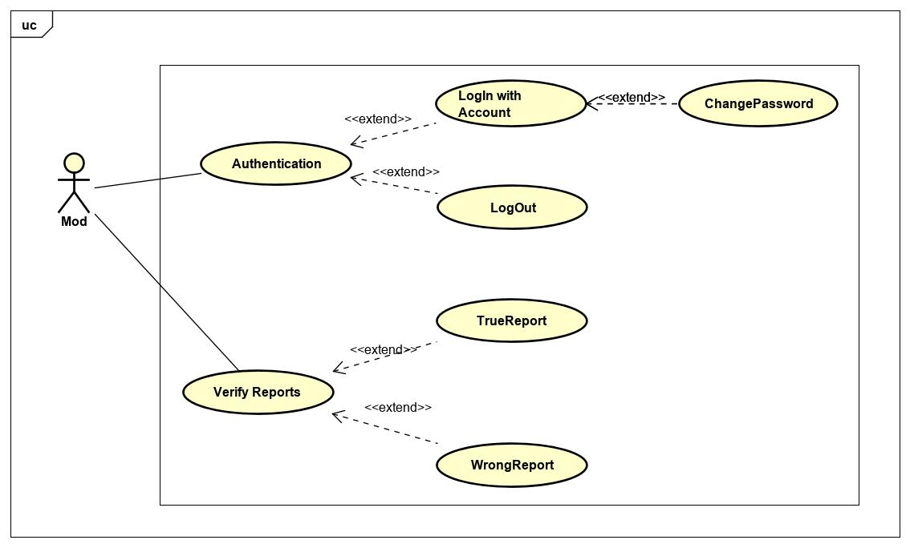

Figure 13 - Use case diagram of Mod actor

* + - * 1. Authentication

**\*Login with account**

|  |  |  |  |
| --- | --- | --- | --- |
| **USECASE MD-UC-1.0** **SPECIFICATION** | | | |
| **Use case ID** | AD-UC-1.0 | **Use case version** | V1.0 |
| **Use case name** | Login with Account | | |
| **Author** | Le Duc Chinh | | |
| **Date** | 25/09/2019 | **Priority** | High |
| **Primary actor** | Moderator | **Secondary actor** | N/A |
| **Description** | Allows moderator login to PD system in website. | | |
| **Pre-condition** | Mod has an account and the account is still working. | | |
| **Post-condition** | When the normal flow completes successfully, the login status is set to true, and the access token is saved on the website. | | |
| **Trigger** |  | | |
| **Main flow:**   |  |  |  | | --- | --- | --- | | **No.** | **Actor events** | **System respond** | | **1.** | Mod goes to login page |  | | **2.** |  | Website displays the details, which includes the following:  Title: Đăng nhập vào hệ thống PD  TextInput: Tài khoản  TextInput: Mật khẩu  Button: Đăng nhập | | **3.** | Mod fills account and password then clicks “Đăng nhập” button. |  | | **4.** |  | System generates cookies and save them. | | **5.** |  | Website navigates to homepage. |   **Alternative Flows: Mod logged and not yet log out.**   |  |  |  | | --- | --- | --- | | **No.** | **Actor events** | **System respond** | | **1.** | Mod goes to homepage |  | | **2.** |  | Website checks cookies then navigates to login page if not exist cookies. |   **Extension Flows: N/A**  **Exception:**  **MD1.0-E1 – Cannot connect with Account API**  System displays error message.  **MD1.0-E2 – Wrong account or password**  System displays error message and requests login again.    **Business Rules: B3, B4** | | | |
|  | | | |

**\*Logout**

|  |  |  |  |
| --- | --- | --- | --- |
| **USECASE MD-UC-2.0** **SPECIFICATION** | | | |
| **Use case ID** | MD-UC-2.0 | **Use case version** | V1.0 |
| **Use case name** | LogOut | | |
| **Author** | Le Duc Chinh | | |
| **Date** | 25/09/2019 | **Priority** | High |
| **Primary actor** | Moderator | **Secondary actor** | N/A |
| **Description** | Log out the PD System. | | |
| **Pre-condition** | Mod has logged into PD system. | | |
| **Post-condition** | When the normal flow completes successfully, the login status is set to false, and the access token is cleared. | | |
| **Trigger** |  | | |
| **Main flow:**   |  |  |  | | --- | --- | --- | | **No.** | **Actor events** | **System respond** | | **1.** | Clicks icon “Account” on top right of website. |  | | **2.** |  | Website displays “Account Management” pop-up | | **3.** | Admin/Mod clicks “Đăng xuất” on top right of website. |  | | **4.** |  | Website navigates to Login page. |   **Alternative Flows: N/A**  **Extension Flows:**  **Exception: N/A**  **Business Rules: N/A** | | | |
|  | | | |

**\*Change Password**

|  |  |  |  |
| --- | --- | --- | --- |
| **USECASE MD-UC-3.0** **SPECIFICATION** | | | |
| **Use case ID** | MD-UC-3.0 | **Use case version** | V1.0 |
| **Use case name** | Change Password | | |
| **Author** | Le Duc Chinh | | |
| **Date** | 25/09/2019 | **Priority** | High |
| **Primary actor** | Moderator | **Secondary actor** | N/A |
| **Description** | Allows mod to change their password. | | |
| **Pre-condition** | Mod logged in to system. | | |
| **Post-condition** | Password has been changed. | | |
| **Trigger** |  | | |
| **Main flow:**   |  |  |  | | --- | --- | --- | | **No.** | **Actor events** | **System respond** | | **1.** | Clicks icon “Account” on top right of website. |  | | **2.** |  | Website displays “Account Management” pop-up | | **3.** | Clicks “Đổi mật khẩu” |  | | **4.** |  | Website directs to “Đổi mật khẩu” interface | | **5.** | Fills all require field and presses the “Xác nhận” button |  | | **6.** |  | Shows sucess message and directs “Thông tin cá nhân” page |   **Alternative Flows: N/A**  **Extension Flows: N/A**  **Exception: N/A**  **Business Rules: N/A** | | | |
|  | | | |

* + - * 1. Verify Reports

|  |  |  |  |
| --- | --- | --- | --- |
| **USECASE MD-UC-3.0 and 4.0** **SPECIFICATION** | | | |
| **Use case ID** | MD-UC-3.0 and 4.0 | **Use case version** | V1.0 |
| **Use case name** | Verify Report | | |
| **Author** | Le Duc Chinh | | |
| **Date** | 26/09/2019 | **Priority** | Medium |
| **Primary actor** | Moderator | **Secondary actor** | N/A |
| **Description** | Handling reports from User | | |
| **Pre-condition** | **MD-3.0&4.0 – PRE1** Mod has logged in the system by moderator account.  **MD-3.0&4.0 – PRE2** At least report has been summited. | | |
| **Post-condition** |  | | |
| **Trigger** |  | | |
| **Main flow:**   |  |  |  | | --- | --- | --- | | **No.** | **Actor events** | **System respond** | | **1.** | Mod clicks “Xác minh báo cáo” |  | | **2.** |  | Website displays report page. | | **3.** | Mod clicks id of reports. |  | | **4.** |  | Website display information about report that include:  Image or video  Owner of post | | **5.1** | Mod verify and deliver result. Clicks “Vi phạm” button |  | | **6.1** |  | The system checks the number of violations of the violator. If the number less than 3, alert message to violator. If the number greater than 3, ban account. |   **Alternative Flows:**   |  |  |  | | --- | --- | --- | | **No.** | **Actor events** | **System respond** | | **5.2** | Mod verify and deliver result. Clicks “Không vi phạm” button |  | | **6.2** |  | Website redirect to report page. |   **Extension Flows: N/A**  **Exception:**  **MD3.0&4.0-E1 – Cannot communicate with API server**  System displays error message.    **Business Rules: N/A** | | | |
|  | | | |

* + - 1. **User**

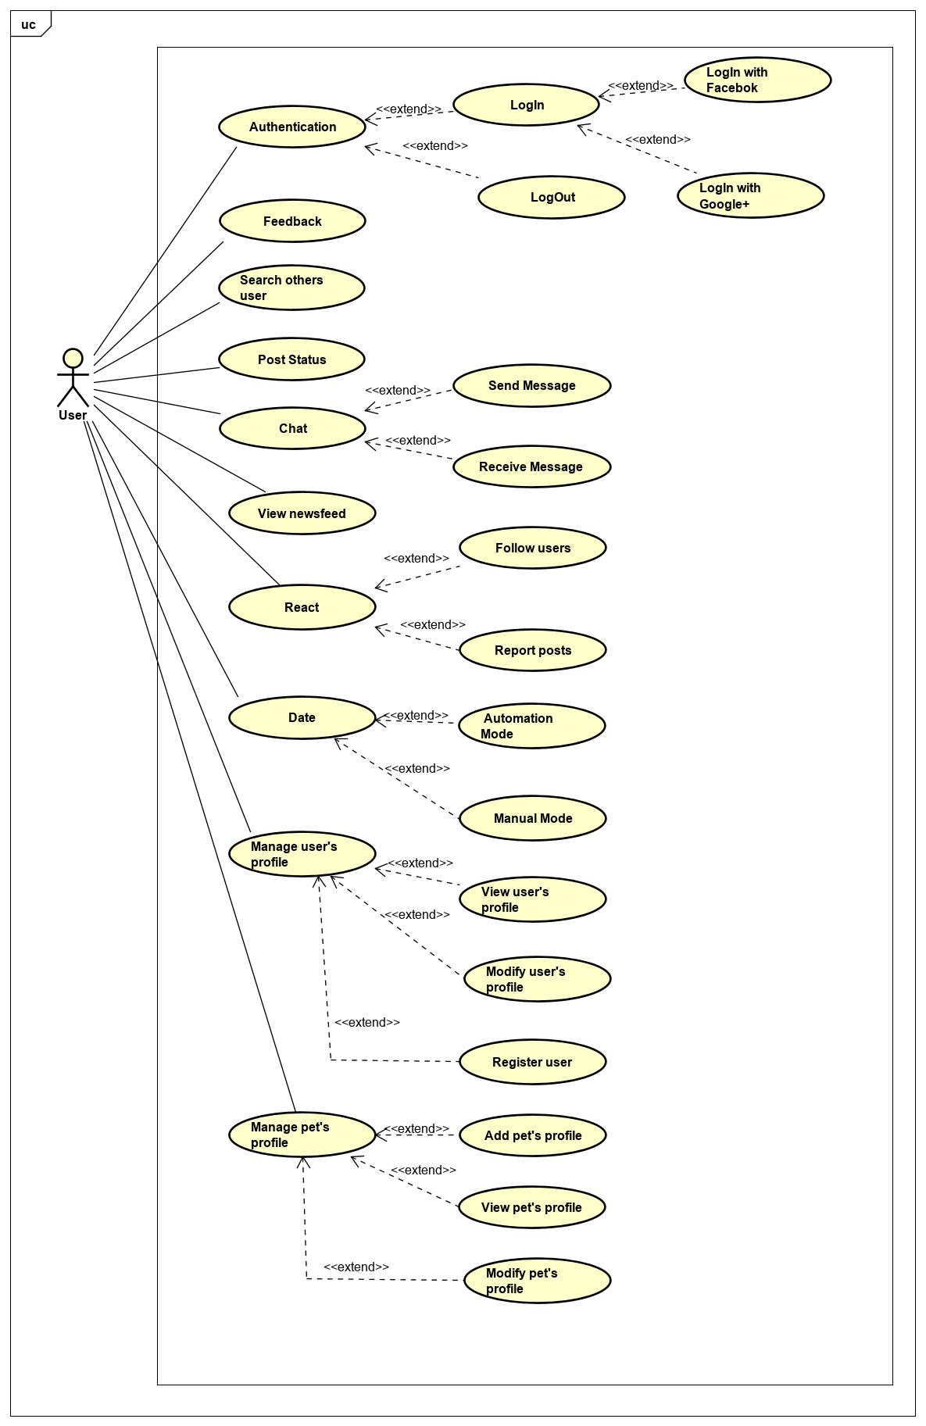

Figure 14 - Use case diagram of User actor

* + - * 1. Authentication

**\*Login with Google+ or Facebook**

|  |  |  |  |
| --- | --- | --- | --- |
| **USECASE US-UC-1.0** **SPECIFICATION** | | | |
| **Use case ID** | US-UC-1.0 | **Use case version** | V1.0 |
| **Use case name** | Login with Google+ or Facebook | | |
| **Author** | Le Duc Chinh | | |
| **Date** | 25/09/2019 | **Priority** | High |
| **Primary actor** | User | **Secondary actor** | N/A |
| **Description** | Allows User login to PD system in mobile application. | | |
| **Pre-condition** | People has a Google/Facebook account and the account is still working. | | |
| **Post-condition** | When the normal flow completes successfully, the login status is set to true, and the access token is saved on the application. | | |
| **Trigger** |  | | |
| **Main flow:**   |  |  |  | | --- | --- | --- | | **No.** | **Actor events** | **System respond** | | **1.** | User opens PD application |  | | **2.** |  | App displays title “Đăng nhập vào PETDATING”, “Đăng nhập với Google+” button and “Đăng nhập với Facebook” button. | | **3.** | User clicks “Đăng nhập với Google+” or “Đăng nhập với Facebook”. |  | | **4.** |  | App shows a pop-up login. | | **5.** | User fills email and password or choose account (if signed in before) |  | | **6.** |  | System generates access token, user profile and save it on application. | | **7.** |  | App navigates to inside app. |   **Alternative Flows: User logged and not yet log out.**   |  |  |  | | --- | --- | --- | | **No.** | **Actor events** | **System respond** | | **1.** | User opens PD application |  | | **2.** |  | Application checks data then navigates to inside app. |   **Extension Flows: N/A**  **Exception:**  **US1.0-E1 – Cannot connect with Google API**  System displays error message.  **US1.0-E2 – Cannot connect with Facebook API**  System displays error message.    **Business Rules: B1** | | | |
|  | | | |

**\*Logout**

|  |  |  |  |
| --- | --- | --- | --- |
| **USECASE MD-UC-2.0** **SPECIFICATION** | | | |
| **Use case ID** | MD-UC-2.0 | **Use case version** | V1.0 |
| **Use case name** | LogOut | | |
| **Author** | Le Duc Chinh | | |
| **Date** | 25/09/2019 | **Priority** | High |
| **Primary actor** | Moderator | **Secondary actor** | N/A |
| **Description** | Log out the PD System. | | |
| **Pre-condition** | Has logged into PD system. | | |
| **Post-condition** | When the normal flow completes successfully, the login status is set to false, and the access token is cleared. | | |
| **Trigger** |  | | |
| **Main flow:**   |  |  |  | | --- | --- | --- | | **No.** | **Actor events** | **System respond** | | **1.** | User clicks top right icon on top tab bar |  | | **2.** |  | Application displays “NavScreen” | | **3.** | User clicks “Đăng xuất” to logout system |  | | **4.** |  | Application navigates to Login screen |   **Alternative Flows: N/A**  **Extension Flows:**  **Exception: N/A**  **Business Rules: N/A** | | | |
|  | | | |

* + - * 1. Feedback

|  |  |  |  |
| --- | --- | --- | --- |
| **USECASE US-UC-3.0** **SPECIFICATION** | | | |
| **Use case ID** | US-UC-3.0 | **Use case version** | V1.0 |
| **Use case name** | Feedback | | |
| **Author** | Le Duc Chinh | | |
| **Date** | 27/07/2019 | **Priority** | Low |
| **Primary actor** | User | **Secondary actor** | N/A |
| **Description** | User feedbacks about system. | | |
| **Pre-condition** | User has logged into application. | | |
| **Post-condition** |  | | |
| **Trigger** |  | | |
| **Main flow:**   |  |  |  | | --- | --- | --- | | **No.** | **Actor events** | **System respond** | | **1.** | User clicks top right icon on top tab bar |  | | **2.** |  | Application displays “Account Management” screen | | **3.** | User clicks “Phản hồi” to feedback about system. |  | | **4.** |  | Application links to other mail apps. | | **5.** | User uses own mail app to send feedback. |  |   **Alternative Flows: N/A**  **Extension Flows: N/A**  **Exception:**  **Business Rules: N/A** | | | |
|  | | | |

* + - * 1. Search others user

|  |  |  |  |
| --- | --- | --- | --- |
| **USECASE US-UC-4.0** **SPECIFICATION** | | | |
| **Use case ID** | US-UC-4.0 | **Use case version** | V1.0 |
| **Use case name** | Search others user | | |
| **Author** | Le Duc Chinh | | |
| **Date** | 27/07/2019 | **Priority** | Medium |
| **Primary actor** | User | **Secondary actor** | N/A |
| **Description** | User search others user. | | |
| **Pre-condition** | User has logged into application. | | |
| **Post-condition** |  | | |
| **Trigger** |  | | |
| **Main flow:**   |  |  |  | | --- | --- | --- | | **No.** | **Actor events** | **System respond** | | **1.** | User clicks top left icon on top tab bar |  | | **2.** |  | Application displays “News Feed” screen, which includes:  Search bar  New post  List of posts | | **3.** | User clicks search bar then fills keyword and clicks search button on bottom right of keyboard |  | | **4.** |  | Application displays list of users which have same keyword. | | **5.** | User clicks the right user name. |  |   **Alternative Flows: N/A**  **Extension Flows: N/A**  **Exception:**  **US4.0-E1 – Cannot communicate with API server**  System displays error message.  **US4.0-E2 – User does not exist and not match**  System displays nothing.  **Business Rules: N/A** | | | |
|  | | | |

* + - * 1. Chat

**\*Send message**

|  |  |  |  |
| --- | --- | --- | --- |
| **USECASE US-UC-5.0** **SPECIFICATION** | | | |
| **Use case ID** | US-UC-5.0 | **Use case version** | V1.0 |
| **Use case name** | Send message | | |
| **Author** | Le Duc Chinh | | |
| **Date** | 27/07/2019 | **Priority** | High |
| **Primary actor** | User | **Secondary actor** | N/A |
| **Description** | User sends messages to others user. | | |
| **Pre-condition** | User has logged into application. | | |
| **Post-condition** |  | | |
| **Trigger** |  | | |
| **Main flow:**   |  |  |  | | --- | --- | --- | | **No.** | **Actor events** | **System respond** | | **1.** | Do US-UC-2.0 then view receiver profile. |  | | **2.** |  | Application displays receiver profile. | | **3.** | User clicks “Nhắn tin” button in receiver profile. |  | | **4.** |  | Application displays “Chat” screen. | | **5.** | User enters message then clicks icon send. |  | |  |  | Application sends message to receiver. |   **Alternative Flows:**   |  |  |  | | --- | --- | --- | | **No.** | **Actor events** | **System respond** | | **1.** | User click message icon on top tab bar |  | | **2.** |  | Application displays “ConversationList” screen. | | **3.** | User clicks specific conversation |  | | **4.** |  | Application displays “Chat” screen. | | **5.** | User fills receiver name and enter message then clicks icon send. |  | |  |  | Application sends message to receiver. |   **Extension Flows: N/A**  **Exception:**  **US5.0-E1 – Cannot communicate with API server**  System displays error message.  **US5.0-E2 – User does not exist or empty**  System cannot send message.  **Business Rules: B9** | | | |
|  | | | |

**\*Receive message**

|  |  |  |  |
| --- | --- | --- | --- |
| **USECASE US-UC-6.0** **SPECIFICATION** | | | |
| **Use case ID** | US-UC-6.0 | **Use case version** | V1.0 |
| **Use case name** | Receive message | | |
| **Author** | Le Duc Chinh | | |
| **Date** | 27/07/2019 | **Priority** | High |
| **Primary actor** | User | **Secondary actor** | N/A |
| **Description** | User receives messages from others user. | | |
| **Pre-condition** | User has logged into application. | | |
| **Post-condition** |  | | |
| **Trigger** |  | | |
| **Main flow:**   |  |  |  | | --- | --- | --- | | **No.** | **Actor events** | **System respond** | | **1.** | User click message icon on top tab bar |  | | **2.** |  | Application displays “ConversationList” screen. | | **3.** | User clicks sender name to read message. |  | | **4.** |  | Application displays chatting screen with sender. |   **Alternative Flows: N/A**  **Extension Flows: N/A**  **Exception:**  **US6.0-E1 – Cannot communicate with API server**  System displays error message.    **Business Rules: N/A** | | | |
|  | | | |

* + - * 1. View newsfeed

|  |  |  |  |
| --- | --- | --- | --- |
| **USECASE US-UC-7.0** **SPECIFICATION** | | | |
| **Use case ID** | US-UC-7.0 | **Use case version** | V1.0 |
| **Use case name** | View newsfeed | | |
| **Author** | Le Duc Chinh | | |
| **Date** | 27/07/2019 | **Priority** | Medium |
| **Primary actor** | User | **Secondary actor** | N/A |
| **Description** | User views posts of others user. | | |
| **Pre-condition** | User has logged into application. | | |
| **Post-condition** |  | | |
| **Trigger** |  | | |
| **Main flow:**   |  |  |  | | --- | --- | --- | | **No.** | **Actor events** | **System respond** | | **1.** | User clicks top left icon on top tab bar |  | | **2.** |  | Application displays “News Feed” screen, which includes:  New post  List of posts | | **3.** | User roll down to read posts. |  |   **Alternative Flows: N/A**  **Extension Flows: N/A**  **Exception:**  **US7.0-E1 – Cannot communicate with API server**  System displays error message.    **Business Rules: N/A** | | | |
|  | | | |

* + - * 1. React

**\*Follow user**

|  |  |  |  |
| --- | --- | --- | --- |
| **USECASE US-UC-8.0** **SPECIFICATION** | | | |
| **Use case ID** | US-UC-8.0 | **Use case version** | V1.0 |
| **Use case name** | Follow user | | |
| **Author** | Le Duc Chinh | | |
| **Date** | 27/07/2019 | **Priority** | High |
| **Primary actor** | User | **Secondary actor** | N/A |
| **Description** | User sends messages to others user. | | |
| **Pre-condition** | User has logged into application. | | |
| **Post-condition** | Privacy of user is public | | |
| **Trigger** |  | | |
| **Main flow:**   |  |  |  | | --- | --- | --- | | **No.** | **Actor events** | **System respond** | | **1.** | Do US-UC-4.0 then view target profile. |  | | **2.** |  | Application displays target profile. | | **3.** | User clicks follow icon in target profile. |  | | **4.** |  | Application displays success message. |   **Alternative Flows: N/A**  **Extension Flows:**   |  |  |  | | --- | --- | --- | | **No.** | **Actor events** | **System respond** | | **1.** | Click “username” on post |  | | **2.** |  | Application displays target profile. | | **3.** | User clicks follow icon in target profile. |  | | **4.** |  | Application displays success message. |   **Exception:**  **US8.0-E1 – Cannot communicate with API server**  System displays error message.  **Business Rules: N/A** | | | |
|  | | | |

**\*Report post**

|  |  |  |  |
| --- | --- | --- | --- |
| **USECASE US-UC-9.0** **SPECIFICATION** | | | |
| **Use case ID** | US-UC-9.0 | **Use case version** | V1.0 |
| **Use case name** | Report post | | |
| **Author** | Le Duc Chinh | | |
| **Date** | 27/07/2019 | **Priority** | Medium |
| **Primary actor** | User | **Secondary actor** | N/A |
| **Description** | User report posts of others user. | | |
| **Pre-condition** | User has logged into application. | | |
| **Post-condition** |  | | |
| **Trigger** |  | | |
| **Main flow:**   |  |  |  | | --- | --- | --- | | **No.** | **Actor events** | **System respond** | | **1.** | Do US-UC-7.0 then clicks report icon. |  | | **2.** |  | Application displays list of report types. | | **3.** | User chooses the type then submit. |  | | **4.** |  | Application displays success message. |   **Alternative Flows: N/A**  **Extension Flows: N/A**  **Exception:**  **US9.0-E1 – Cannot communicate with API server**  System displays error message.    **Business Rules: N/A** | | | |
|  | | | |

* + - * 1. Date

**\*Automation Mode**

|  |  |  |  |
| --- | --- | --- | --- |
| **USECASE US-UC-10.0** **SPECIFICATION** | | | |
| **Use case ID** | US-UC-10.0 | **Use case version** | V1.0 |
| **Use case name** | Automation Mode | | |
| **Author** | Le Duc Chinh | | |
| **Date** | 27/07/2019 | **Priority** | High |
| **Primary actor** | User | **Secondary actor** | N/A |
| **Description** | User selects automation mode for dating. | | |
| **Pre-condition** | User has logged into application. | | |
| **Post-condition** |  | | |
| **Trigger** |  | | |
| **Main flow:**   |  |  |  | | --- | --- | --- | | **No.** | **Actor events** | **System respond** | | **1.** | User clicks dating icon on top tab bar. |  | | **2.** |  | Application displays “Dating” Screen | | **3.** | User chooses pet that want to dating. |  | | **4.** | User clicks “Kết nối” button. |  | | **5.** |  | Application display list of users valid. |   **Alternative Flows: N/A**  **Extension Flows: N/A**  **Exception:**  **US10.0-E1 – Cannot communicate with API server**  System displays error message.  **Business Rules: N/A** | | | |
|  | | | |

**\*Manual Mode**

|  |  |  |  |
| --- | --- | --- | --- |
| **USECASE US-UC-11.0** **SPECIFICATION** | | | |
| **Use case ID** | US-UC-11.0 | **Use case version** | V1.0 |
| **Use case name** | Manual Mode | | |
| **Author** | Le Duc Chinh | | |
| **Date** | 27/07/2019 | **Priority** | High |
| **Primary actor** | User | **Secondary actor** | N/A |
| **Description** | User selects manual mode for dating. | | |
| **Pre-condition** | User has logged into application. | | |
| **Post-condition** |  | | |
| **Trigger** |  | | |
| **Main flow:**   |  |  |  | | --- | --- | --- | | **No.** | **Actor events** | **System respond** | | **1.** | User clicks dating icon on top tab bar. |  | | **2.** |  | Application displays “Dating” Screen. | | **3.** | User chooses pet that want to dating. |  | | **4.** | User clicks “Chế độ” then choose “Thủ công”. |  | | **5.** | User fills and select all required information then clicks “Kết nối” button. |  | | **6.** |  | Application display list of users valid. |   **Alternative Flows: N/A**  **Extension Flows: N/A**  **Exception:**  **US11.0-E1 – Cannot communicate with API server**  System displays error message.  **Business Rules: N/A** | | | |
|  | | | |

* + - * 1. Manage user’s profile

**\*View user’s profile**

|  |  |  |  |
| --- | --- | --- | --- |
| **USECASE US-UC-12.0** **SPECIFICATION** | | | |
| **Use case ID** | US-UC-12.0 | **Use case version** | V1.0 |
| **Use case name** | View user’s profile | | |
| **Author** | Le Duc Chinh | | |
| **Date** | 27/07/2019 | **Priority** | High |
| **Primary actor** | User | **Secondary actor** | N/A |
| **Description** | User views own profile. | | |
| **Pre-condition** | User has logged into application. | | |
| **Post-condition** |  | | |
| **Trigger** |  | | |
| **Main flow:**   |  |  |  | | --- | --- | --- | | **No.** | **Actor events** | **System respond** | | **1.** | User clicks account icon on top tab bar |  | | **2.** |  | Application displays “Account Management” screen | | **3.** |  | Application navigates to “Own Profile” screen, which include:  Ảnh đại diện  Thông tin cá nhân  Lưu trữ: ảnh, video, …  Các bài viết |   **Alternative Flows: N/A**  **Extension Flows: N/A**  **Exception:**  **US12.0-E1 – Cannot communicate with API server**  System displays error message.  **Business Rules: N/A** | | | |
|  | | | |

**\*Modify user’s profile**

|  |  |  |  |
| --- | --- | --- | --- |
| **USECASE US-UC-13.0** **SPECIFICATION** | | | |
| **Use case ID** | US-UC-13.0 | **Use case version** | V1.0 |
| **Use case name** | Modify user’s profile | | |
| **Author** | Le Duc Chinh | | |
| **Date** | 27/07/2019 | **Priority** | High |
| **Primary actor** | User | **Secondary actor** | N/A |
| **Description** | User modify own profile. | | |
| **Pre-condition** | User has logged into application. | | |
| **Post-condition** |  | | |
| **Trigger** |  | | |
| **Main flow:**   |  |  |  | | --- | --- | --- | | **No.** | **Actor events** | **System respond** | | **1.** | User clicks “Account” icon on top tab bar |  | | **2.** |  | Application displays “Account Management” screen | | **3.** |  | Application navigates to “Own Profile” screen, which include:  Ảnh đại diện  Thông tin cá nhân  Lưu trữ: ảnh, video, …  Các bài viết | | **4.** | User clicks “Chỉnh sửa trang cá nhân”. |  | | **5.** |  | Application navigates to “Modify Profile” screen. | | **6.** | User fills and select all required information then clicks “Chỉnh sửa” button. |  | |  |  | Application displays success message. |   **Alternative Flows: N/A**  **Extension Flows: N/A**  **Exception:**  **US13.0-E1 – Cannot communicate with API server**  System displays error message.  **Business Rules: B8, B9, B12, B13, B14, B15** | | | |
|  | | | |

**\*Register user**

|  |  |  |  |
| --- | --- | --- | --- |
| **USECASE US-UC-14.0** **SPECIFICATION** | | | |
| **Use case ID** | US-UC-14.0 | **Use case version** | V1.0 |
| **Use case name** | Register user | | |
| **Author** | Le Duc Chinh | | |
| **Date** | 27/07/2019 | **Priority** | High |
| **Primary actor** | User | **Secondary actor** | N/A |
| **Description** | Reigster user if user not in the system | | |
| **Pre-condition** | User has logged success by Google or Facebook. | | |
| **Post-condition** |  | | |
| **Trigger** |  | | |
| **Main flow:**   |  |  |  | | --- | --- | --- | | **No.** | **Actor events** | **System respond** | | **1.** | Navigate to “CreateUserScreen” after user logged by Google/Facebook |  | | **2.** |  | Application displays “CreateUserScreen” screen, which includes:  Ảnh đại diện  Tên đại diện  Giới tính  Thành phố | | **3.** | User clicks “Tham gia PetDating”. |  | | **5.** |  | Application alert message and navigates to “Login” screen. |   **Alternative Flows: N/A**  **Extension Flows: N/A**  **Exception:**  **US14.0-E1 – Cannot communicate with API server**  System displays error message.  **Business Rules: B8, B9, B12, B13, B15** | | | |
|  | | | |

* + - * 1. Manage pet’s profile

**\*Add pet’s profile**

|  |  |  |  |
| --- | --- | --- | --- |
| **USECASE US-UC-15.0** **SPECIFICATION** | | | |
| **Use case ID** | US-UC-15.0 | **Use case version** | V1.0 |
| **Use case name** | Add pet’s profile | | |
| **Author** | Le Duc Chinh | | |
| **Date** | 27/07/2019 | **Priority** | High |
| **Primary actor** | User | **Secondary actor** | N/A |
| **Description** | User adds own pet’s profile. | | |
| **Pre-condition** | User has logged into application. | | |
| **Post-condition** |  | | |
| **Trigger** |  | | |
| **Main flow:**   |  |  |  | | --- | --- | --- | | **No.** | **Actor events** | **System respond** | | **1.** | User clicks pet icon on top tab bar |  | | **2.** |  | Application displays “Pet Management” screen | | **3.** | User click new icon. |  | | **4.** |  | Application navigates to “New Pet” screen. | | **5.** | User fills and select all required information then clicks “Thêm mới” button. |  | | **6.** |  | Application displays success message. |   **Alternative Flows: N/A**  **Extension Flows: N/A**  **Exception:**  **US15.0-E1 – Cannot communicate with API server**  System displays error message.  **Business Rules: B7, B9, B11, B13, B15** | | | |
|  | | | |

**\*View pet’s profile**

|  |  |  |  |
| --- | --- | --- | --- |
| **USECASE US-UC-16.0** **SPECIFICATION** | | | |
| **Use case ID** | US-UC-16.0 | **Use case version** | V1.0 |
| **Use case name** | View pet’s profile | | |
| **Author** | Le Duc Chinh | | |
| **Date** | 27/07/2019 | **Priority** | High |
| **Primary actor** | User | **Secondary actor** | N/A |
| **Description** | User views own pet’s profile. | | |
| **Pre-condition** | User has logged into application. | | |
| **Post-condition** |  | | |
| **Trigger** |  | | |
| **Main flow:**   |  |  |  | | --- | --- | --- | | **No.** | **Actor events** | **System respond** | | **1.** | User clicks pet icon on top tab bar |  | | **2.** |  | Application displays “Pet Management” screen | | **3.** | User click avatar of pet to view pet’s profile |  | |  |  | Application navigates to “Pet Profile” screen |   **Alternative Flows: N/A**  **Extension Flows: N/A**  **Exception:**  **US16.0-E1 – Cannot communicate with API server**  System displays error message.  **Business Rules: N/A** | | | |
|  | | | |

**\*Modify pet’s profile**

|  |  |  |  |
| --- | --- | --- | --- |
| **USECASE US-UC-17.0** **SPECIFICATION** | | | |
| **Use case ID** | US-UC-17.0 | **Use case version** | V1.0 |
| **Use case name** | View pet’s profile | | |
| **Author** | Le Duc Chinh | | |
| **Date** | 27/07/2019 | **Priority** | High |
| **Primary actor** | User | **Secondary actor** | N/A |
| **Description** | User views own pet’s profile. | | |
| **Pre-condition** | User has logged into application. | | |
| **Post-condition** |  | | |
| **Trigger** |  | | |
| **Main flow:**   |  |  |  | | --- | --- | --- | | **No.** | **Actor events** | **System respond** | | **1.** | Do US-UC-16.0 then click “Sửa đổi thông tin” |  | | **2.** |  | Application navigates to “ModifyPet Profile” screen | | **3.** | User fills and select all required information then clicks “Sửa đổi” button. |  | |  |  | Application displays success message. |   **Alternative Flows: N/A**  **Extension Flows: N/A**  **Exception:**  **US17.0-E1 – Cannot communicate with API server**  System displays error message.  **Business Rules: B7, B9, B11, B13, B15** | | | |
|  | | | |

* + - * 1. Post status

**\*Post status**

|  |  |  |  |
| --- | --- | --- | --- |
| **USECASE US-UC-18.0** **SPECIFICATION** | | | |
| **Use case ID** | US-UC-18.0 | **Use case version** | V1.0 |
| **Use case name** | Post status | | |
| **Author** | Le Duc Chinh | | |
| **Date** | 01/12/2019 | **Priority** | High |
| **Primary actor** | User | **Secondary actor** | N/A |
| **Description** | User posts owner status | | |
| **Pre-condition** | User has logged into application. | | |
| **Post-condition** |  | | |
| **Trigger** |  | | |
| **Main flow:**   |  |  |  | | --- | --- | --- | | **No.** | **Actor events** | **System respond** | | **1.** | Click “home” icon on tab bar |  | | **2.** |  | Application navigates to “PostScreen” screen | | **3.** | Click your avatar next to “Bạn muốn chia sẻ” |  | | **4.** |  | Application navigates to “CreatePost” screen. | | **5.** | User fills and select all required information then clicks “Đăng” button. |  | | **6.** |  | Application displays post screen |   **Alternative Flows: N/A**  **Extension Flows: N/A**  **Exception:**  **US17.0-E1 – Cannot communicate with API server**  System displays error message.  **Business Rules: B9, B15** | | | |
|  | | | |

* 1. Non-functional Requirement

3. 3. 1. Security

* User must use Google authentication (login with Google) or Facebook authentication (login with Facebook) in order to join the system. So, this is an absolute guarantee of account information security.
* Admin/Mod does not access to database of user.
* Your information can hide in private mode.
  + 1. Availability
* The system active 24/24.
  + 1. Usability
* User interface should be friendly and easy to use.
* Application supports Android.
* The guideline is clearly and easy to use.
* The system is easy to deploy.

# **CHAPTER 4: SOFTWARE DESIGN**



## Purpose

This chapter is to give the developer team an overview of what the system’s architecture  
is, and how they should be implemented. This chapter consists of:

* Overview of system architecture
* Database Design
* Detailed Design

## Overview of System Architecture



### Diagram

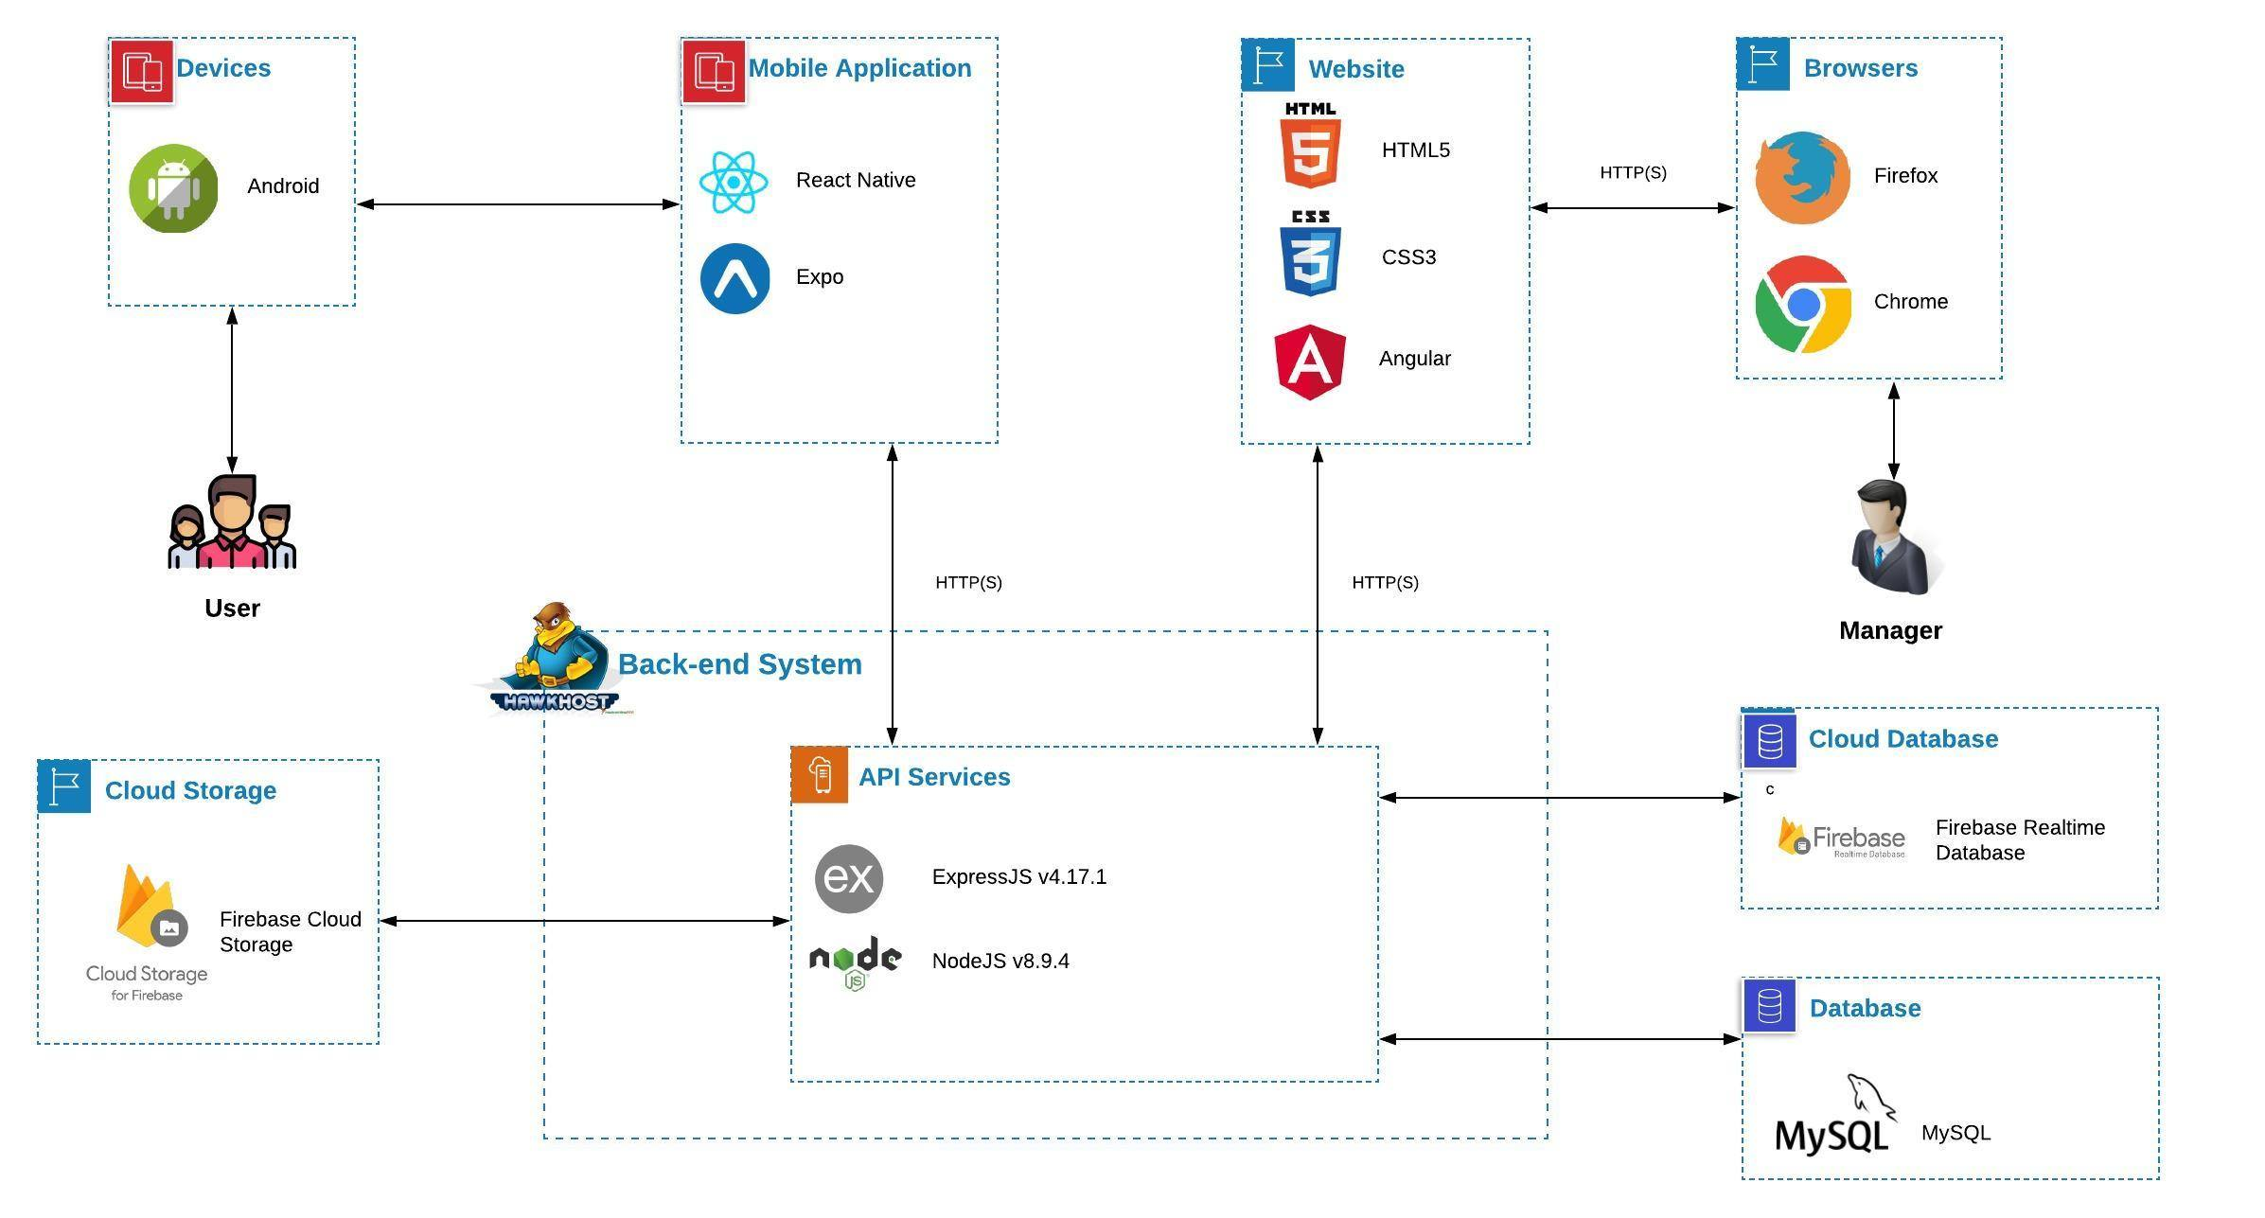

Figure 15 - PetDating system architecture

### Component Explanation

This section will explain the function and mechanism of each unit in the system architecture design.

#### Deployment and Hosting

##### *Hawkhost*



Hawkhost is a service provider like as hosting,VPS, Cloud,... We use Hawkhost to deploy API services, hosting for website.

##### *Firebase Cloud Storage*



**Firebase Cloud Storage** is a online file storage web service for storing and accessing data on Firebase Cloud Platform infrastructure. The service combines the performance and scalability of Google's cloud with advanced security and sharing capabilities. **We use Firebase Cloud Storage for storing images that uploaded from users.**

#### Mobile Application components

##### *React Native*



**React Native** combines the best parts of native development with React, a best-in-class JavaScript library for building user interfaces. Many platforms, one React. Create platform-specific versions of components so a single codebase can share code across platforms**.**

##### *Expo*



**Expo** is a toolchain built around React Native to help you quickly start an app. It provides a set of tools that simplify the development and testing of React Native app and interface and services that are usually available in third-party native React Native components. **We use Expo to build an application that available for Android based on React Native.**

#### Website components

##### *HTML5 and CSS3*



Using **HTML5 and CSS3** provides advantages to businesses that develop and deploy web content and web applications, to create refined and accurate web pages and web systems that **operate across devices, operating systems and web browsers**.

##### *Angular*



**Angular** is a platform for building mobile and desktop web applications. **We use Angular for font-end website.**

#### API Services components

##### *NodeJS*



Node.js is an open-source, cross-platform JavaScript runtime environment that executes  
JavaScript code server-side. It uses an event-driven, non-blocking I/O model that makes it  
lightweight and efficient. **We use NodeJS to develop API services.**

##### *ExpressJS*



**ExpressJS** is a NodeJS framework. It’s fast, unopinionated, minimalist framework for NodeJS. **We use ExpressJS and many of its modules to construct our API services.**

#### Database components

##### *Firebase Realtime Database*



The **Firebase Realtime Database** is a cloud-hosted database. Data is stored as JSON and synchronized in real-time to every connected client. **We use it to work with chatting function.**

##### *MySQL*



**MySQL** is a fast, easy-to-use RDBMS being used for many small and big businesses. **We use MongoDB to manage PD data.**

## Application Custom MVC Design

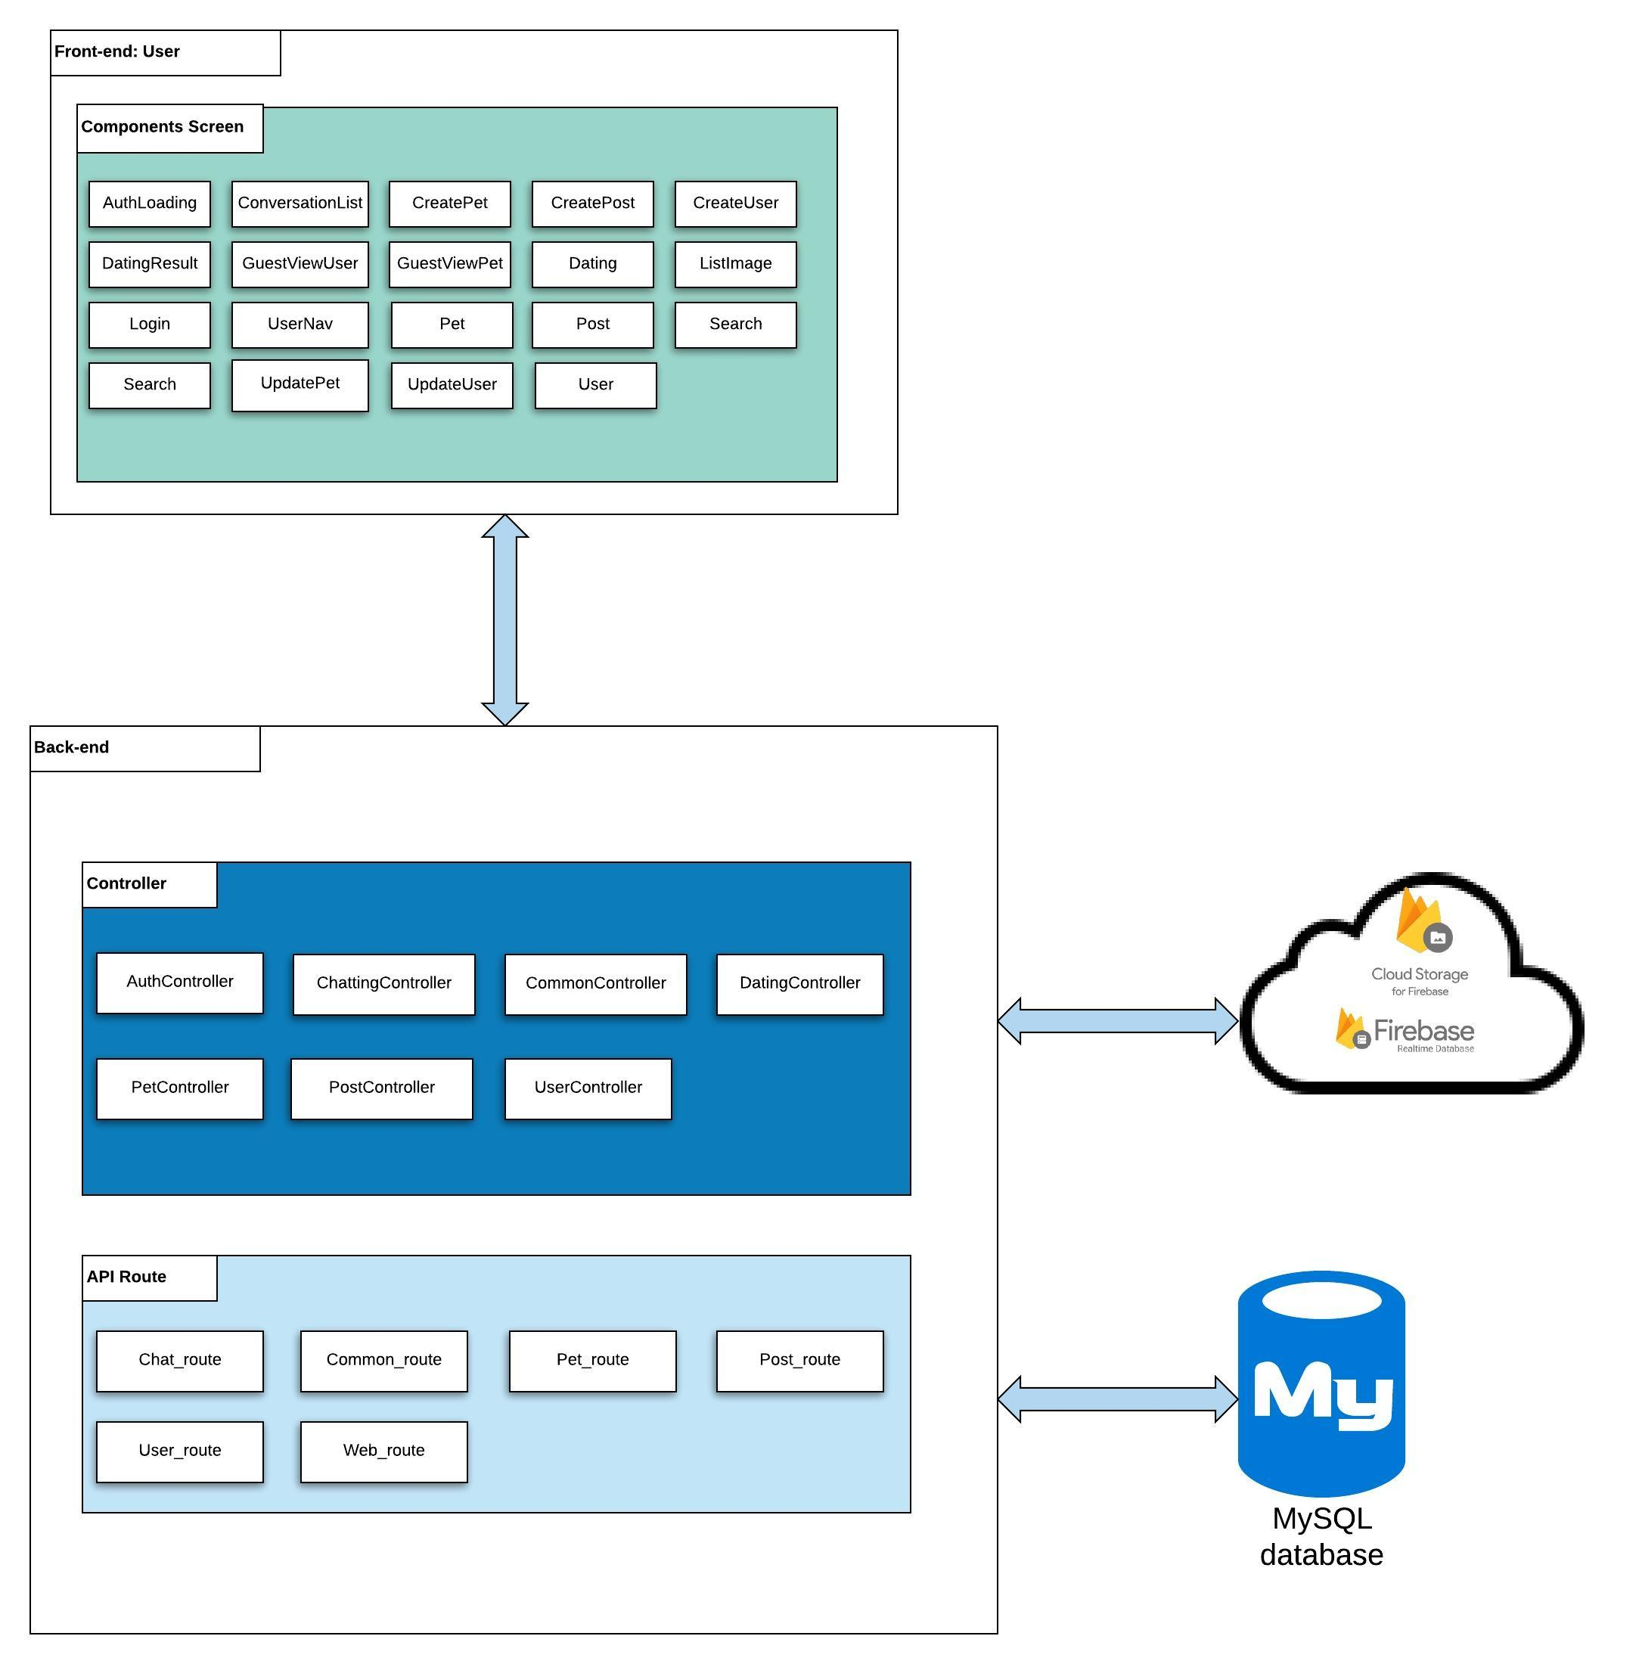

Figure 16 - PetDating react native design

## Database Design



### Entity relationship diagram

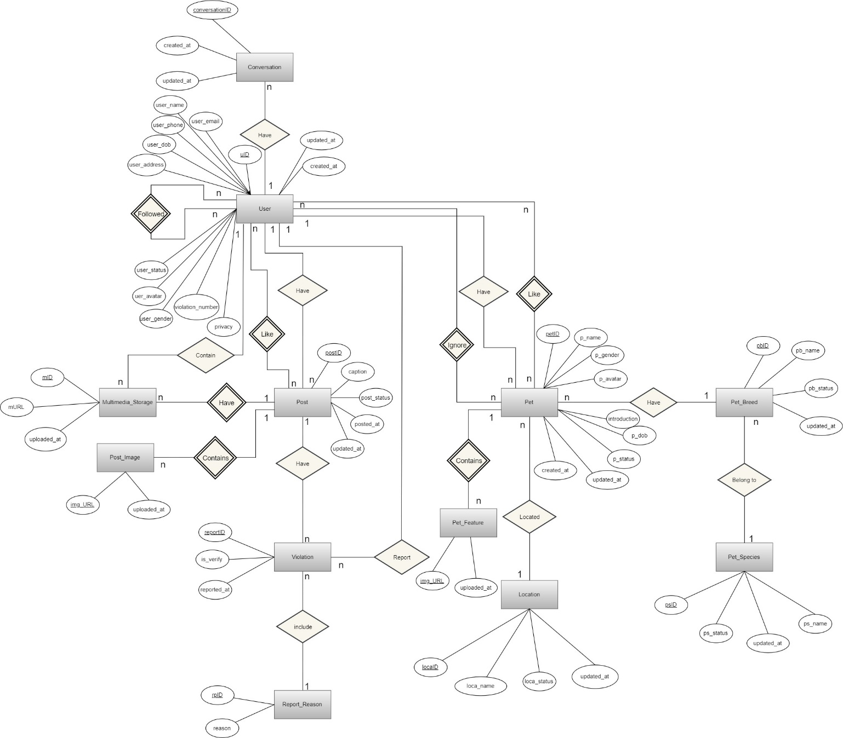

Figure 17 - Entity relationship diagram

|  |  |  |
| --- | --- | --- |
| **Entity** | **Attributes** | **Description** |
| User | **uID** | id of user |
| user_email | email of user |
| user_name | name of user |
| user_avatar | avatar of user |
| user_gender | gender of user |
| user_phone | phone of user |
| user_dob | birthdate of user |
| user_address | address of user |
| user_status | status of user |
| privacy | privacy of user |
| violation_number | number of violations (3=ban) |
| created_at | datetime that the user was created |
| updated_at | datetime that the user was updated |
| Pet | **petID** | id of pet |
| p_name | name of pet |
| p_dob | birthdate of pet |
| p_gender | gender of pet |
| p_avatar | link to the avatar of pet |
| p_status | status of pet |
| introduction | introduction of the pet |
| created_at | datetime that the pet was created |
| updated_at | datetime that the pet was updated |
| Pet_Breed | **pb_id** | id of pet breed |
| pb_name | specific name of pet breed |
| pb_status | status of pet breed |
| updated_at | datetime that the pet breed was updated |
| Pet_Species | **ps_id** | id of pet specie |
| ps_name | specific name of specie |
| ps_status | status of specie |
| updated_at | datetime that the specie was updated |
| Location | **loca_id** | id of pet location |
| loca_name | specific name of location |
| loca_status | status of location |
| updated_at | datetime that the specie was updated |
| Post | **postID** | id of the post |
| caption | caption of the post |
| post_status | status of post |
| posted_at | datetime that the post was publicized |
| updated_at | datetime that the post was updated |
| Violation | **reportID** | id of the report |
| reported_at | datetime that the report was issued |
| Report_Reason | **rpid** | id of the reason |
| reason | content of the reason |
| Multimedia_Storage | **mID** | id of multimedia |
| mURL | link to multimedia |
| uploaded_at | datetime that the multimedia was uploaded |
| Conversation | **conversationID** | id of conversation |
| created_at | datetime that the conversation was created |
| updated_at | datetime that the last message in conversation was updated |
| Post_Image | **img_URL** | url of the image |
| uploaded_at | datetime that the image was uploaded |
| Pet_Feature | **img_URL** | url of the image |
| uploaded_at | datetime that the image was uploaded |

Figure 18 - ERD description

### Database diagram

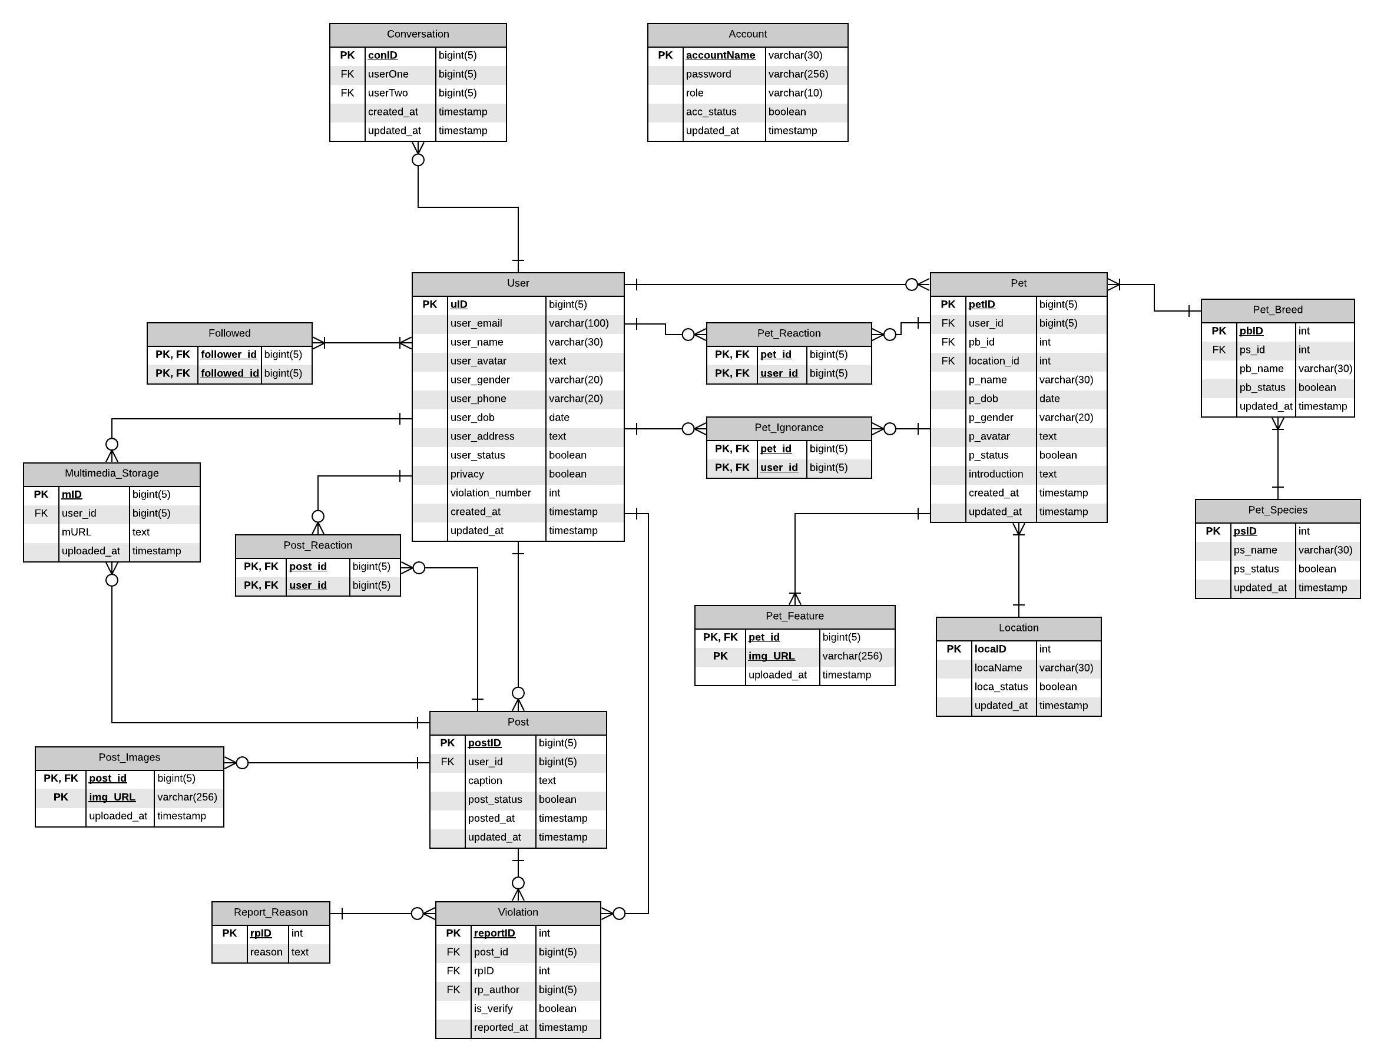

Figure 19 - Database diagram

**Database Explanation:**

**\*User:**

|  |  |  |  |  |
| --- | --- | --- | --- | --- |
| **No** | **Field Name** | **Type** | **Allow Null** | **Desceription** |
| 1 | **uID** | bigint(5) | no | id of user  **PRIMARY KEY** |
| 2 | user_email | varchar(100) | No | email of user  **UNIQUE** |
| 3 | user_name | varchar(30) | No | name of user |
| 4 | user_avatar | text | No | avatar of user |
| 5 | user_gender | varchar(20) | No | gender of user (Nam; Nữ; Không công khai) |
| 6 | user_phone | varchar(20) | Yes | phone of user |
| 7 | user_dob | date | No | birthdate of user |
| 8 | user_address | text | Yes | address of user |
| 9 | user_status | boolean | No | status of user  1: Activated - Default  0: inActivated |
| 10 | privacy | boolean | No | privacy of user  1: Công khai - Default  0: Riêng tư |
| 11 | violation_number | int | No | number violation of user(Default: 0). |
| 12 | created_at | timestamp | No | datetime that the user was created  Default: CURRENT_TIMESTAMP |
| 13 | updated_at | timestamp | No | datetime that the pet was updated  Default: CURRENT_TIMESTAMP  ON UPDATE CURRENT_TIMESTAMP |

**\*Pet:**

|  |  |  |  |  |
| --- | --- | --- | --- | --- |
| **No** | **Field Name** | **Type** | **Allow Null** | **Desceription** |
| 1 | **petID** | bigint(5) | No | id of pet  **Primary key** |
| 2 | *user_id* | bigint(20) | No | id of user who have pets  Foreign key references to uID in “User” table |
| 3 | *pb_id* | int | No | breed of pet  Foreign key references to pbID in “PetBreed” table |
| 4 | *location_id* | int | No | location of pet  Foreign key refernces to locaID in “Location” table |
| 5 | p_name | varchar(30) | No | name of pet |
| 6 | p_dob | date | No | birthdate of pet |
| 7 | p_gender | varchar(20) | No | gender of pet (Đực; Cái) |
| 8 | p_avatar | text | No | avatar of pet |
| 9 | p_status | boolean | No | status of pet  1: Activated - Default  0: inActivated |
| 10 | introduction | text | Yes | introduction about pet |
| 11 | created_at | timestamp | No | datetime that the pet was created  Default: CURRENT_TIMESTAMP |
| 12 | updated_id | timestamp | No | datetime that the pet was updated  Default: CURRENT_TIMESTAMP  ON UPDATE CURRENT_TIMESTAMP |

**\*Pet_Breed:**

|  |  |  |  |  |
| --- | --- | --- | --- | --- |
| **No** | **Field Name** | **Type** | **Allow Null** | **Desceription** |
| 1 | **pbID** | int | No | id of pet’s breed  **Primary key** |
| 2 | *ps_id* | int | No | id of pet’s species  Foreign key references to psID in “PetSpecies” table |
| 3 | pb_name | varchar(30) | No | name of breed |
| 4 | pb_status | boolean | No | status of breed  1: Activated - Default  0: inActivated |
| 5 | updated_at | timestamp | No | datetime that the breed was updated.  Default: CURRENT_TIMESTAMP  ON UPDATE CURRENT_TIMESTAMP |

**\*Pet_Species:**

|  |  |  |  |  |
| --- | --- | --- | --- | --- |
| **No** | **Field Name** | **Type** | **Allow Null** | **Desceription** |
| 1 | **psID** | int | No | id of pet’s species  **Primary key** |
| 2 | ps_name | varchar(30) | No | name of specie |
| 3 | ps_status | boolean | No | status of specie  1: Activated - Default  0: inActivated |
| 4 | updated_at | timestamp | No | datetime that the specie was updated.  Default: CURRENT_TIMESTAMP  ON UPDATE CURRENT_TIMESTAMP |

**\*Location:**

|  |  |  |  |  |
| --- | --- | --- | --- | --- |
| **No** | **Field Name** | **Type** | **Allow Null** | **Desceription** |
| 1 | **locaID** | int | No | id of location  **Primary key** |
| 2 | locaName | varchar(30) | No | name of location |
| 3 | loca_status | boolean | No | status of location  1: Activated - Default  0: inActivated |
| 4 | updated_at | timestamp | No | time that the location was updated. |

**\*Conversation:**

|  |  |  |  |  |
| --- | --- | --- | --- | --- |
| **No** | **Field Name** | **Type** | **Allow Null** | **Desceription** |
| 1 | **conID** | bigint(5) | No | id of conversation  **Primary key** |
| 2 | *userOne* | bigint(5) | No | id of user one who join in a conversation  Foreign key references to uID in “User” table |
| 3 | *userTwo* | bigint(5) | No | email of user two who join in a conversation  Foreign key references to uID in “User” table |
| 4 | created_at | timestamp | No | datetime that the conversation was created  Default: CURRENT_TIMESTAMP |
| 5 | updated_at | timestamp | No | datetime that the last message in conversation was updated  Default: CURRENT_TIMESTAMP  ON UPDATE CURRENT_TIMESTAMP |

**\*Post:**

|  |  |  |  |  |
| --- | --- | --- | --- | --- |
| **No** | **Field Name** | **Type** | **Allow Null** | **Desceription** |
| 1 | **postID** | bigint(5) | No | id of post  **Primary key** |
| 2 | *user_id* | bigint(5) | No | user_id of user who posted this caption  Foreign key refernces to uID in “User” table |
| 3 | caption | text | No | caption of post |
| 4 | post_status | boolean | No | status of post  1: Available - Default  0: Delete |
| 5 | posted_at | timestamp | No | datetime that the post was publicized  Default: CURRENT_TIMESTAMP |
| 6 | updated_at | timestamp | No | datetime that the post was updated  Default: CURRENT_TIMESTAMP  ON UPDATE CURRENT_TIMESTAMP |

**\*Multimedia_Storage:**

|  |  |  |  |  |
| --- | --- | --- | --- | --- |
| **No** | **Field Name** | **Type** | **Allow Null** | **Desceription** |
| 1 | **mID** | bigint(5) | No | id of multimedia  **Primary key** |
| 2 | *user_id* | bigint(5) | No | user_id of user who has multimedia  Foreign key refernces to uID in “User” table |
| 3 | mURL | int | No | number like of post |
| 4 | uploaded_at | timestamp | No | datetime that the multimedia was uploaded  Default: CURRENT_TIMESTAMP |

**\*Violation:**

|  |  |  |  |  |
| --- | --- | --- | --- | --- |
| **No** | **Field Name** | **Type** | **Allow Null** | **Desceription** |
| 1 | **reportID** | int | No | id of violation  **Primary key** |
| 2 | *post_id* | bigint(5) | No | id of post that the user want to report about violation  Foreign key references to postID in “Post” table |
| 3 | *rpID* | int | No | if of reason that the user reported  Foreign key references to rpID in “ReportReason” table |
| 4 | *rp_author* | bigint(5) | No | user_id of user who reported  Foreign key refernces to uID in “User” table |
| 5 | is_verify | boolean | No | Status of verification |
| 6 | reported_at | timestamp | No | time that the post was reported  Default: CURRENT_TIMESTAMP |

**\*Report_Reason:**

|  |  |  |  |  |
| --- | --- | --- | --- | --- |
| **No** | **Field Name** | **Type** | **Allow Null** | **Desceription** |
| 1 | **rpID** | int | No | id of report’s reason  **Primary key** |
| 2 | reason | text | No | contain of reason |

**\*Followed:**

|  |  |  |  |  |
| --- | --- | --- | --- | --- |
| **No** | **Field Name** | **Type** | **Allow Null** | **Desceription** |
| 1 | ***follower_id*** | bigint(5) | No | id of follower  **Primary key**  Foreign key refernces to uID in “User” table |
| 2 | ***followed_id*** | bigint(5) | No | id of user who has followed  **Primary key**  Foreign key refernces to uID in “User” table |

**\*Post_Reaction:**

|  |  |  |  |  |
| --- | --- | --- | --- | --- |
| **No** | **Field Name** | **Type** | **Allow Null** | **Desceription** |
| 1 | ***post_id*** | bigint(5) | No | id of post  **Primary key**  Foreign key references to postID in “Post” table |
| 2 | ***user_id*** | bigint(5) | No | id of user who has reacted about post  **Primary key**  Foreign key refernces to uID in “User” table |

**\*Post_Images:**

|  |  |  |  |  |
| --- | --- | --- | --- | --- |
| **No** | **Field Name** | **Type** | **Allow Null** | **Desceription** |
| 1 | ***post_id*** | bigint(5) | No | id of post  **Primary key**  Foreign key references to postID in “Post” table |
| 2 | ***img_URL*** | varchar(256) | No | id of image that contained in this post  **Primary key** |
| 3 | uploaded_at | timestamp | No | datetime that the image was uploaded  Default: CURRENT_TIMESTAMP |

**\*Pet_Feature:**

|  |  |  |  |  |
| --- | --- | --- | --- | --- |
| **No** | **Field Name** | **Type** | **Allow Null** | **Desceription** |
| 1 | ***pet_id*** | bigint(5) | No | id of pet  **Primary key**  Foreign key references to petID in “pet” table |
| 2 | ***img_URL*** | varchar(256) | No | id of image that contained in the feature of pet  **Primary key** |
| 3 | uploaded_at | timestamp | No | datetime that the image was uploaded  Default: CURRENT_TIMESTAMP |

**\*Pet_Reaction:**

|  |  |  |  |  |
| --- | --- | --- | --- | --- |
| **No** | **Field Name** | **Type** | **Allow Null** | **Desceription** |
| 1 | ***pet_id*** | bigint(5) | No | id of pet  **Primary key**  Foreign key references to petID in “Pet” table |
| 2 | ***user_id*** | bigint(5) | No | id of user who has reacted about pet  **Primary key**  Foreign key refernces to uID in “User” table |

**\*Pet_Ignoreance:**

|  |  |  |  |  |
| --- | --- | --- | --- | --- |
| **No** | **Field Name** | **Type** | **Allow Null** | **Desceription** |
| 1 | ***pet_id*** | bigint(5) | No | id of pet  **Primary key**  Foreign key references to petID in “Pet” table |
| 2 | ***user_id*** | bigint(5) | No | id of user who has ignored about pet  **Primary key**  Foreign key refernces to uID in “User” table |

**\*Account:**

|  |  |  |  |  |
| --- | --- | --- | --- | --- |
| **No** | **Field Name** | **Type** | **Allow Null** | **Desceription** |
| 1 | **accountName** | varchar(30) | No | name of manager’s account  **Primary key** |
| 2 | password | varchar(256) | No | password of account |
| 3 | role | varchar(10) | No | Role of manager : Admin or Moderator |
| 4 | acc_status | boolean | No | status of account  1: Available - Default  0: InAvailable |
| 5 | updated_time | timestamp | No | time that the account was updated  Default: CURRENT_TIMESTAMP  ON UPDATE CURRENT_TIMESTAMP |

## Detailed Design

### ReactComponent

**\*ReactComponent class**

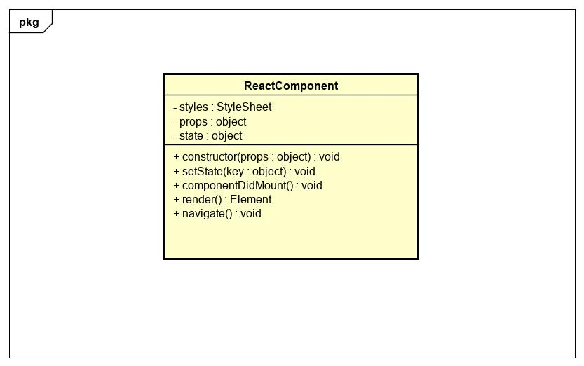

Figure 20 - ReactComponent class

|  |  |  |  |  |  |
| --- | --- | --- | --- | --- | --- |
| **Name** | ReactComponent | | | **Type** | Class |
| **Description** | A class that represents a React component to be rendered on React Native | | | | |
| **Attributes** | | | | | |
| **Name** | **Type** | **Visibility** | **Description** | | |
| styles | StyleSheet | private | Includes style of this class | | |
| props | object | private | Properties of the component | | |
| state | object | private | State of the component | | |
| **Operations** | | | | | |
| **Name** | **Type** | **Visibility** | **Description** | | |
| constructor(props : object) | void | public | Create a React Native component | | |
| setState(key : object) | void | public | Update the state of the component | | |
| componentDidMount() | void | public | Handle the event when the component is loaded firstly. | | |
| render() | Element | public | Render the components on the application | | |

### Login

**\*Login class diagram**

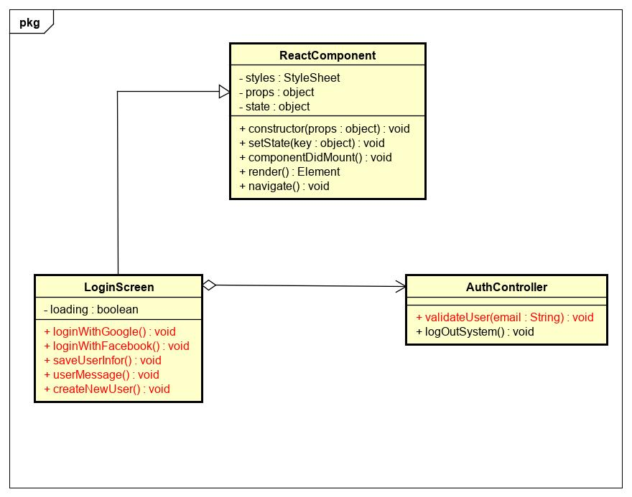

Figure 21 - Login class diagram

|  |  |  |  |  |  |
| --- | --- | --- | --- | --- | --- |
| **Name** | AuthController | | | **Type** | Class |
| **Description** | Controller class to control authentication. | | | | |
| **Attributes** | | | | | |
| **Name** | **Type** | **Visibility** | **Description** | | |
|  |  |  |  | | |
| **Operations** | | | | | |
| **Name** | **Type** | **Visibility** | **Description** | | |
| validateUser(email) | void | public | Validate the email in database. | | |
|  |  |  |  | | |
|  |  |  |  | | |

|  |  |  |  |  |  |
| --- | --- | --- | --- | --- | --- |
| **Name** | LoginScreen | | | **Type** | Class |
| **Description** | A class that displays login screen. | | | | |
| **Attributes** | | | | | |
| **Name** | **Type** | **Visibility** | **Description** | | |
| loading | boolean | private | state of loading modal | | |
|  |  |  |  | | |
|  |  |  |  | | |
| **Operations** | | | | | |
| **Name** | **Type** | **Visibility** | **Description** | | |
| loginWithGoogle() | void | public | Handle login with google | | |
| loginWithFacebook() | void | public | Handle login with facebook | | |
| saveUserInfo() | void | public | Save user information in AsyncStorage | | |
| userMessage() | void | public | Display deactivated message | | |
| createNewUser() | void | public | Navigate to CreateUser Screen | | |
|  |  |  |  | | |

**\*Login with Google sequence diagram**

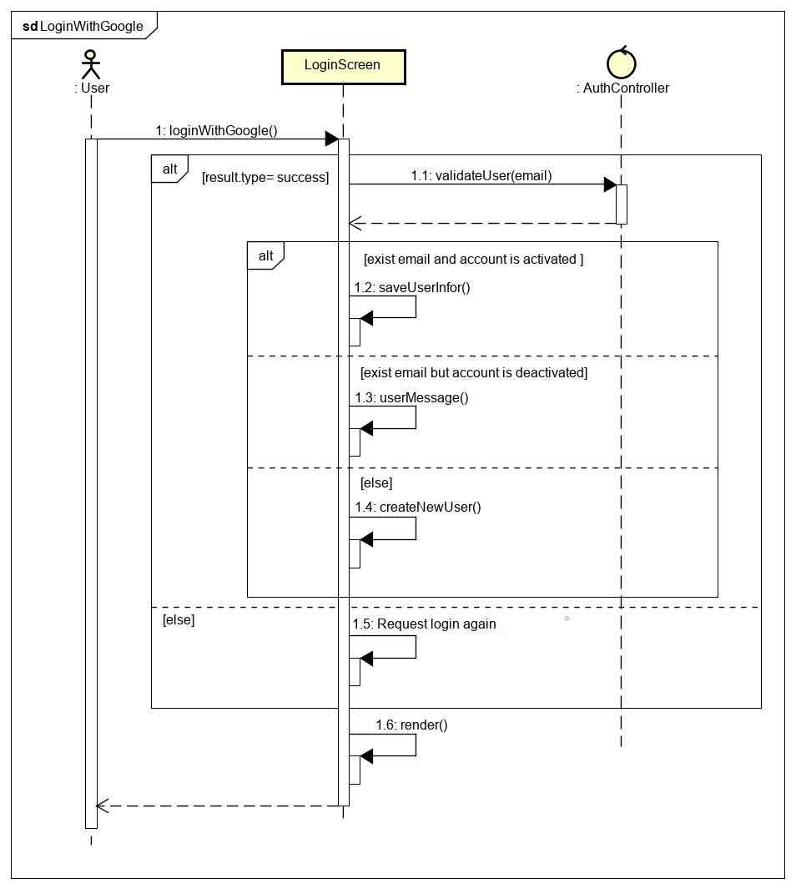

Figure 22 - Login with Google sequence diagram

**\*Login with Facebook sequence diagram**

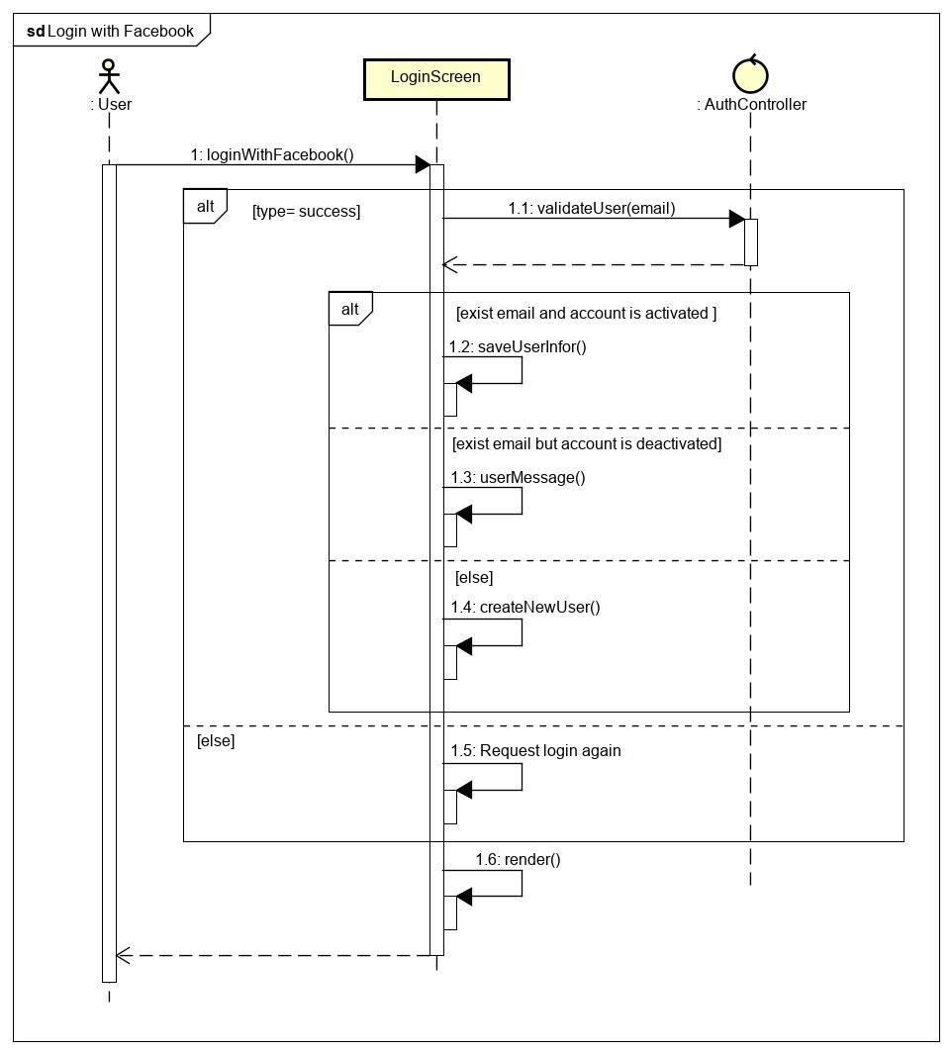

Figure 23 - Login with Facebook class diagram

### Logout

**\*Logout class diagram**

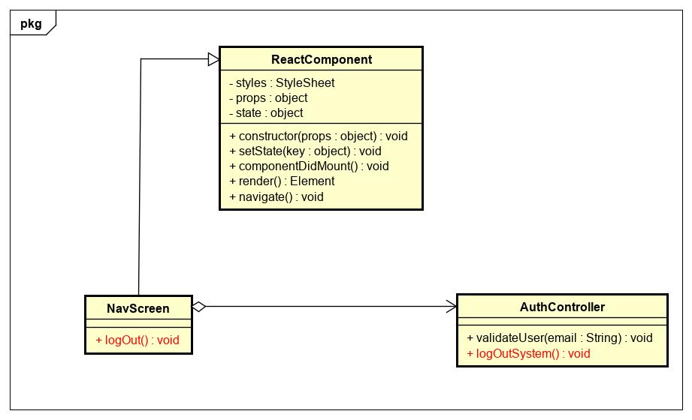

Figure 24 - Logout class diagram

|  |  |  |  |  |  |
| --- | --- | --- | --- | --- | --- |
| **Name** | AuthController | | | **Type** | Class |
| **Description** | Controller class to control authentication. | | | | |
| **Attributes** | | | | | |
| **Name** | **Type** | **Visibility** | **Description** | | |
|  |  |  |  | | |
| **Operations** | | | | | |
| **Name** | **Type** | **Visibility** | **Description** | | |
| logOutSystem() | void | public | Clear AnsyncStorage and logout user from application. | | |
|  |  |  |  | | |

|  |  |  |  |  |  |
| --- | --- | --- | --- | --- | --- |
| **Name** | NavScreen | | | **Type** | Class |
| **Description** | A class that displays navigator screen. | | | | |
| **Attributes** | | | | | |
| **Name** | **Type** | **Visibility** | **Description** | | |
|  |  |  |  | | |
| **Operations** | | | | | |
| **Name** | **Type** | **Visibility** | **Description** | | |
| logOut() | void | public | Handle logout from application. | | |
|  |  |  |  | | |

**\*Logout sequence diagram**

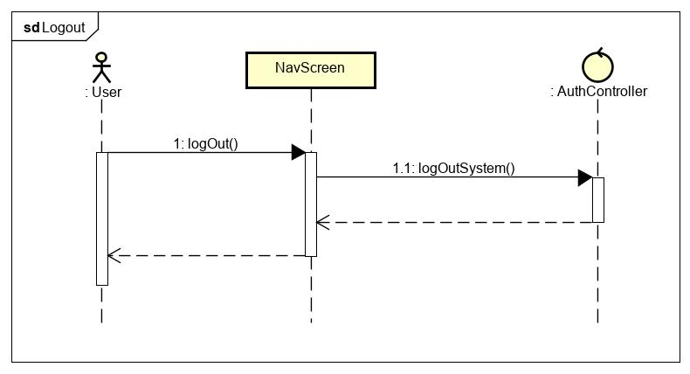

Figure 25 - Logout sequence diagram

### View User

**\*View user class diagram**

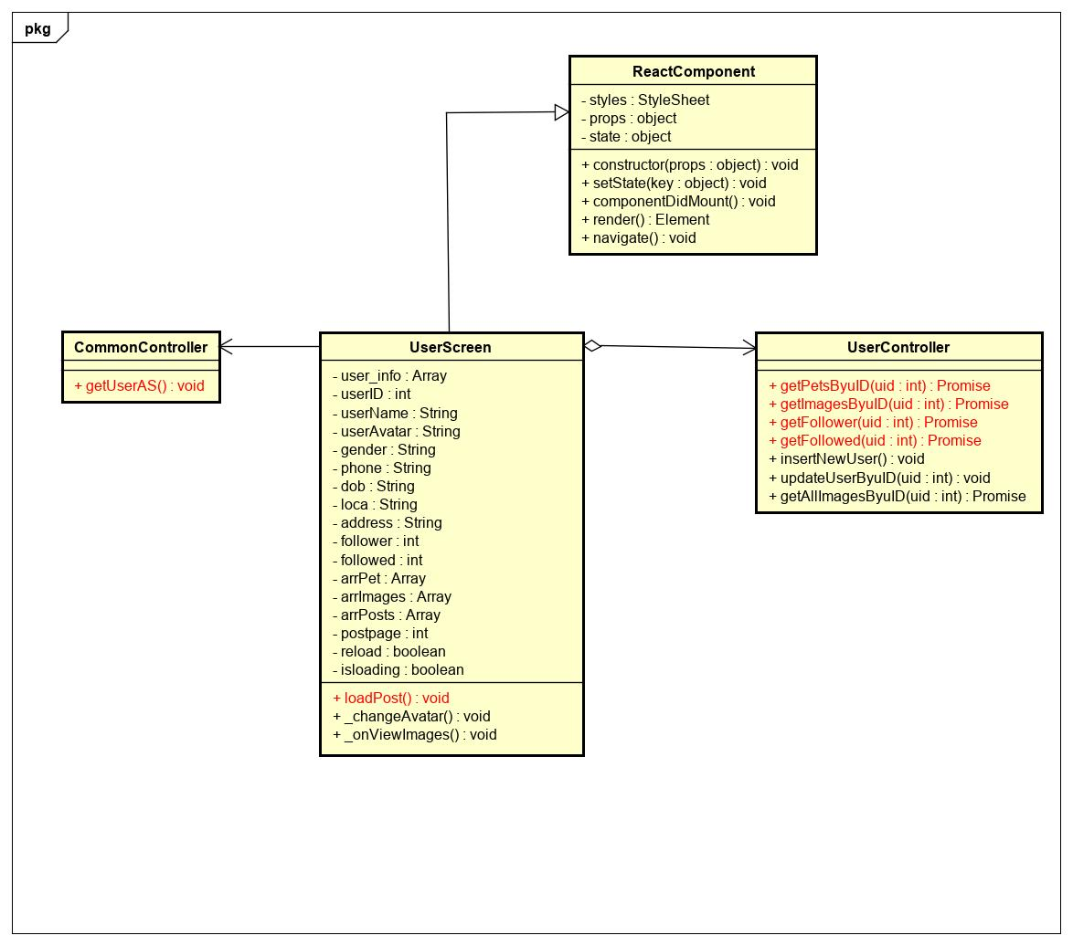

Figure 26 - View user class diagram

|  |  |  |  |  |  |
| --- | --- | --- | --- | --- | --- |
| **Name** | CommonController | | | **Type** | Class |
| **Description** | Controller class to control common. | | | | |
| **Attributes** | | | | | |
| **Name** | **Type** | **Visibility** | **Description** | | |
|  |  |  |  | | |
| **Operations** | | | | | |
| **Name** | **Type** | **Visibility** | **Description** | | |
| getUserAS() | Promise | public | Get user information of user that saved in AsyncStorage | | |

|  |  |  |  |  |  |
| --- | --- | --- | --- | --- | --- |
| **Name** | UserController | | | **Type** | Class |
| **Description** | Controller class to control user. | | | | |
| **Attributes** | | | | | |
| **Name** | **Type** | **Visibility** | **Description** | | |
|  |  |  |  | | |
| **Operations** | | | | | |
| **Name** | **Type** | **Visibility** | **Description** | | |
| getPetsByuID(uid) | Promise | public | Get Pets Information that owned by user | | |
| getImagesByuID(uid) | Promise | public | Get images that user uploaded | | |
| getFollower (uid) | Promise | public | Get number people that follow my user | | |
| getFollowed(uid) | Promise | public | Get number people that followed by user | | |

|  |  |  |  |  |  |
| --- | --- | --- | --- | --- | --- |
| **Name** | UserScreen | | | **Type** | Class |
| **Description** | A class that displays user screen. | | | | |
| **Attributes** | | | | | |
| **Name** | **Type** | **Visibility** | **Description** | | |
| user_info | Array | private | User information that saved in AsyncStorage | | |
| userID | int | private | Id of user | | |
| userName | String | private | Name of user | | |
| userAvatar | String | private | Avatar of user | | |
| gender | String | private | Gender of user | | |
| phone | String | private | Phone number of user | | |
| loca | int | private | Loca id of user | | |
| address | String | private | Addres of user | | |
| follower | int | private | Number follower | | |
| followed | int | private | Number followed | | |
| arrPet | Array | private | List of pets that owned by user | | |
| arrImages | Array | private | List of images that uploaded by user | | |
| arrPosts | Array | private | List of posts that posted by user | | |
| postpage | int | private | current page of post | | |
| reload | boolean | private | Status reload | | |
| isloading | boolean | private | Status loading modal | | |
| **Operations** | | | | | |
| **Name** | **Type** | **Visibility** | **Description** | | |
| loadPost() | void | public | Get post that posted by user | | |

**\*View user sequence diagram**

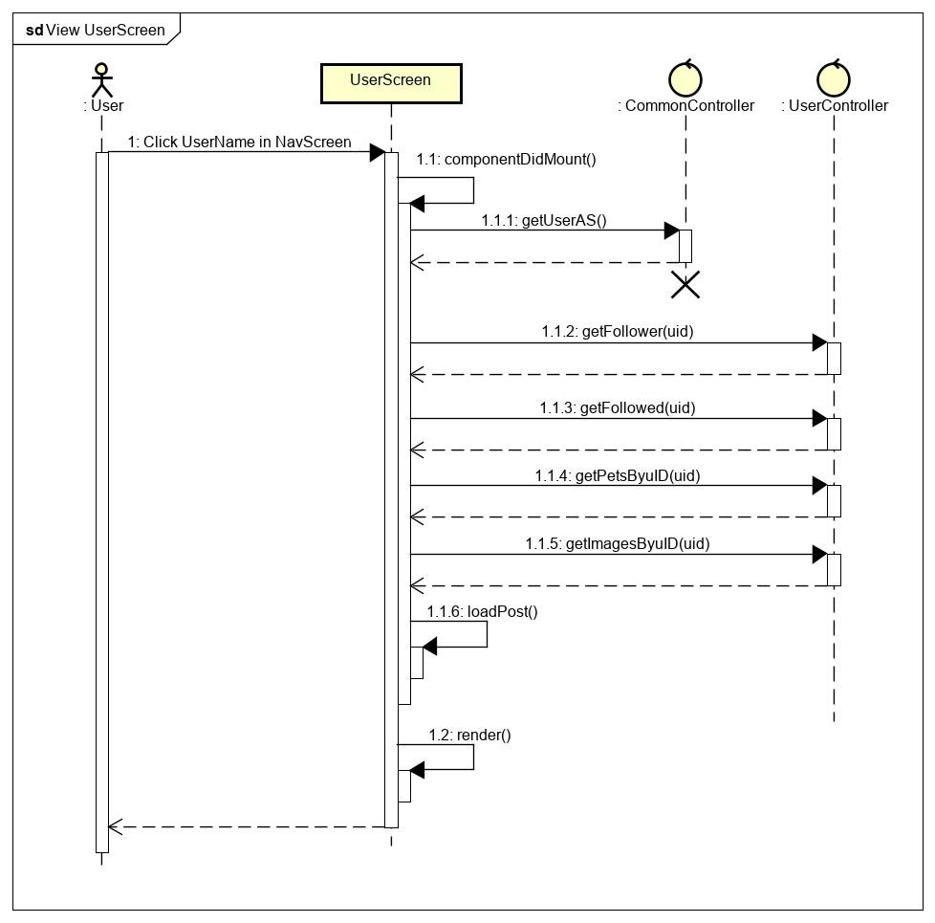

Figure 27 - View user sequence diagram

### Register User

**\*Register user class diagram**

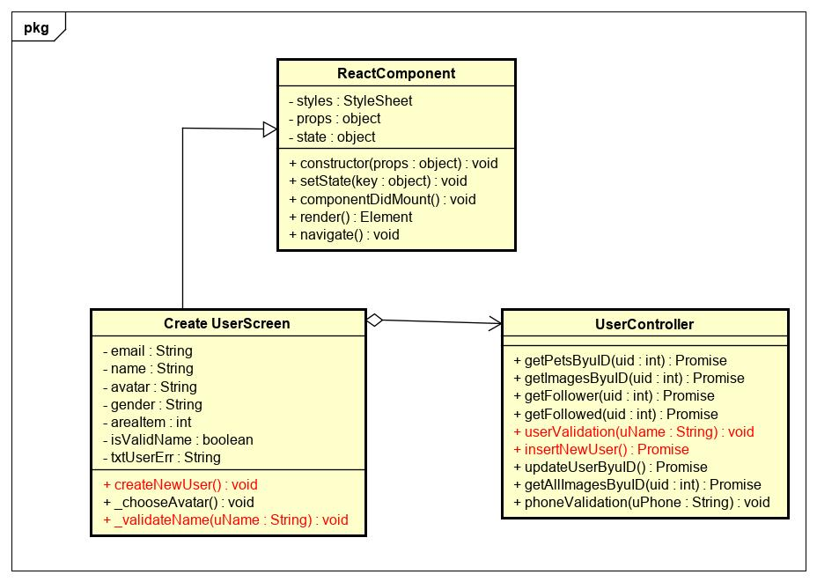

Figure 28 - Register user class diagram

|  |  |  |  |  |  |
| --- | --- | --- | --- | --- | --- |
| **Name** | UserController | | | **Type** | Class |
| **Description** | Controller class to control user. | | | | |
| **Attributes** | | | | | |
| **Name** | **Type** | **Visibility** | **Description** | | |
|  |  |  |  | | |
| **Operations** | | | | | |
| **Name** | **Type** | **Visibility** | **Description** | | |
| insertNewUser() | Promise | public | Insert new user to database | | |
| userValidation(username) | void | public | Validate username | | |

|  |  |  |  |  |  |
| --- | --- | --- | --- | --- | --- |
| **Name** | Create UserScreen | | | **Type** | Class |
| **Description** | A class that displays create user screen. | | | | |
| **Attributes** | | | | | |
| **Name** | **Type** | **Visibility** | **Description** | | |
| email | String | private | Email of user | | |
| name | String | private | Nickname of user | | |
| avatar | String | private | Avatar of user | | |
| gender | String | private | Gender of user | | |
| areaItem | int | private | Id of location | | |
| isValidName | boolean | private | Status of validation user name | | |
| txtUserErr | String | private | Error message | | |
| **Operations** | | | | | |
| **Name** | **Type** | **Visibility** | **Description** | | |
| createNewUser() | void | public | Handle create new user | | |
| _validateName(uName) | void | public | Handle validation user name | | |

**\*Register user sequence diagram**

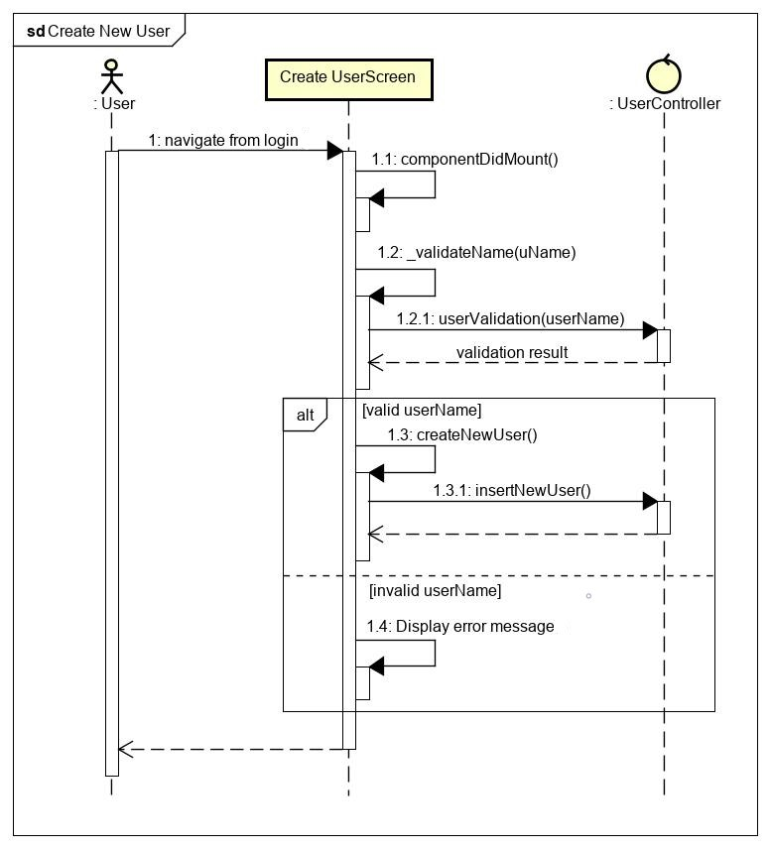

Figure 29 - Register user sequence diagram

### Update User

**\*Update user class diagram**

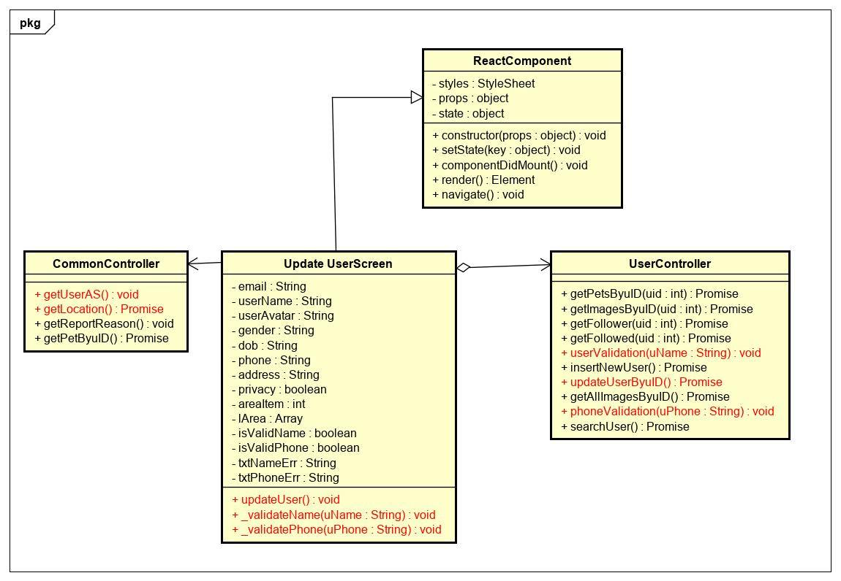

Figure 30 - Update user class diagram

|  |  |  |  |  |  |
| --- | --- | --- | --- | --- | --- |
| **Name** | CommonController | | | **Type** | Class |
| **Description** | Controller class to control common. | | | | |
| **Attributes** | | | | | |
| **Name** | **Type** | **Visibility** | **Description** | | |
|  |  |  |  | | |
| **Operations** | | | | | |
| **Name** | **Type** | **Visibility** | **Description** | | |
| getUserAS() | Promise | public | Get user information of user that saved in AsyncStorage | | |
| getLocation() | Promise | public | Get location information | | |

|  |  |  |  |  |  |
| --- | --- | --- | --- | --- | --- |
| **Name** | UserController | | | **Type** | Class |
| **Description** | Controller class to control user. | | | | |
| **Attributes** | | | | | |
| **Name** | **Type** | **Visibility** | **Description** | | |
|  |  |  |  | | |
| **Operations** | | | | | |
| **Name** | **Type** | **Visibility** | **Description** | | |
| updateUserByuID() | Promise | public | Update user | | |
| userValidation(uName) | void | puiblic | Validate user’s name | | |
| phoneValidation(uPhone) | void | public | Validate user’s phone | | |

|  |  |  |  |  |  |
| --- | --- | --- | --- | --- | --- |
| **Name** | Update UserScreen | | | **Type** | Class |
| **Description** | A class that displays update user screen. | | | | |
| **Attributes** | | | | | |
| **Name** | **Type** | **Visibility** | **Description** | | |
| email | String | private | Email of user | | |
| username | String | private | Nickname of user | | |
| userAvatar | String | private | Avatar of user | | |
| gender | String | private | Gender of user | | |
| dob | String | private | Birthdate of user | | |
| phone | String | private | Phone number of user | | |
| address | String | private | Address of user | | |
| privacy | boolean | private | Privacy of user | | |
| areaItem | int | private | Id of location that user picked | | |
| lArea | Array | private | List locations | | |
| isValidName | boolean | private | Status of validation user name | | |
| isValidPhone | boolean | private | Status of validation phone number | | |
| txtNameErr | String | private | Error message of validation user name | | |
| txtPhoneErr | String | private | Error message of validation phone number | | |
| **Operations** | | | | | |
| **Name** | **Type** | **Visibility** | **Description** | | |
| updateUser() | void | public | Handle update user | | |
| _validateName(uName) | void | public | Handle validation user name | | |
| _validatePhone(uPhone) | void | public | Handle validation phone number | | |

**\*Update user sequence diagram**

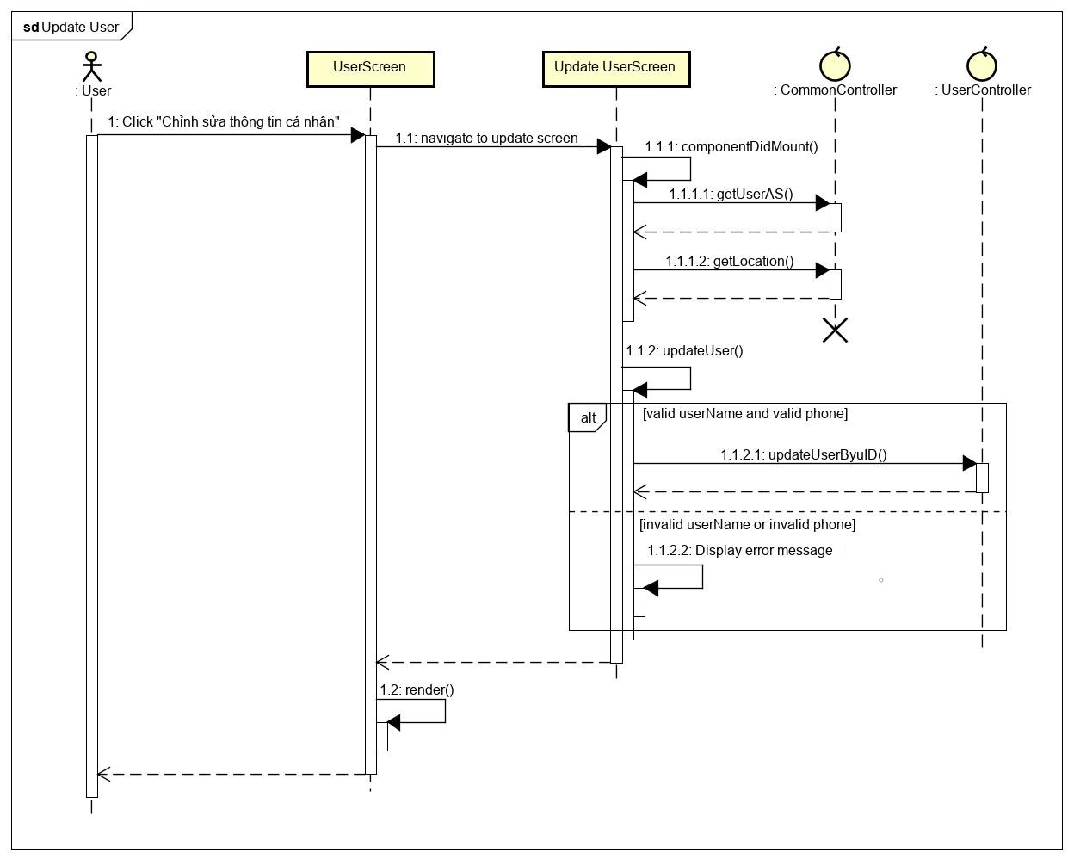

Figure 31 - Update user sequence diagram

### View Pet

**\*View pet class diagram**

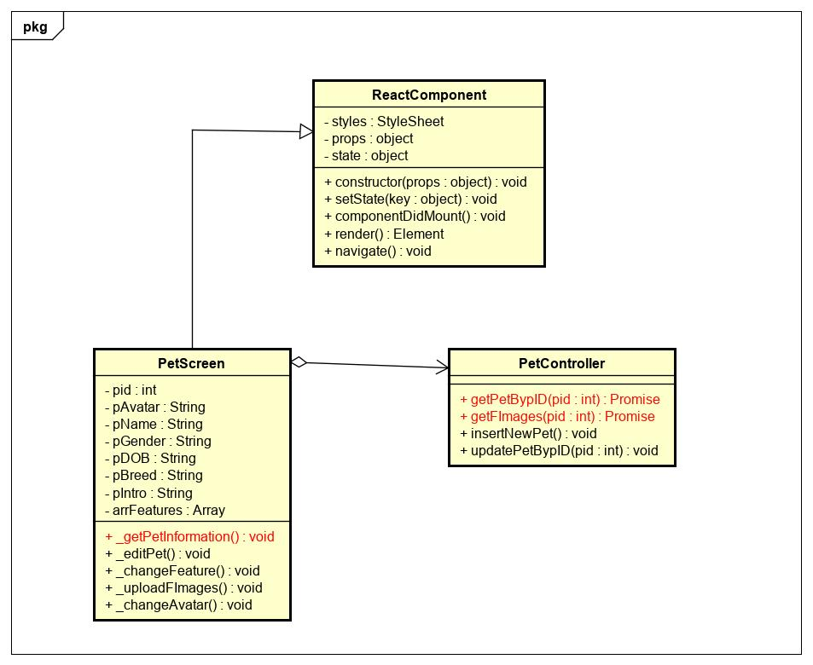

Figure 32 - View pet class diagram

|  |  |  |  |  |  |
| --- | --- | --- | --- | --- | --- |
| **Name** | PetController | | | **Type** | Class |
| **Description** | Controller class to control pet. | | | | |
| **Attributes** | | | | | |
| **Name** | **Type** | **Visibility** | **Description** | | |
|  |  |  |  | | |
| **Operations** | | | | | |
| **Name** | **Type** | **Visibility** | **Description** | | |
| getPetBypID(pid) | Promise | public | Get information of pet by pet id | | |
| getFImages(pid) | Promise | puiblic | Get all featured pictures of pet | | |

|  |  |  |  |  |  |
| --- | --- | --- | --- | --- | --- |
| **Name** | PetScreen | | | **Type** | Class |
| **Description** | A class that displays pet screen. | | | | |
| **Attributes** | | | | | |
| **Name** | **Type** | **Visibility** | **Description** | | |
| pid | int | private | Id of pet | | |
| pAvatar | String | private | Avatar of pet | | |
| pName | String | private | Nickname of pet | | |
| pGender | String | private | Gender of pet | | |
| pDOB | String | private | Birthdate of pet | | |
| pBreed | String | private | Breed of pet | | |
| pIntro | String | private | Intro of pet | | |
| arrFeatures | Array | private | Array of fetured pictures of pet | | |
| **Operations** | | | | | |
| **Name** | **Type** | **Visibility** | **Description** | | |
| _getPetInformation() | void | public | Get informayion of pet | | |

**\*View pet sequence diagram**

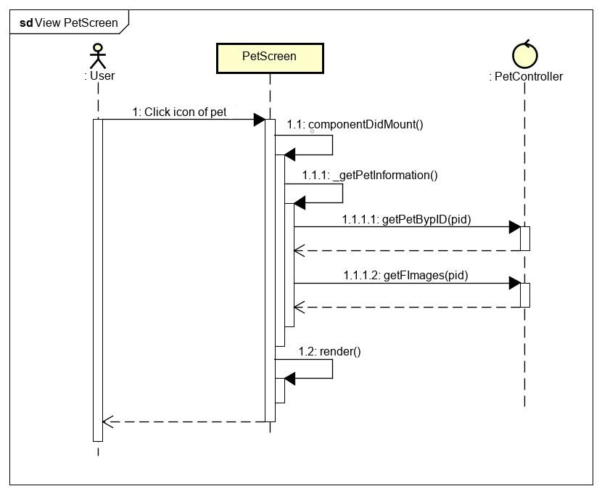

Figure 33 - View pet sequence diagram

### Create Pet

**\*Create pet class diagram**

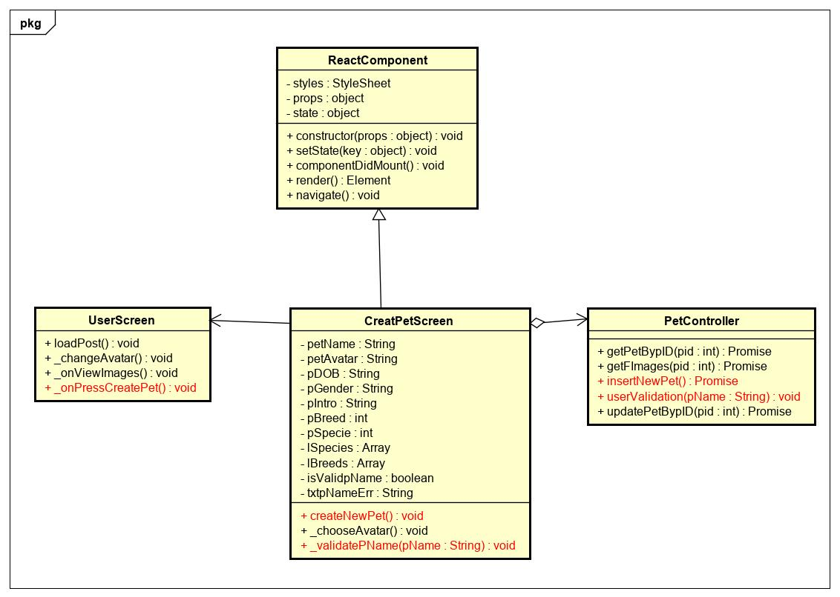

Figure 34 - Create pet class diagram

|  |  |  |  |  |  |
| --- | --- | --- | --- | --- | --- |
| **Name** | PetController | | | **Type** | Class |
| **Description** | Controller class to control pet. | | | | |
| **Attributes** | | | | | |
| **Name** | **Type** | **Visibility** | **Description** | | |
|  |  |  |  | | |
| **Operations** | | | | | |
| **Name** | **Type** | **Visibility** | **Description** | | |
| insertNewPet() | void | public | Insert pet to database | | |
| userValidation(pName) | void | public | Validate pet’s name | | |

|  |  |  |  |  |  |
| --- | --- | --- | --- | --- | --- |
| **Name** | UserScreen | | | **Type** | Class |
| **Description** | A class that displays user screen. | | | | |
| **Attributes** | | | | | |
| **Name** | **Type** | **Visibility** | **Description** | | |
|  |  |  |  | | |
| **Operations** | | | | | |
| **Name** | **Type** | **Visibility** | **Description** | | |
| _onPressCreatePet() | void | public | Navigate to create pet | | |

|  |  |  |  |  |  |
| --- | --- | --- | --- | --- | --- |
| **Name** | CreatePetScreen | | | **Type** | Class |
| **Description** | A class that displays create pet screen. | | | | |
| **Attributes** | | | | | |
| **Name** | **Type** | **Visibility** | **Description** | | |
| petName | String | private | Nick name of pet | | |
| petAvatar | String | private | Avatar of pet | | |
| pDOB | String | private | Birthdate of pet | | |
| pGender | String | private | Gender of pet | | |
| pIntro | String | private | Intro of pet | | |
| pBreed | int | private | Breed id of pet | | |
| pSpecie | int | private | Specie id of pet | | |
| lSpecies | Array | private | List species in database | | |
| lBreeds | Array | private | List breeds base on specie in database | | |
| isValidpName | boolean | private | Status of validation pet name | | |
| txtpNameErr | String | private | Error message of validation pet name | | |
| **Operations** | | | | | |
| **Name** | **Type** | **Visibility** | **Description** | | |
| createNewPet() | void | public | Handle create pet | | |
| _validatePName(pName) | void | public | Handle validation pet name | | |

**\*Create pet sequence diagram**

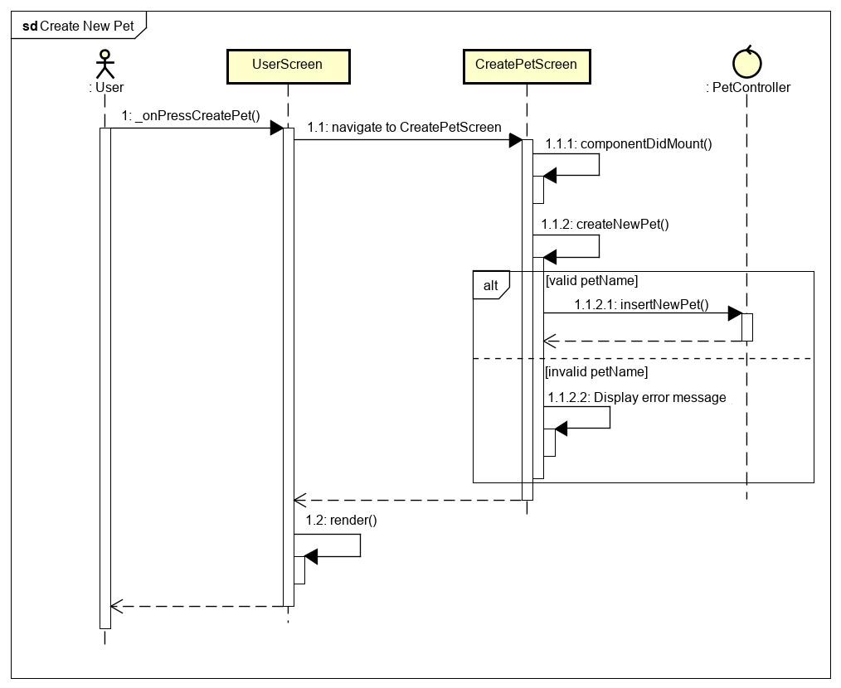

Figure 35 - Create pet sequence diagram

### Update Pet

**\*Update pet class diagram**

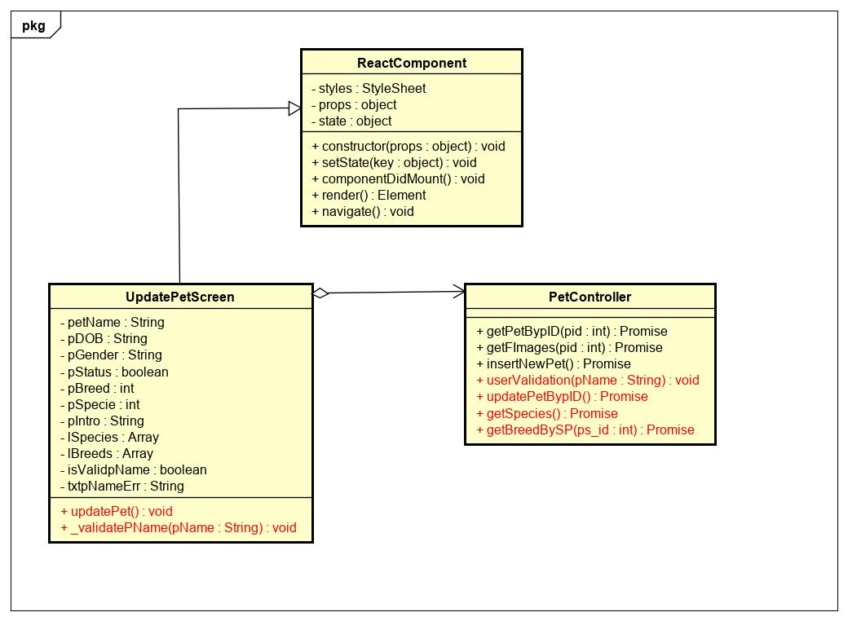

Figure 36 - Update pet class diagram

|  |  |  |  |  |  |
| --- | --- | --- | --- | --- | --- |
| **Name** | PetController | | | **Type** | Class |
| **Description** | Controller class to control pet. | | | | |
| **Attributes** | | | | | |
| **Name** | **Type** | **Visibility** | **Description** | | |
|  |  |  |  | | |
| **Operations** | | | | | |
| **Name** | **Type** | **Visibility** | **Description** | | |
| updatePetBypID() | Promise | public | Update pet in database | | |
| getSpecies() | Promise | public | Get species of pet | | |
| getBreedBySP(ps_id) | Promise | public | Get breed of pet by specie_id | | |
| userValidation(pName) | void | public | Validation pet’s name | | |

|  |  |  |  |  |  |
| --- | --- | --- | --- | --- | --- |
| **Name** | UpdatePetScreen | | | **Type** | Class |
| **Description** | A class that displays update pet screen. | | | | |
| **Attributes** | | | | | |
| **Name** | **Type** | **Visibility** | **Description** | | |
| petName | String | private | Nick name of pet | | |
| pDOB | String | private | Birthdate of pet | | |
| pGender | String | private | Gender of pet | | |
| pStatus | boolean | private | Status of pet | | |
| pBreed | int | private | Breed id of pet | | |
| pSpecie | int | private | Specie id of pet | | |
| pIntro | String | private | Intro of pet | | |
| lSpecies | Array | private | List species in database | | |
| lBreeds | Array | private | List breeds base on specie in database | | |
| isValidpName | boolean | private | Status of validation pet name | | |
| txtNameErr | String | private | Error message of validation pet name | | |
| **Operations** | | | | | |
| **Name** | **Type** | **Visibility** | **Description** | | |
| updatePet() | void | public | Handle update pet | | |
| _validationPName(pName) | void | public | Handle validation pet name | | |

**\*Update pet sequence diagram**

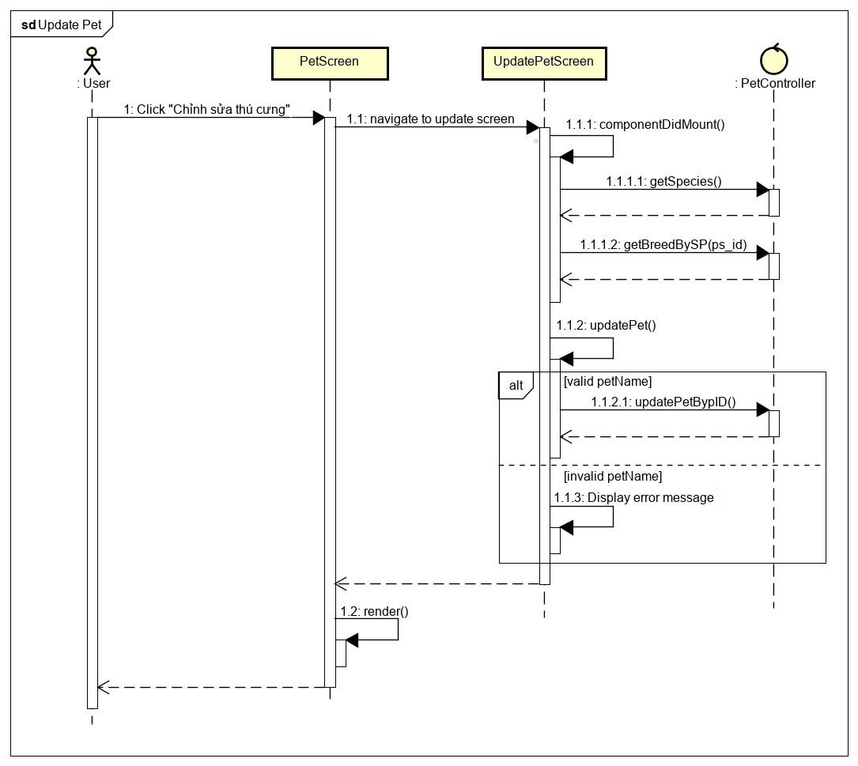

Figure 37 - Update pet sequence diagram

### View Dating

**\*View dating class diagram**

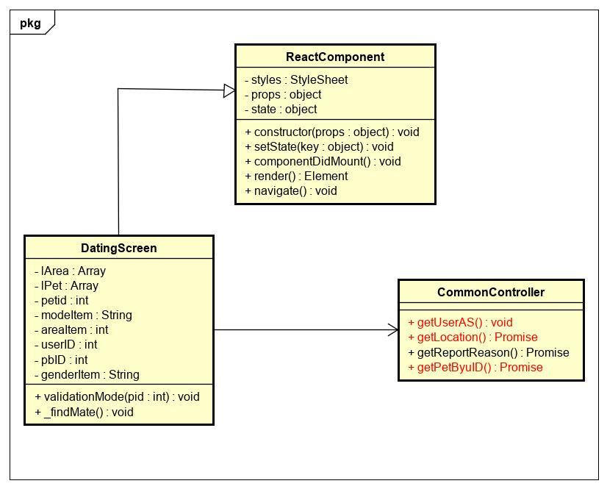

Figure 38 - View dating class diagram

|  |  |  |  |  |  |
| --- | --- | --- | --- | --- | --- |
| **Name** | CommonController | | | **Type** | Class |
| **Description** | Controller class to control common. | | | | |
| **Attributes** | | | | | |
| **Name** | **Type** | **Visibility** | **Description** | | |
|  |  |  |  | | |
| **Operations** | | | | | |
| **Name** | **Type** | **Visibility** | **Description** | | |
| getUserAS() | void | public | Get user information | | |
| getPetByuID(uid) | Promise | public | Get information of pets that owned by user | | |
| getLocation() | Promise | public | Get locations from database | | |

|  |  |  |  |  |  |
| --- | --- | --- | --- | --- | --- |
| **Name** | DatingScreen | | | **Type** | Class |
| **Description** | A class that displays dating screen. | | | | |
| **Attributes** | | | | | |
| **Name** | **Type** | **Visibility** | **Description** | | |
| lArea | Array | private | Array of locations | | |
| lPet | Array | private | Array of pets | | |
| petid | int | private | Id of pet that user picked | | |
| modeItem | String | private | Name of mode that user picked | | |
| areaItem | int | private | Name of location that user picked | | |
| userID | int | private | Id of user | | |
| pbID | int | private | Pet breed id | | |
| genderItem | String | private | Gender of pet that user picked | | |
| **Operations** | | | | | |
| **Name** | **Type** | **Visibility** | **Description** | | |
|  |  |  |  | | |
|  |  |  |  | | |

**\*View dating sequence diagram**

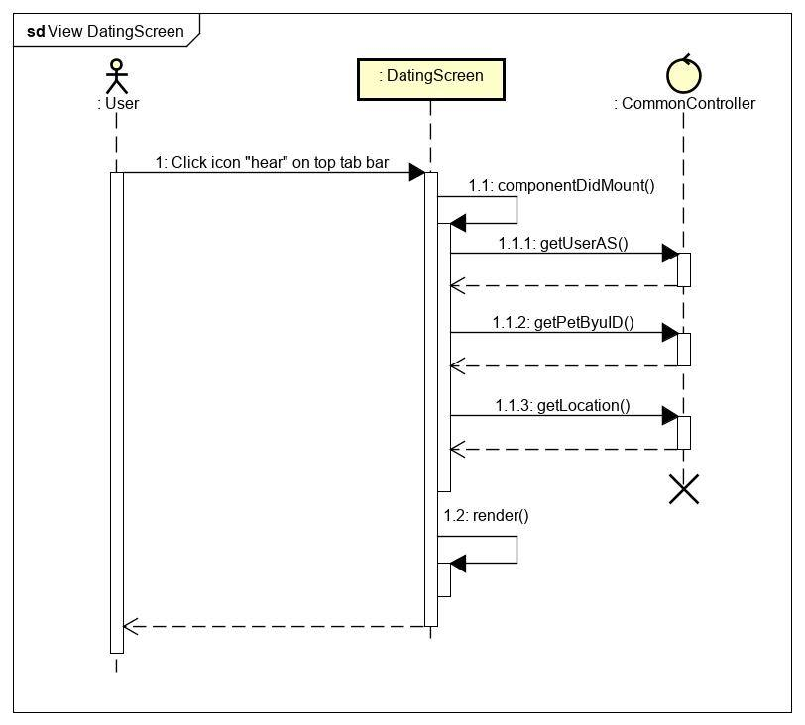

Figure 39 - View Dating sequence diagram

### Find mate

**\*Find mate class diagram**

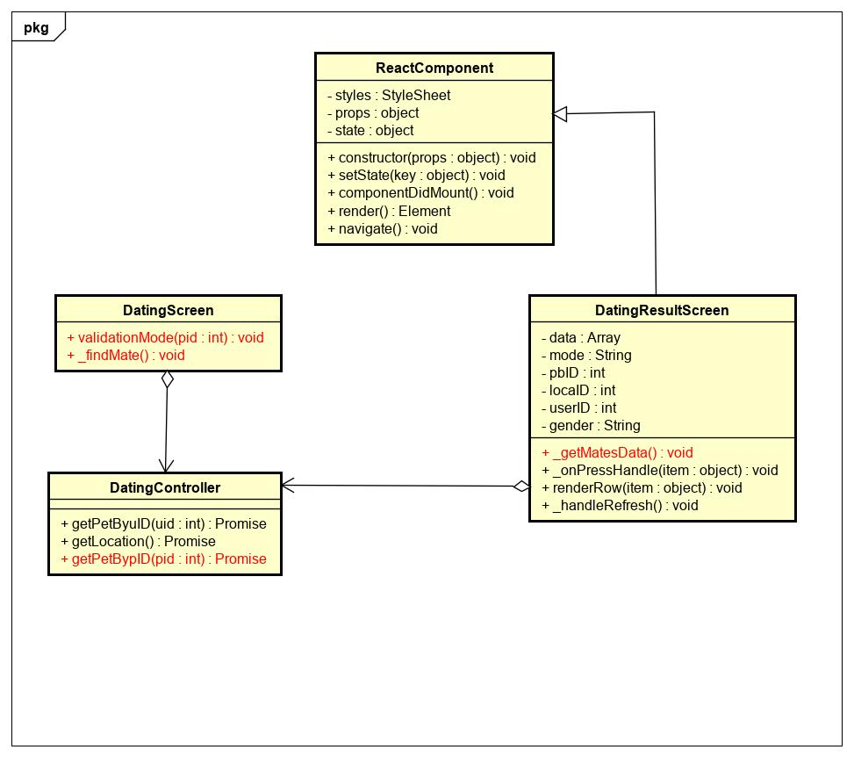

Figure 40 – Find mate class diagram

|  |  |  |  |  |  |
| --- | --- | --- | --- | --- | --- |
| **Name** | DatingController | | | **Type** | Class |
| **Description** | Controller class to control dating. | | | | |
| **Attributes** | | | | | |
| **Name** | **Type** | **Visibility** | **Description** | | |
|  |  |  |  | | |
| **Operations** | | | | | |
| **Name** | **Type** | **Visibility** | **Description** | | |
| getPetBypID(pid) | Promise | public | Get information of pet by pet id | | |
|  |  |  |  | | |

|  |  |  |  |  |  |
| --- | --- | --- | --- | --- | --- |
| **Name** | DatingScreen | | | **Type** | Class |
| **Description** | A class that displays dating screen. | | | | |
| **Attributes** | | | | | |
| **Name** | **Type** | **Visibility** | **Description** | | |
|  |  |  |  | | |
| **Operations** | | | | | |
| **Name** | **Type** | **Visibility** | **Description** | | |
| validationMode(pid) | void | public | Validate mode of dating | | |
| _findMate | void | public | Handle mate for pet | | |

|  |  |  |  |  |  |
| --- | --- | --- | --- | --- | --- |
| **Name** | DatingResultScreen | | | **Type** | Class |
| **Description** | A class that displays datingresult screen. | | | | |
| **Attributes** | | | | | |
| **Name** | **Type** | **Visibility** | **Description** | | |
| data | Array | private | Array of pets that valid information picked | | |
| mode | String | private | Mode of dating | | |
| pbID | int | private | Breed id of pet | | |
| locaID | int | private | Location id of pet | | |
| userID | int | private | User id who owned pet | | |
| gender | String | private | Gender of pet | | |
| **Operations** | | | | | |
| **Name** | **Type** | **Visibility** | **Description** | | |
| _getMatesData() | void | public | Get mates for pet from last information | | |
|  |  |  |  | | |

**\*Dating sequence diagram**

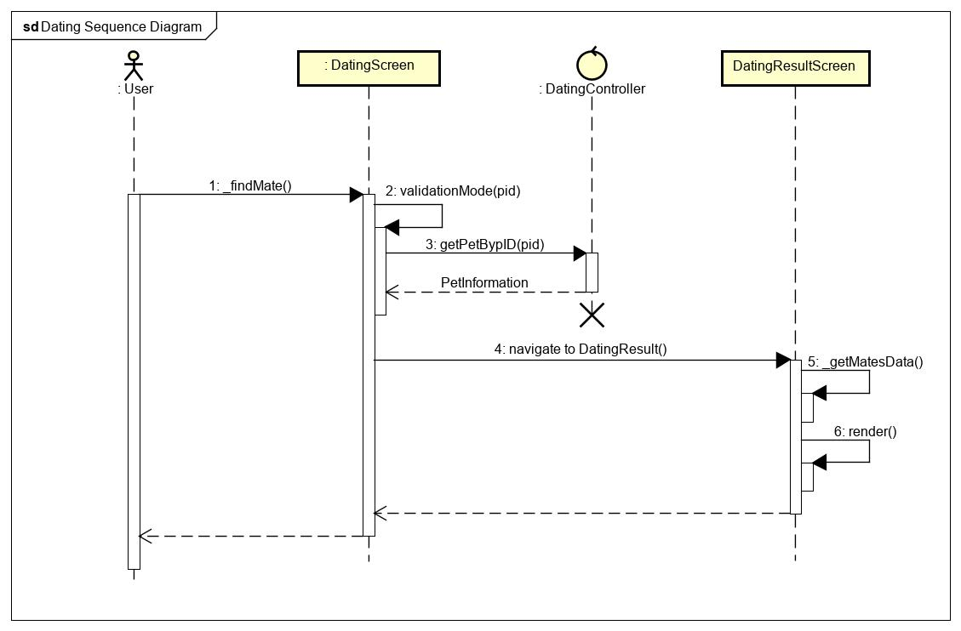

Figure 41 – Find mate sequence diagram

### View Post

**\*View post class diagram**

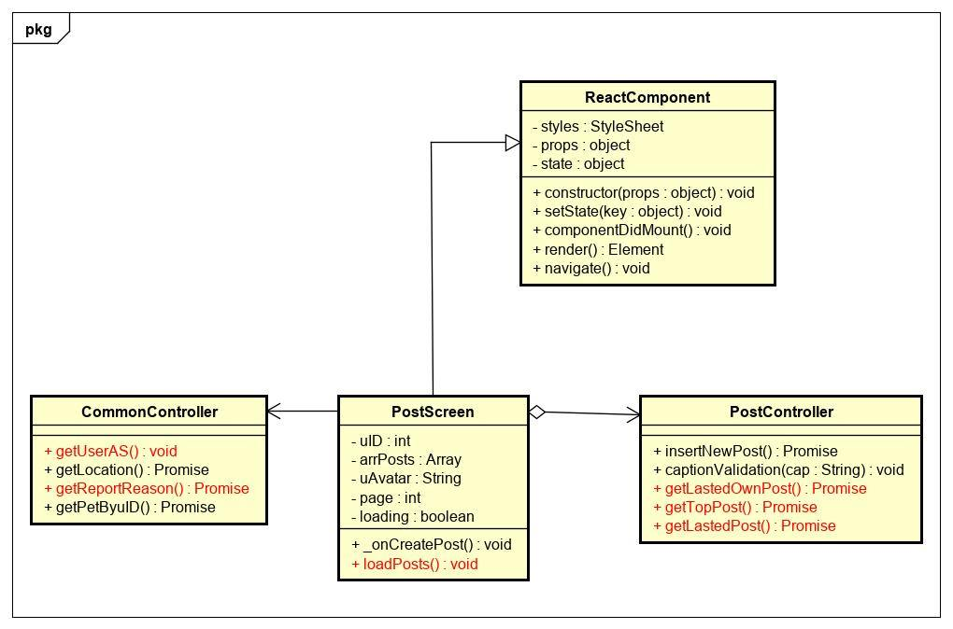

Figure 42 - View post class diagram

|  |  |  |  |  |  |
| --- | --- | --- | --- | --- | --- |
| **Name** | CommonController | | | **Type** | Class |
| **Description** | Controller class to control common. | | | | |
| **Attributes** | | | | | |
| **Name** | **Type** | **Visibility** | **Description** | | |
|  |  |  |  | | |
| **Operations** | | | | | |
| **Name** | **Type** | **Visibility** | **Description** | | |
| getUserAS() | Promise | public | Get user information of user that saved in AsyncStorage | | |
| getReportReason() | Promise | public | Get report reasons from database | | |

|  |  |  |  |  |  |
| --- | --- | --- | --- | --- | --- |
| **Name** | PostScreen | | | **Type** | Class |
| **Description** | A class that displays list post screen | | | | |
| **Attributes** | | | | | |
| **Name** | **Type** | **Visibility** | **Description** | | |
| uID | int | private | Id of user | | |
| arrPosts | Array | private | Array of posts. | | |
| uAvatar | String | private | Avatar of user | | |
| page | int | private | Number page | | |
| loading | boolean | private | Status of loading | | |
| **Operations** | | | | | |
| **Name** | **Type** | **Visibility** | **Description** | | |
|  |  |  |  | | |

|  |  |  |  |  |  |
| --- | --- | --- | --- | --- | --- |
| **Name** | PostController | | | **Type** | Class |
| **Description** | A class that control PostScreen | | | | |
| **Attributes** | | | | | |
| **Name** | **Type** | **Visibility** | **Description** | | |
| **Operations** | | | | | |
| **Name** | **Type** | **Visibility** | **Description** | | |
| getLastedOwnPost() | Promise | public | Get a lasted owned post | | |
| getTopPost() | Promise | public | Get 6 top post that posted by most follower | | |
| getLastedPost() | Promise | public | Get 3 newest post from database | | |

**\*View post sequence diagram**

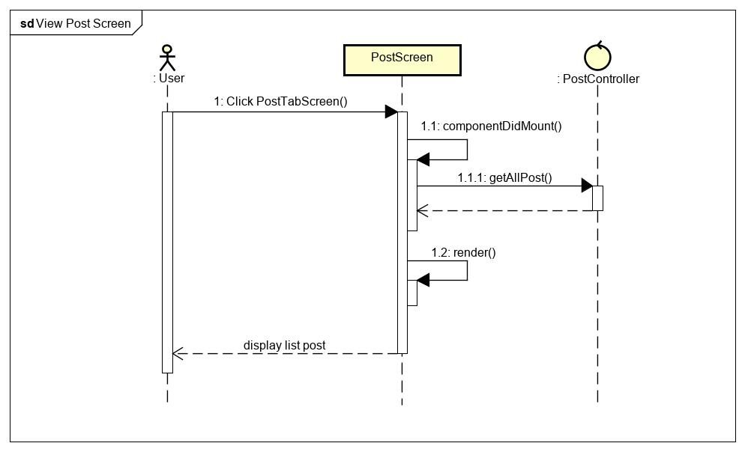

Figure 43 - View post sequence diagram

### View Images Album

**\*View images album class diagram**

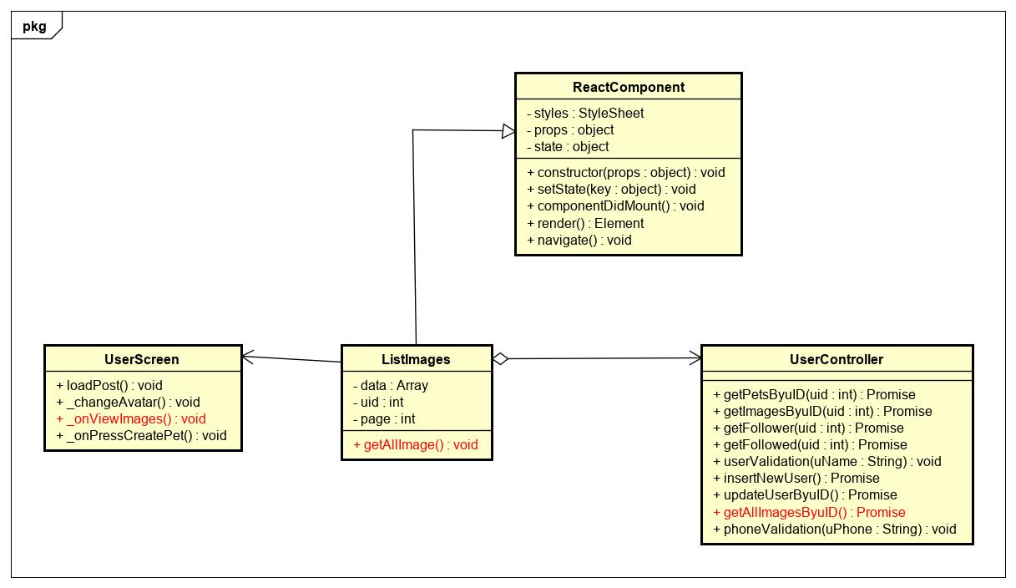

Figure 44 - View images album classs diagram

|  |  |  |  |  |  |
| --- | --- | --- | --- | --- | --- |
| **Name** | UserController | | | **Type** | Class |
| **Description** | Controller class to control user. | | | | |
| **Attributes** | | | | | |
| **Name** | **Type** | **Visibility** | **Description** | | |
|  |  |  |  | | |
| **Operations** | | | | | |
| **Name** | **Type** | **Visibility** | **Description** | | |
| getAllImagesByuID() | Promise | public | Get all images that uploaded by user | | |
|  |  |  |  | | |

|  |  |  |  |  |  |
| --- | --- | --- | --- | --- | --- |
| **Name** | UserScreen | | | **Type** | Class |
| **Description** | A class that displays user screen. | | | | |
| **Attributes** | | | | | |
| **Name** | **Type** | **Visibility** | **Description** | | |
|  |  |  |  | | |
| **Operations** | | | | | |
| **Name** | **Type** | **Visibility** | **Description** | | |
| _onViewImages() | void | public | Navigate to ListImages | | |

|  |  |  |  |  |  |
| --- | --- | --- | --- | --- | --- |
| **Name** | ListImages | | | **Type** | Class |
| **Description** | A class displays list images that uploaded by user. | | | | |
| **Attributes** | | | | | |
| **Name** | **Type** | **Visibility** | **Description** | | |
| data | Array | private | Array of images that uploaded by user | | |
| uid | int | private | Id of user | | |
| page | int | private | Number page | | |
| **Operations** | | | | | |
| **Name** | **Type** | **Visibility** | **Description** | | |
| _getAllImage() | void | public | Handle get images that uploaded by user | | |
|  |  |  |  | | |

**\*View images album sequence diagram**

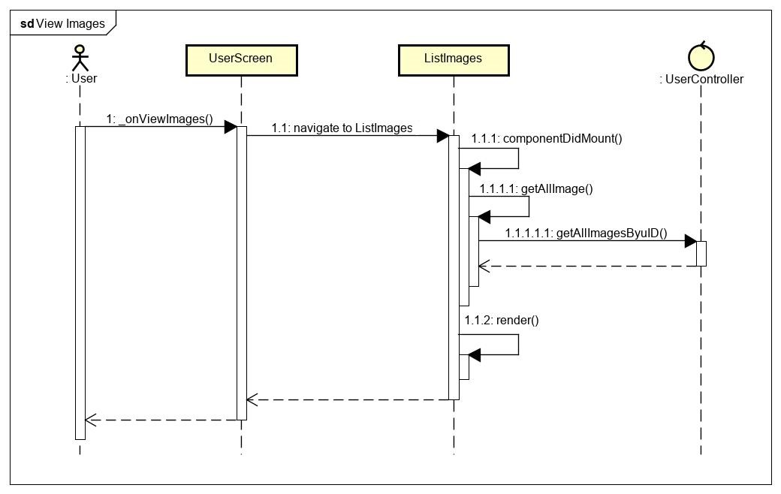

Figure 45 - View list images sequence diagram

### Create Post

**\*Create new post class diagram**

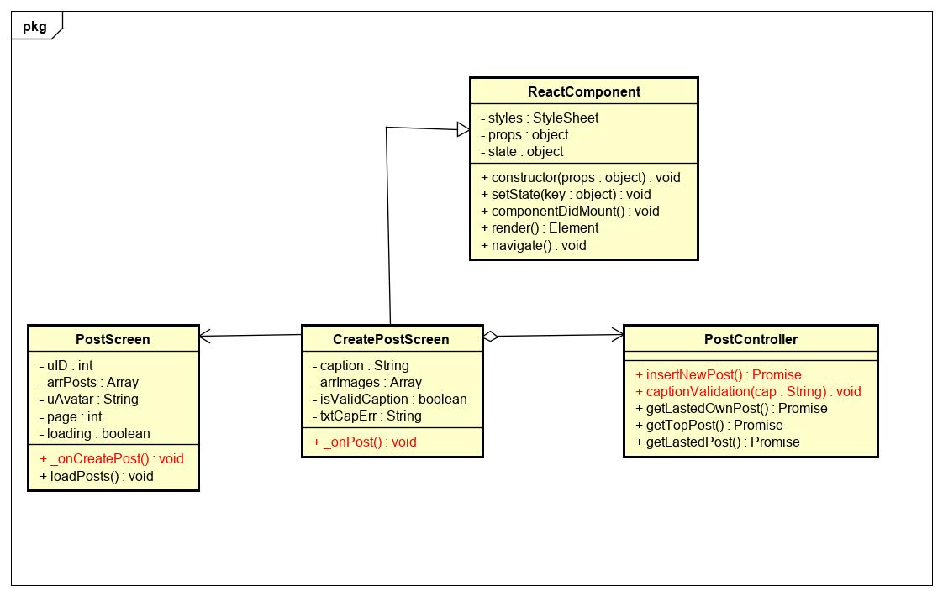

Figure 46 - Create new post class diagram

|  |  |  |  |  |  |
| --- | --- | --- | --- | --- | --- |
| **Name** | PostController | | | **Type** | Class |
| **Description** | Controller class to control post. | | | | |
| **Attributes** | | | | | |
| **Name** | **Type** | **Visibility** | **Description** | | |
|  |  |  |  | | |
| **Operations** | | | | | |
| **Name** | **Type** | **Visibility** | **Description** | | |
| insertNewPost() | Promise | public | Insert new post to database | | |
| captionValidation(cap) | void | public | Validate caption of post | | |

|  |  |  |  |  |  |
| --- | --- | --- | --- | --- | --- |
| **Name** | PostScreen | | | **Type** | Class |
| **Description** | A class display PostScreen. | | | | |
| **Attributes** | | | | | |
| **Name** | **Type** | **Visibility** | **Description** | | |
|  |  |  |  | | |
| **Operations** | | | | | |
| **Name** | **Type** | **Visibility** | **Description** | | |
| _onCreatePost | void | public | Navigation to CreatePost | | |
|  |  |  |  | | |

|  |  |  |  |  |  |
| --- | --- | --- | --- | --- | --- |
| **Name** | CreatePostScreen | | | **Type** | Class |
| **Description** | A class display createPostScreen. | | | | |
| **Attributes** | | | | | |
| **Name** | **Type** | **Visibility** | **Description** | | |
| arrImages | Array | private | Array of images that uploaded in this post | | |
| caption | String | private | Caption of this post | | |
| isValidationCaption | boolean | private | Status of validation caption | | |
| txtCapErr | String | private | Error message of validation caption | | |
| **Operations** | | | | | |
| **Name** | **Type** | **Visibility** | **Description** | | |
| _onPost () | void | public | Handle create new post | | |
|  |  |  |  | | |

**\*Create new post sequence diagram**

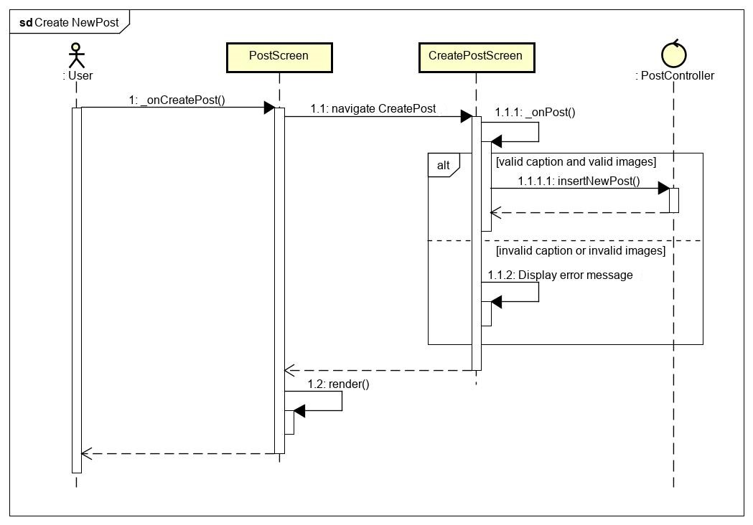

Figure 47 - Create new post sequence diagram

### Chatting

**\*View ConversationList Class Diagram**

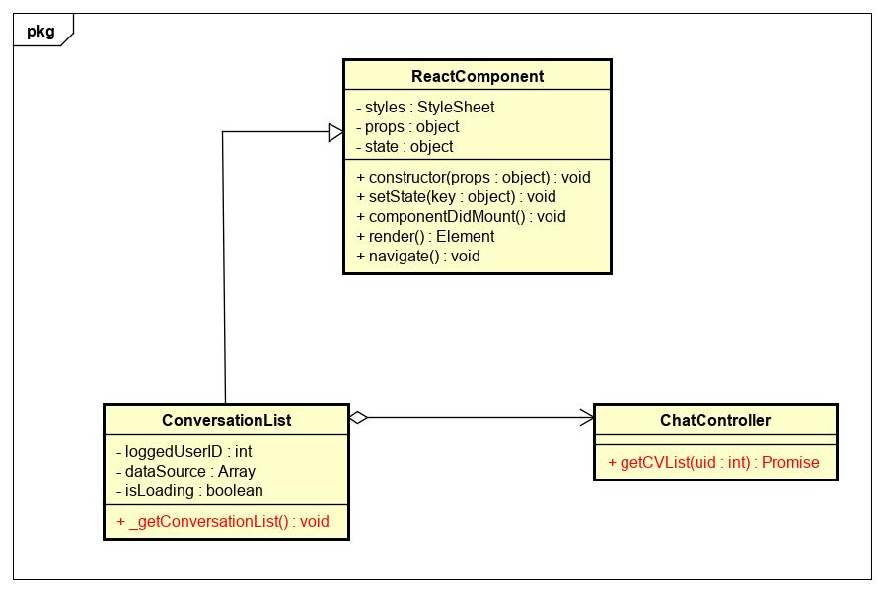

Figure 48 - Conversation list class diagram

|  |  |  |  |  |  |
| --- | --- | --- | --- | --- | --- |
| **Name** | ChatController | | | **Type** | Class |
| **Description** | The screen controls chatting action | | |  |  |
| **Attributes** | | | | | |
| **Name** | **Type** | **Visibility** | **Description** | | |
|  |  |  |  | | |
| **Operations** | | | | | |
| **Name** | **Type** | **Visibility** | **Description** | | |
| getCVList(uid) | Promise | public | Get list of conversations in database | | |

|  |  |  |  |  |  |
| --- | --- | --- | --- | --- | --- |
| **Name** | ConversationList | | | **Type** | Class |
| **Description** | The screen displays content of conver | | | sation |  |
| **Attributes** | | | | | |
| **Name** | **Type** | **Visibility** | **Description** | | |
| loggedUserID | int | private | Id of user | | |
| dataSource | Array | private | List of conversations | | |
| isLoading | boolean | private | Status of loading | | |
| **Operations** | | | | | |
| **Name** | **Type** | **Visibility** | **Description** | | |
| _getConversationList() | void | public | Handle get list of conversations | | |

**\*View ConversationList Sequence Diagram**

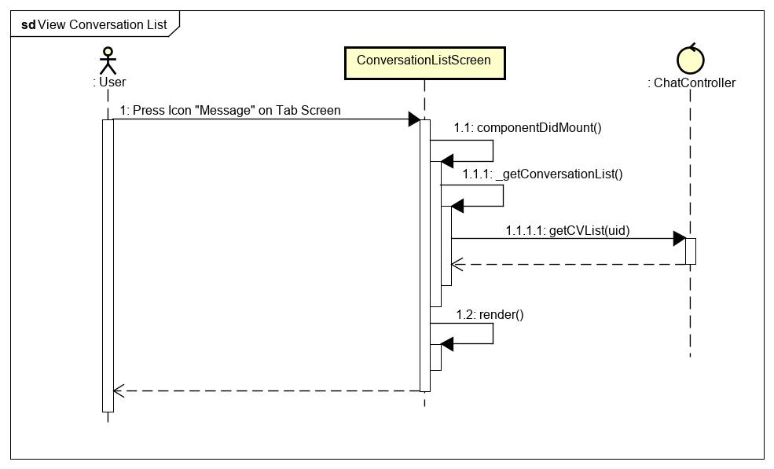

Figure 49 - Conversation list sequence diagram

**\*Send Messages class diagram**

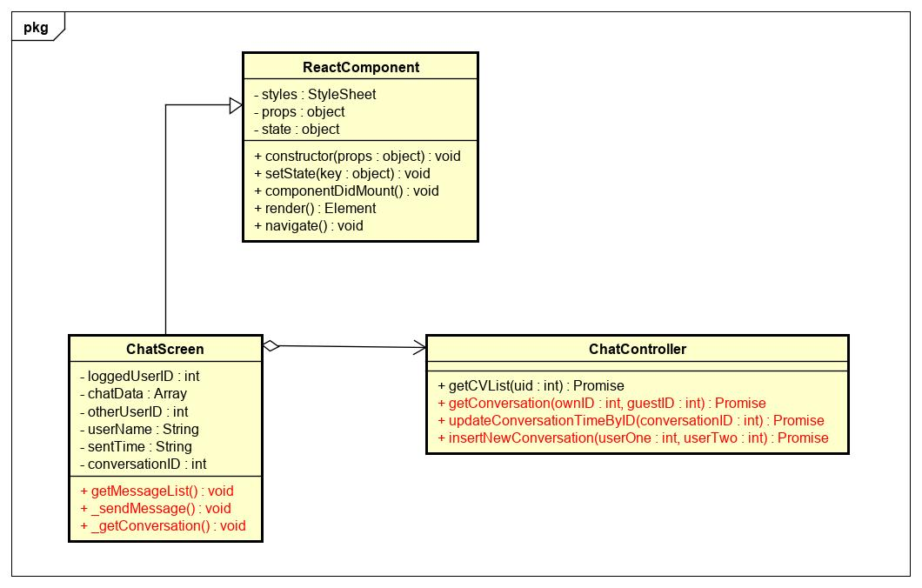

Figure 50 - Send message class diagram

|  |  |  |  |  |  |
| --- | --- | --- | --- | --- | --- |
| **Name** | ChatController | | | **Type** | Class |
| **Description** | The screen controls chatting action | | |  |  |
| **Attributes** | | | | | |
| **Name** | **Type** | **Visibility** | **Description** | | |
|  |  |  |  | | |
| **Operations** | | | | | |
| **Name** | **Type** | **Visibility** | **Description** | | |
| getConversation() | Promise | public | Get detail of the conversations in database | | |
| updateConversationTimeByID() | Promise | public | Update conversation time | | |
| insertNewConversation() | Promise | public | Insert new conversation to database | | |

|  |  |  |  |  |  |
| --- | --- | --- | --- | --- | --- |
| **Name** | ChatScreen | | | **Type** | Class |
| **Description** | The screen displays content of chat | | |  |  |
| **Attributes** | | | | | |
| **Name** | **Type** | **Visibility** | **Description** | | |
| loggedUserID | int | private | Id of own user | | |
| chatData | Array | private | List messages | | |
| otherUserID | int | private | Status of loading | | |
| userName | String | private | Name of user | | |
| sentTime | String | private | Current time to send message | | |
| conversationID | int | private | Id of this conversation | | |
| **Operations** | | | | | |
| **Name** | **Type** | **Visibility** | **Description** | | |
| _getConversation() | void | public | Handle get detail of conversations | | |
| _sendMessage() | void | public | Handle send message | | |
| getMessageList() | void | public | Get list of messages | | |

**\*Send Messages sequence diagram**

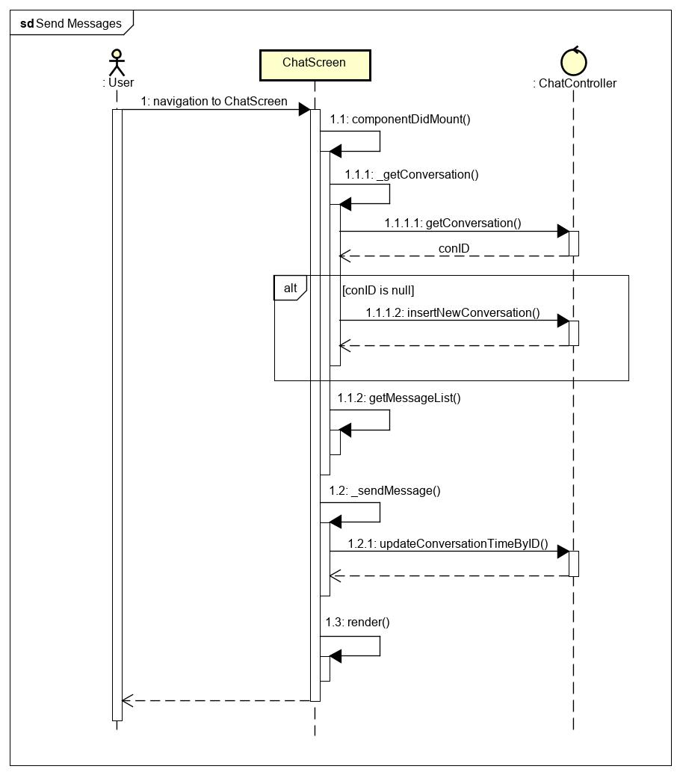

Figure 51 - Send message sequence diagram

**\*Receive Messages class diagram**

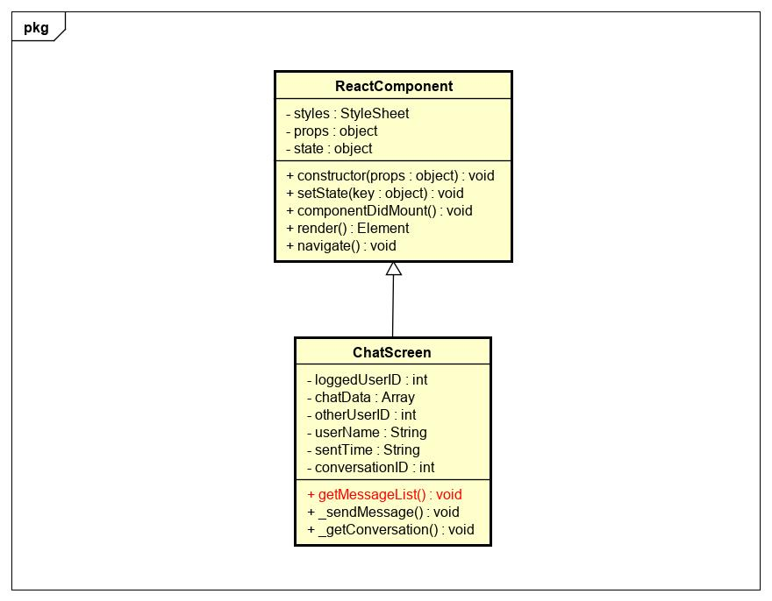

Figure 52 - Receive message class diagram

|  |  |  |  |  |  |
| --- | --- | --- | --- | --- | --- |
| **Name** | ChatScreen | | | **Type** | Class |
| **Description** | The screen displays content of chat | | |  |  |
| **Attributes** | | | | | |
| **Name** | **Type** | **Visibility** | **Description** | | |
| loggedUserID | int | private | Id of own user | | |
| chatData | Array | private | List messages | | |
| otherUserID | int | private | Status of loading | | |
| userName | String | private | Name of user | | |
| sentTime | String | private | Current time to send message | | |
| conversationID | int | private | Id of this conversation | | |
| **Operations** | | | | | |
| **Name** | **Type** | **Visibility** | **Description** | | |
| getMessageList() | void | public | Get list of messages | | |

**\* Receive Messages sequence diagram**

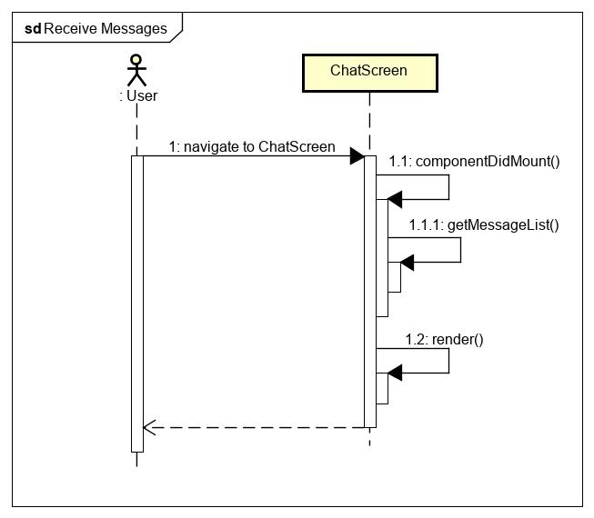

Figure 53 - Receive message sequence diagram

### Search Others User

**\*Searching Class Diagram**

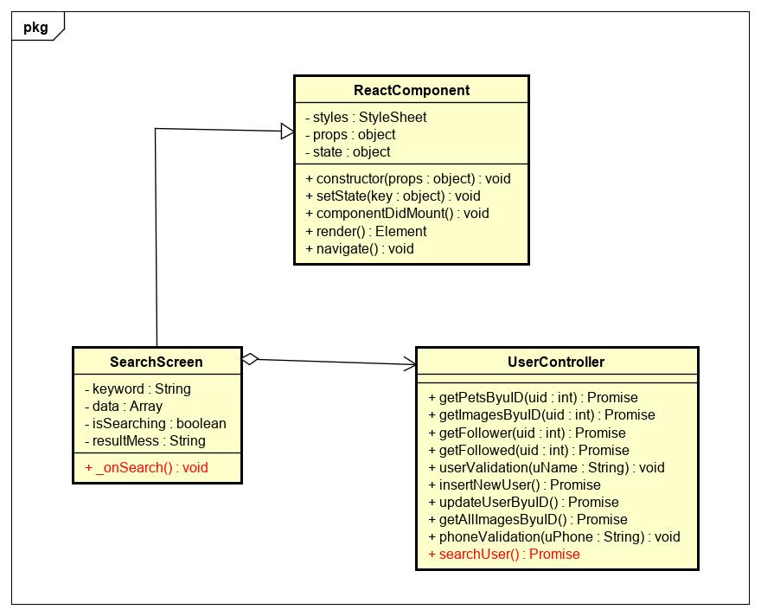

Figure 54 - Searching class diagram

|  |  |  |  |  |  |
| --- | --- | --- | --- | --- | --- |
| **Name** | UserController | | | **Type** | Class |
| **Description** | The screen controls user action | | |  |  |
| **Attributes** | | | | | |
| **Name** | **Type** | **Visibility** | **Description** | | |
|  |  |  |  | | |
| **Operations** | | | | | |
| **Name** | **Type** | **Visibility** | **Description** | | |
| searchUser | Promise | public | Search others user | | |

|  |  |  |  |  |  |
| --- | --- | --- | --- | --- | --- |
| **Name** | SearchScreen | | | **Type** | Class |
| **Description** | A class display SearchScreen. | | |  |  |
| **Attributes** | | | | | |
| **Name** | **Type** | **Visibility** | **Description** | | |
| keyword | String | private | Keyword for search | | |
| data | Array | private | List of users that matched with keyword | | |
| isSearch | boolean | private | Status of searching | | |
| resultMess | String | private | Result after search | | |
| **Operations** | | | | | |
| **Name** | **Type** | **Visibility** | **Description** | | |
| _onSearch | void | public | Handle search function | | |

**\*Searching Sequence Diagram**

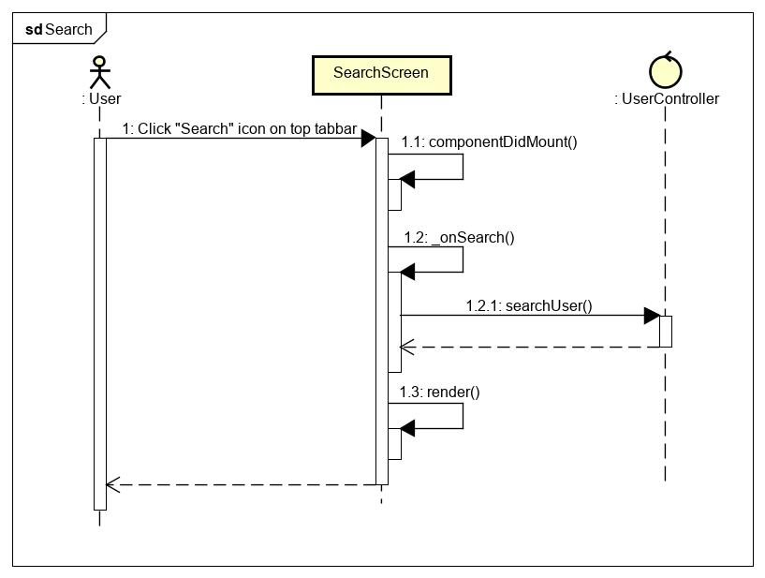

Figure 55 - Searching sequence diagram

### Manage Location

**\*View location class diagram**

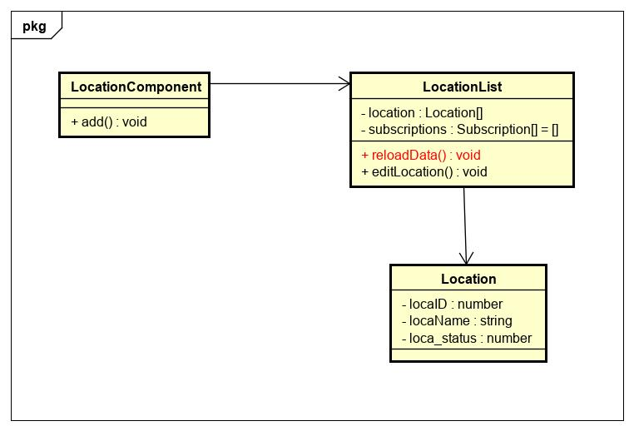

Figure 56 - View location class diagram

|  |  |  |  |  |  |
| --- | --- | --- | --- | --- | --- |
| **Name** | LocationList | | | **Type** | Class |
| **Description** | A class that contains content of locations category. | | | | |
|  | **Attributes** | | | | |
| **Name** | **Type** | **Visibility** | **Description** | | |
| location | object | private | Object of Location class. | | |
| subscriptions | object | private | Manager all subcribes. | | |
|  | **Operations** | | | | |
| **Name** | **Type** | **Visibility** | **Description** | | |
| reloadData() | void | private | Get all location then display in table website. | | |

|  |  |  |  |  |  |
| --- | --- | --- | --- | --- | --- |
| **Name** | Location | | | **Type** | Class |
| **Description** | A class that contains model of location category. | | | | |
|  | **Attributes** | | | | |
| **Name** | **Type** | **Visibility** | **Description** | | |
| locaID | number | public | Id of location. | | |
| locaName | string | public | Name of location. | | |
| loca_status | number | public | Status of location. | | |
|  | **Operations** | | | | |
| **Name** | **Type** | **Visibility** | **Description** | | |

**\*View location sequence diagram**

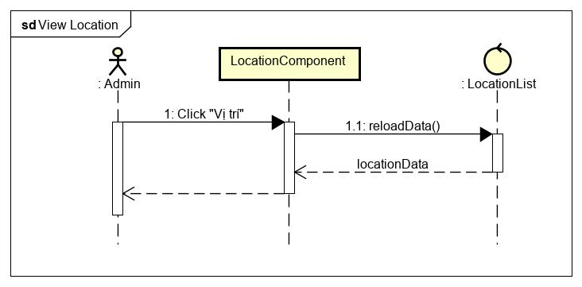

Figure 57 - View location sequence diagram

**\*Update location class diagram**

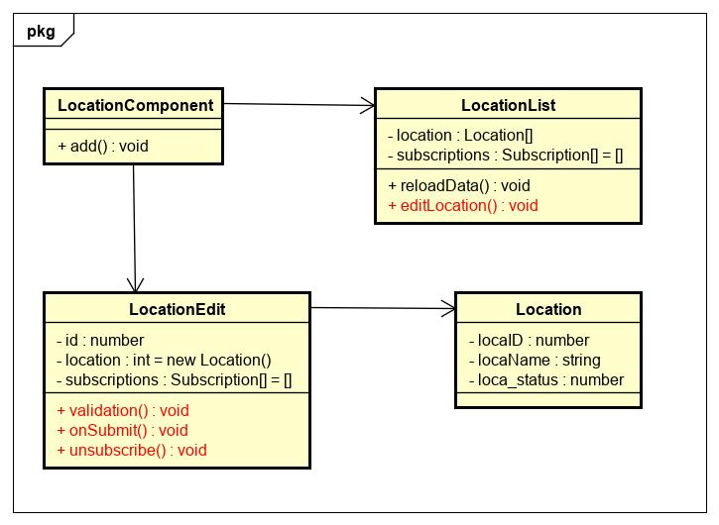

Figure 58 - Update location class diagram

|  |  |  |  |  |  |
| --- | --- | --- | --- | --- | --- |
| **Name** | LocationList | | | **Type** | Class |
| **Description** | A class that contains content of location category. | | | | |
|  | **Attributes** | | | | |
| **Name** | **Type** | **Visibility** | **Description** | | |
| location | object | private | Object of Location class. | | |
| subscriptions | object | private | Manager all subscribe . | | |
|  | **Operations** | | | | |
| **Name** | **Type** | **Visibility** | **Description** | | |
| editLocation() | void | private | Show modal edit location . | | |

|  |  |  |  |  |  |
| --- | --- | --- | --- | --- | --- |
| **Name** | LocationEdit | | | **Type** | Class |
| **Description** | A class that contains content of location category. | | | | |
|  | **Attributes** | | | | |
| **Name** | **Type** | **Visibility** | **Description** | | |
| id | number | private | ID of location | | |
| location | object | private | Object of Location class. | | |
| subscriptions | object | private | Manager all subscribe . | | |
|  | **Operations** | | | | |
| **Name** | **Type** | **Visibility** | **Description** | | |
| validation() | void | private | Display modal then add new location in website | | |
| onSubmit() | void | private | Submit the data to be filled out in the modal | | |
| unsubscribe() | void | private | End process of listening for results returned by API | | |

|  |  |  |  |  |  |
| --- | --- | --- | --- | --- | --- |
| **Name** | Location | | | **Type** | Class |
| **Description** | A class that contains model of location category. | | | | |
|  | **Attributes** | | | | |
| **Name** | **Type** | **Visibility** | **Description** | | |
| locaID | number | public | Id of location. | | |
| locaName | string | public | Name of location. | | |
| loca_status | number | public | Status of location. | | |
|  | **Operations** | | | | |
| **Name** | **Type** | **Visibility** | **Description** | | |

**\*Update location sequence diagram**

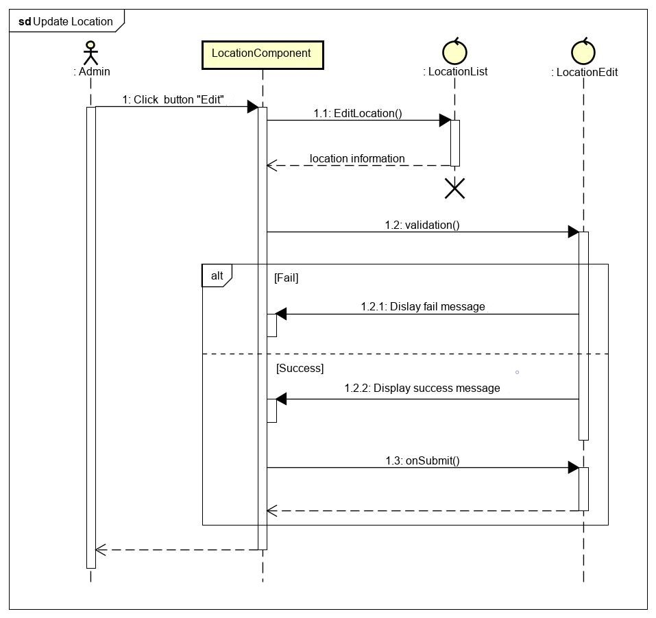

Figure 59 - Update location sequence diagram

**\*Create location class diagram**

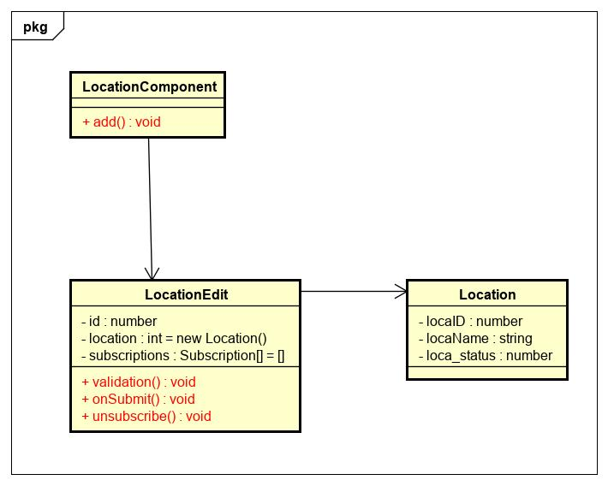

Figure 60 - Create location class diagram

|  |  |  |  |  |  |
| --- | --- | --- | --- | --- | --- |
| **Name** | LocationComponent | | | **Type** | Class |
| **Description** | A class that represents a Location component to be rendered on Website. | | | | |
|  | **Attributes** | | | | |
| **Name** | **Type** | **Visibility** | **Description** | | |
|  |  |  |  | | |
|  | **Operations** | | | | |
| **Name** | **Type** | **Visibility** | **Description** | | |
| add() | void | private | Display modal then add new location in website | | |

|  |  |  |  |  |  |
| --- | --- | --- | --- | --- | --- |
| **Name** | LocationEdit | | | **Type** | Class |
| **Description** | A class that contains content of location category. | | | | |
|  | **Attributes** | | | | |
| **Name** | **Type** | **Visibility** | **Description** | | |
| id | number | private | ID of location | | |
| location | object | private | Object of Location class. | | |
| subscriptions | object | private | Manager all subscribe . | | |
|  | **Operations** | | | | |
| **Name** | **Type** | **Visibility** | **Description** | | |
| validation() | void | private | Display modal then add new location in website | | |
| onSubmit() | void | private | Submit the data to be filled out in the modal | | |
| unsubscribe() | void | private | End process of listening for results returned by API | | |

|  |  |  |  |  |  |
| --- | --- | --- | --- | --- | --- |
| **Name** | Location | | | **Type** | Class |
| **Description** | A class that contains model of location category. | | | | |
|  | **Attributes** | | | | |
| **Name** | **Type** | **Visibility** | **Description** | | |
| locaID | number | public | Id of location. | | |
| locaName | string | public | Name of location. | | |
| loca_status | number | public | Status of location. | | |
|  | **Operations** | | | | |
| **Name** | **Type** | **Visibility** | **Description** | | |

**\*Create location sequence diagram**

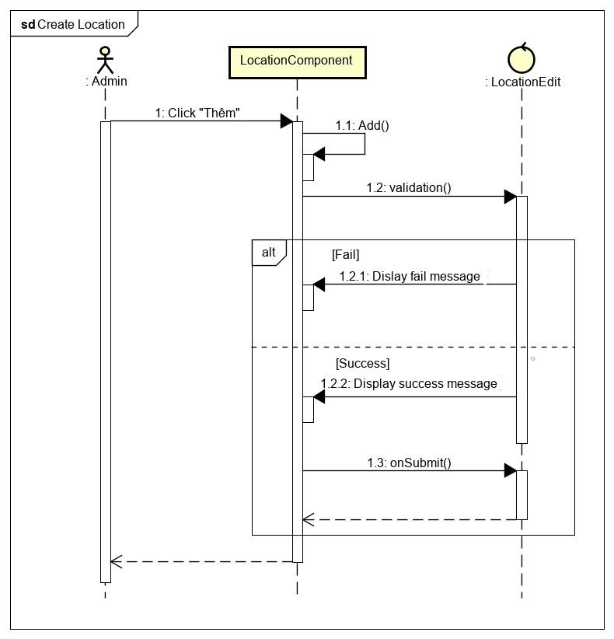

Figure 61 - Create location sequence diagram

### Manage Pet Breed

**\*View pet breed class diagram**

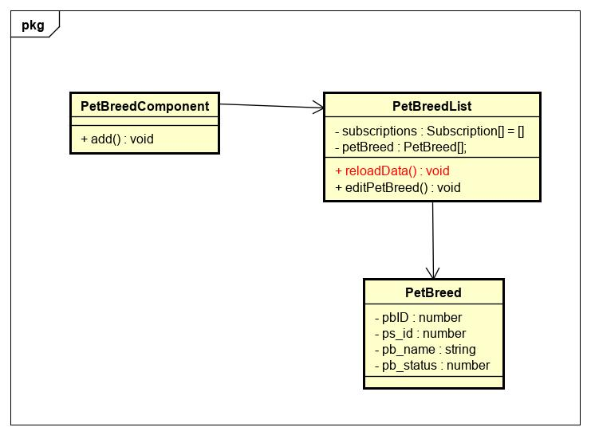

Figure 62 - View pet breed class diagram

|  |  |  |  |  |  |
| --- | --- | --- | --- | --- | --- |
| **Name** | PetBreedList | | | **Type** | Class |
| **Description** | A class that contains content of locations category. | | | | |
|  | **Attributes** | | | | |
| **Name** | **Type** | **Visibility** | **Description** | | |
| petBreed | object | private | Object of Pet Breed class. | | |
| subscriptions | object | private | Manager all subscribe . | | |
|  | **Operations** | | | | |
| **Name** | **Type** | **Visibility** | **Description** | | |
| reloadData() | void | private | Get all pet breed then display in table website. | | |

|  |  |  |  |  |  |
| --- | --- | --- | --- | --- | --- |
| **Name** | PetBreed | | | **Type** | Class |
| **Description** | A class that contains model of pet breed category. | | | | |
|  | **Attributes** | | | | |
| **Name** | **Type** | **Visibility** | **Description** | | |
| pbID | number | public | Id of pet breed. | | |
| ps_id | number | public | Id of pet species. | | |
| pb_name | string | public | Name of pet breed. | | |
| pb_status | number | public | Status of pet breed. | | |
|  | **Operations** | | | | |
| **Name** | **Type** | **Visibility** | **Description** | | |

**\*View pet breed sequence diagram**

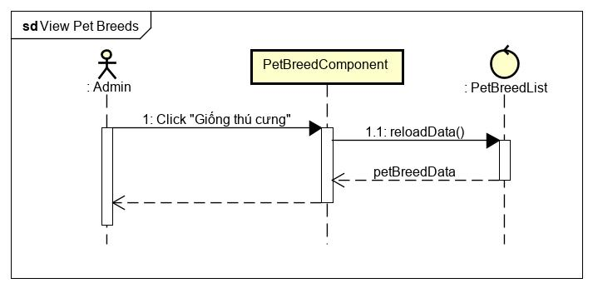

Figure 63 - View pet breed sequence diagram

**\*Update pet breed class diagram**

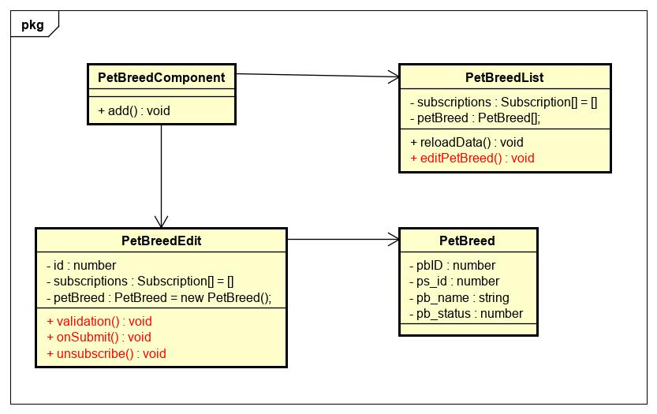

Figure 64 - Update pet breed class diagram

|  |  |  |  |  |  |
| --- | --- | --- | --- | --- | --- |
| **Name** | PetBreedList | | | **Type** | Class |
| **Description** | A class that contains content of locations category. | | | | |
|  | **Attributes** | | | | |
| **Name** | **Type** | **Visibility** | **Description** | | |
| petBreed | object | private | Object of Pet Breed class. | | |
| subscriptions | object | private | Manager all subscribe . | | |
|  | **Operations** | | | | |
| **Name** | **Type** | **Visibility** | **Description** | | |
| editPetBreed() | void | private | Show modal edit pet breed . | | |

|  |  |  |  |  |  |
| --- | --- | --- | --- | --- | --- |
| **Name** | PetBreedEdit | | | **Type** | Class |
| **Description** | A class that contains content of pet’s breed . | | | | |
|  | **Attributes** | | | | |
| **Name** | **Type** | **Visibility** | **Description** | | |
| id | number | private | Breed id of pet | | |
| petBreed | object | private | Object of Pet Breed class. | | |
| subscriptions | object | private | Manager all subscribe . | | |
|  | **Operations** | | | | |
| **Name** | **Type** | **Visibility** | **Description** | | |
| validation() | void | private | Display modal then add new location in website | | |
| onSubmit() | void | private | Submit the data to be filled out in the modal | | |
| unsubscribe() | void | private | End process of listening for results returned by API | | |

**\*Update pet breed sequence diagram**

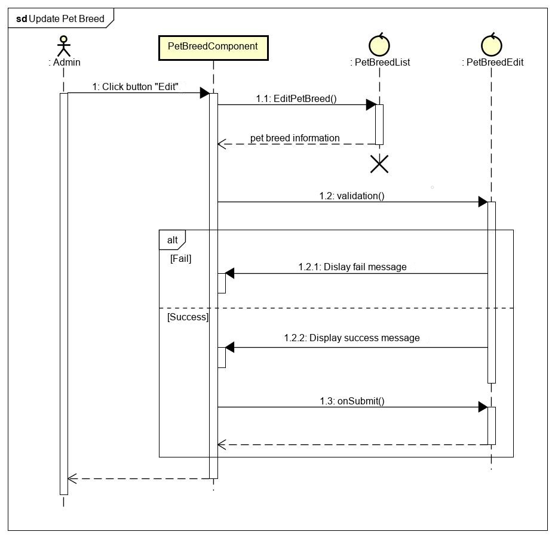

Figure 65 - Update pet breed sequence diagram

**\*Create pet breed class diagram**

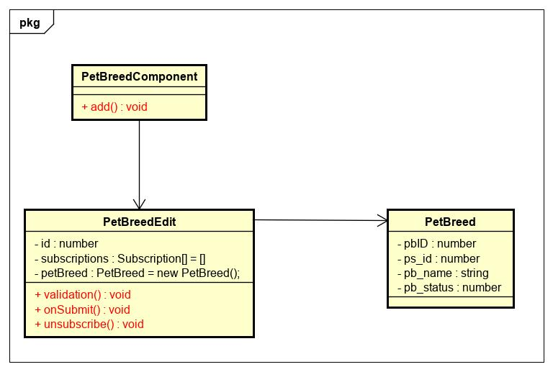

Figure 66 - Create pet breed class diagram

|  |  |  |  |  |  |
| --- | --- | --- | --- | --- | --- |
| **Name** | PetBreedComponent | | | **Type** | Class |
| **Description** | A class that represents a Pet Breed component to be rendered on Website. | | | | |
|  | **Attributes** | | | | |
| **Name** | **Type** | **Visibility** | **Description** | | |
|  |  |  |  | | |
|  | **Operations** | | | | |
| **Name** | **Type** | **Visibility** | **Description** | | |
| add() | void | private | Display modal then add new pet breed in website | | |

|  |  |  |  |  |  |
| --- | --- | --- | --- | --- | --- |
| **Name** | PetBreedEdit | | | **Type** | Class |
| **Description** | A class that contains content of pet’s breed . | | | | |
|  | **Attributes** | | | | |
| **Name** | **Type** | **Visibility** | **Description** | | |
| id | number | private | Breed id of pet | | |
| petBreed | object | private | Object of Pet Breed class. | | |
| subscriptions | object | private | Manager all subscribe . | | |
|  | **Operations** | | | | |
| **Name** | **Type** | **Visibility** | **Description** | | |
| validation() | void | private | Display modal then add new pet breed in website. | | |
| onSubmit() | void | private | Submit the data to be filled out in the modal. | | |
| unsubscribe() | void | private | End process of listening for results returned by API. | | |

**\*Create pet breed sequence diagram**

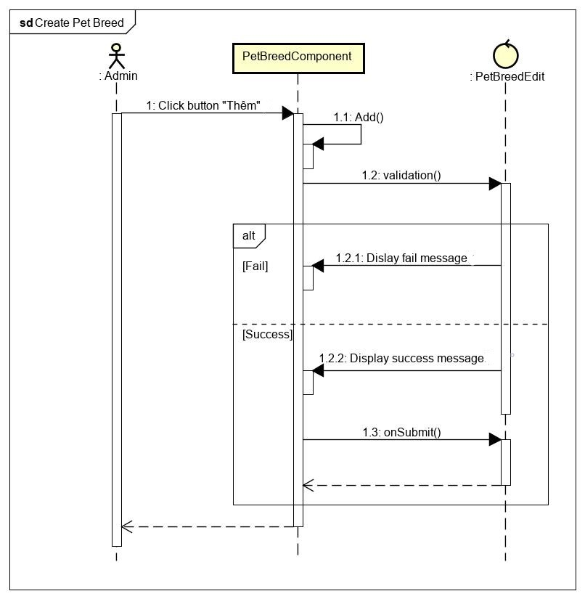

Figure 67 - Create pet breeed sequence diagram

### Manage Pet Species

**\*View pet species class diagram**

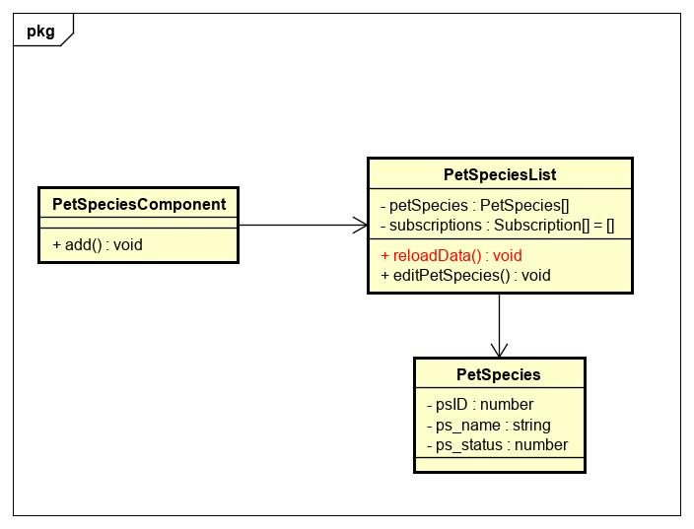

Figure 68 - View pet species class diagram

|  |  |  |  |  |  |
| --- | --- | --- | --- | --- | --- |
| **Name** | PetSpeciesList | | | **Type** | Class |
| **Description** | A class that contains content of Pet Species category. | | | | |
|  | **Attributes** | | | | |
| **Name** | **Type** | **Visibility** | **Description** | | |
| petSpecies | object | private | Object of Pet Species class. | | |
| subscriptions | object | private | Manager all subscribe . | | |
|  | **Operations** | | | | |
| **Name** | **Type** | **Visibility** | **Description** | | |
| reloadData() | void | private | Get all pet species then display in table website. | | |

|  |  |  |  |  |  |
| --- | --- | --- | --- | --- | --- |
| **Name** | PetSpecies | | | **Type** | Class |
| **Description** | A class that contains model of pet species category. | | | | |
|  | **Attributes** | | | | |
| **Name** | **Type** | **Visibility** | **Description** | | |
| psID | number | public | Id of pet species. | | |
| ps_name | number | public | Name of pet species. | | |
| pb_status | string | public | Status of pet species. | | |
|  | **Operations** | | | | |
| **Name** | **Type** | **Visibility** | **Description** | | |

**\*View pet species sequence diagram**

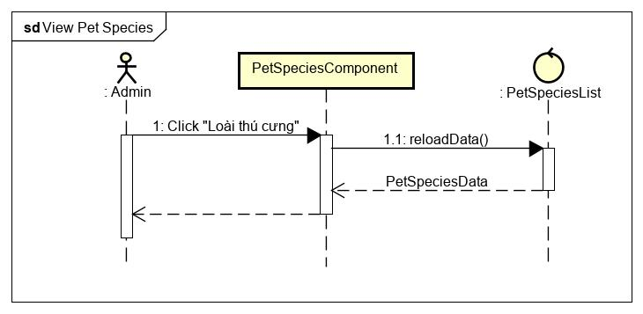

Figure 69 - View pet species sequence diagram

**\*Update pet species class diagram**

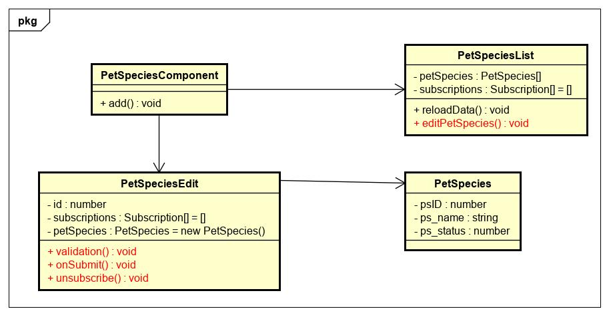

Figure 70 - Update pet species class diagram

|  |  |  |  |  |  |
| --- | --- | --- | --- | --- | --- |
| **Name** | PetSpeciesList | | | **Type** | Class |
| **Description** | A class that contains content of Pet Species category. | | | | |
|  | **Attributes** | | | | |
| **Name** | **Type** | **Visibility** | **Description** | | |
| petSpecies | object | private | Object of Pet Species class. | | |
| subscriptions | object | private | Manager all subscribe . | | |
|  | **Operations** | | | | |
| **Name** | **Type** | **Visibility** | **Description** | | |
| editPetSpecies() | void | private | Show modal edit pet species . | | |

|  |  |  |  |  |  |
| --- | --- | --- | --- | --- | --- |
| **Name** | PetSpeciesEdit | | | **Type** | Class |
| **Description** | A class that contains content of pet species. | | | | |
|  | **Attributes** | | | | |
| **Name** | **Type** | **Visibility** | **Description** | | |
| id | number | private | Specie id of pet | | |
| petSpecies | object | private | Object of Pet Species class. | | |
| subscriptions | object | private | Manager all subscribe . | | |
|  | **Operations** | | | | |
| **Name** | **Type** | **Visibility** | **Description** | | |
| validation() | void | private | Display modal then add new pet species in website. | | |
| onSubmit() | void | private | Submit the data to be filled out in the modal. | | |
| unsubscribe() | void | private | End process of listening for results returned by API. | | |

|  |  |  |  |  |  |
| --- | --- | --- | --- | --- | --- |
| **Name** | PetSpecies | | | **Type** | Class |
| **Description** | A class that contains model of pet species category. | | | | |
|  | **Attributes** | | | | |
| **Name** | **Type** | **Visibility** | **Description** | | |
| psID | number | public | Id of pet species. | | |
| ps_name | number | public | Name of pet species. | | |
| pb_status | string | public | Status of pet species. | | |
|  | **Operations** | | | | |
| **Name** | **Type** | **Visibility** | **Description** | | |

**\*Update pet species sequence diagram**

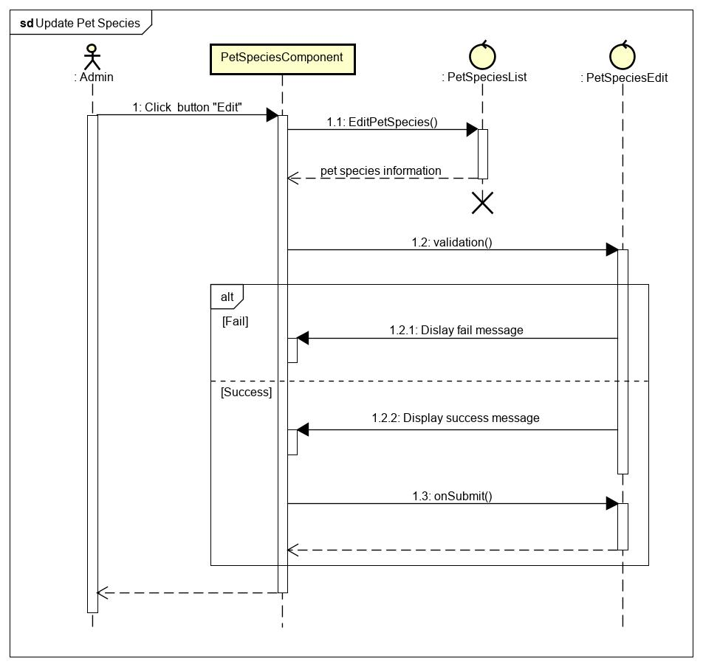

Figure 71 - Update pet species sequence diagram

**\*Create pet species class diagram**

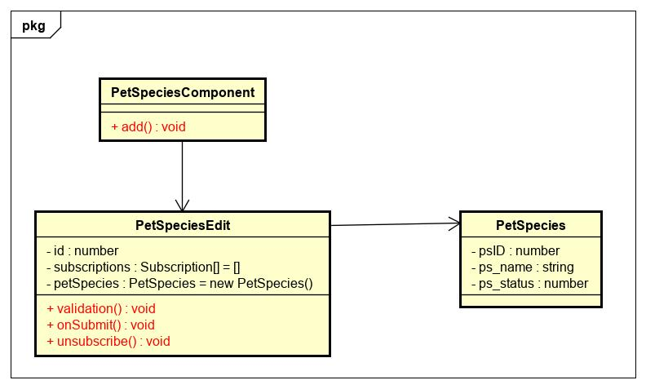

Figure 72 - Create pet species class diagram

|  |  |  |  |  |  |
| --- | --- | --- | --- | --- | --- |
| **Name** | PetSpeciesComponent | | | **Type** | Class |
| **Description** | A class that represents a Pet Species component to be rendered on Website. | | | | |
|  | **Attributes** | | | | |
| **Name** | **Type** | **Visibility** | **Description** | | |
|  |  |  |  | | |
|  | **Operations** | | | | |
| **Name** | **Type** | **Visibility** | **Description** | | |
| add() | void | private | Display modal then add new pet species in website. | | |

|  |  |  |  |  |  |
| --- | --- | --- | --- | --- | --- |
| **Name** | PetSpeciesEdit | | | **Type** | Class |
| **Description** | A class that contains content of pet species. | | | | |
|  | **Attributes** | | | | |
| **Name** | **Type** | **Visibility** | **Description** | | |
| id | number | private | Specie id of pet | | |
| petSpecies | object | private | Object of Pet Species class. | | |
| subscriptions | object | private | Manager all subscribe . | | |
|  | **Operations** | | | | |
| **Name** | **Type** | **Visibility** | **Description** | | |
| validation() | void | private | Display modal then add new pet species in website. | | |
| onSubmit() | void | private | Submit the data to be filled out in the modal. | | |
| unsubscribe() | void | private | End process of listening for results returned by API. | | |

|  |  |  |  |  |  |
| --- | --- | --- | --- | --- | --- |
| **Name** | PetSpecies | | | **Type** | Class |
| **Description** | A class that contains model of pet species category. | | | | |
|  | **Attributes** | | | | |
| **Name** | **Type** | **Visibility** | **Description** | | |
| psID | number | public | Id of pet species. | | |
| ps_name | number | public | Name of pet species. | | |
| pb_status | string | public | Status of pet species. | | |
|  | **Operations** | | | | |
| **Name** | **Type** | **Visibility** | **Description** | | |

**\*Create pet species sequence diagram**

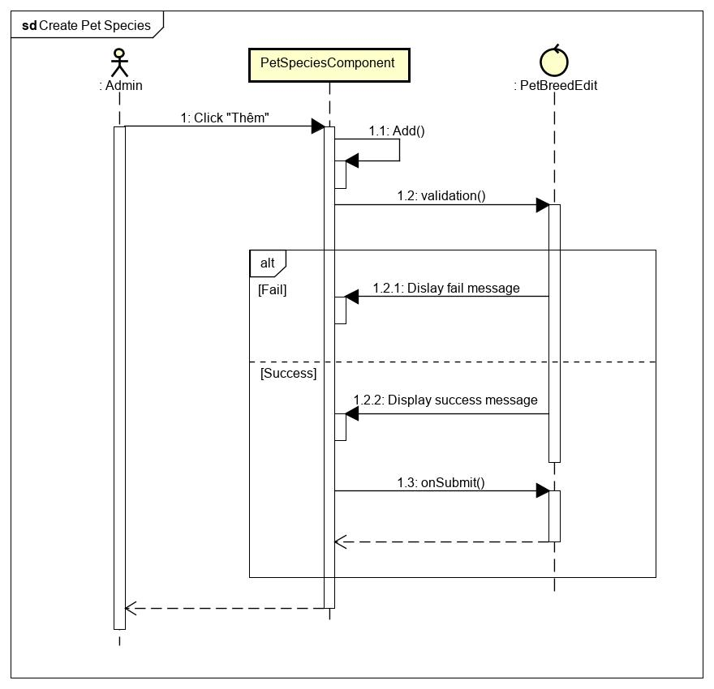

Figure 73 - Create pet species sequence diagram

### Manage Report Reason

**\*View report reason class diagram**

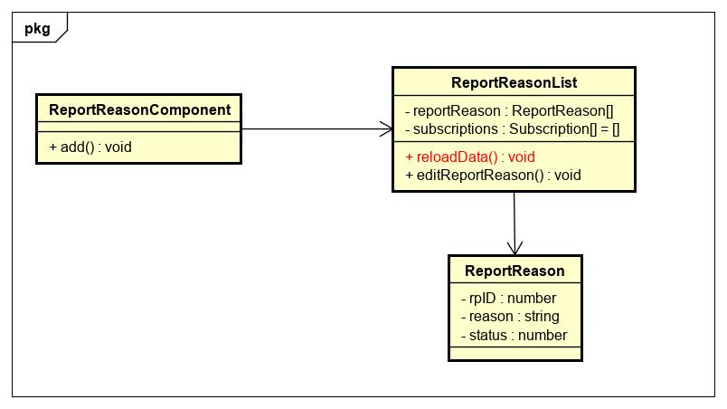

Figure 74 - View report reason class diagram

|  |  |  |  |  |  |
| --- | --- | --- | --- | --- | --- |
| **Name** | ReportReasonList | | | **Type** | Class |
| **Description** | A class that contains content of Report Reason category. | | | | |
|  | **Attributes** | | | | |
| **Name** | **Type** | **Visibility** | **Description** | | |
| reportReason | object | private | Object of Report Reason class. | | |
| subscriptions | object | private | Manager all subscribe . | | |
|  | **Operations** | | | | |
| **Name** | **Type** | **Visibility** | **Description** | | |
| reloadData() | void | private | Get all report reason then display in table website. | | |

|  |  |  |  |  |  |
| --- | --- | --- | --- | --- | --- |
| **Name** | ReportReason | | | **Type** | Class |
| **Description** | A class that contains model of report reason category. | | | | |
|  | **Attributes** | | | | |
| **Name** | **Type** | **Visibility** | **Description** | | |
| rpID | number | public | Id of report reason. | | |
| reason | string | public | Name of report reason. | | |
| status | number | public | Status of report reason. | | |
|  | **Operations** | | | | |
| **Name** | **Type** | **Visibility** | **Description** | | |

**\*View report reason sequence diagram**

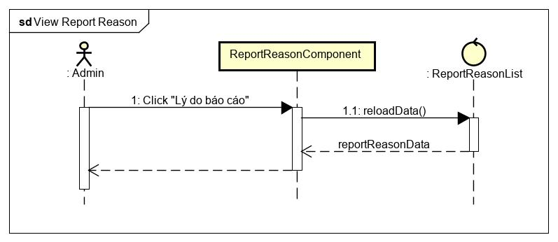

Figure 75 - View report reason sequence diagram

**\*Update report reason class diagram**

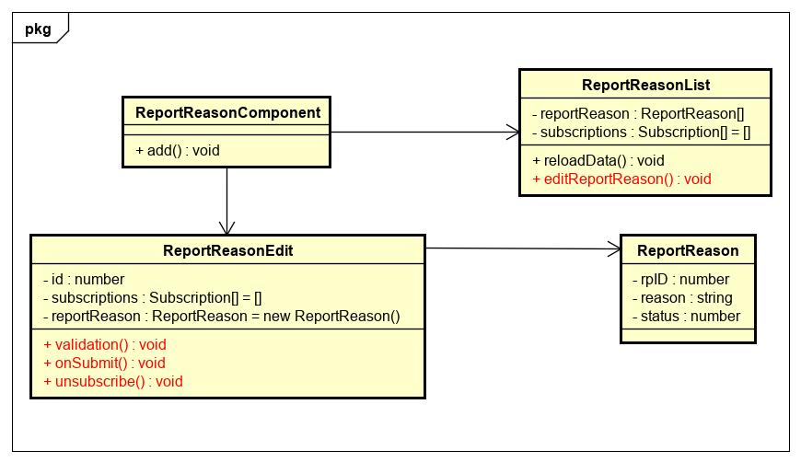

Figure 76 - Update report reason class diagram

|  |  |  |  |  |  |
| --- | --- | --- | --- | --- | --- |
| **Name** | ReportReasonList | | | **Type** | Class |
| **Description** | A class that contains content of report reason category. | | | | |
|  | **Attributes** | | | | |
| **Name** | **Type** | **Visibility** | **Description** | | |
| reportReason | object | private | Object of Report Reason class. | | |
| subscriptions | object | private | Manager all subscribe . | | |
|  | **Operations** | | | | |
| **Name** | **Type** | **Visibility** | **Description** | | |
| editReportReason() | void | private | Show modal edit report reason. | | |

|  |  |  |  |  |  |
| --- | --- | --- | --- | --- | --- |
| **Name** | ReportReasonEdit | | | **Type** | Class |
| **Description** | A class that contains content of report reason. | | | | |
|  | **Attributes** | | | | |
| **Name** | **Type** | **Visibility** | **Description** | | |
| id | number | private | Reason id | | |
| reportReason | object | private | Object of Report Reason class. | | |
| subscriptions | object | private | Manager all subscribe . | | |
|  | **Operations** | | | | |
| **Name** | **Type** | **Visibility** | **Description** | | |
| validation() | void | private | Display modal then add new report reason in website. | | |
| onSubmit() | void | private | Submit the data to be filled out in the modal. | | |
| unsubscribe() | void | private | End process of listening for results returned by API. | | |

|  |  |  |  |  |  |
| --- | --- | --- | --- | --- | --- |
| **Name** | ReportReason | | | **Type** | Class |
| **Description** | A class that contains model of report reason category. | | | | |
|  | **Attributes** | | | | |
| **Name** | **Type** | **Visibility** | **Description** | | |
| rpID | number | public | Id of report reason. | | |
| reason | string | public | Name of report reason. | | |
| status | number | public | Status of report reason. | | |
|  | **Operations** | | | | |
| **Name** | **Type** | **Visibility** | **Description** | | |

**\*Update report reason sequence diagram**

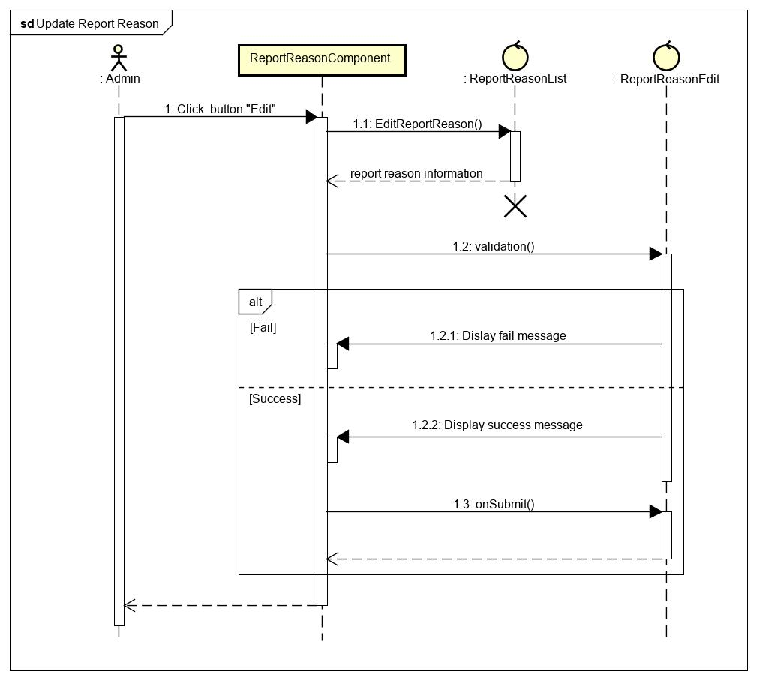

Figure 77 - Update report reason diagram

**\*Create report reason class diagram**

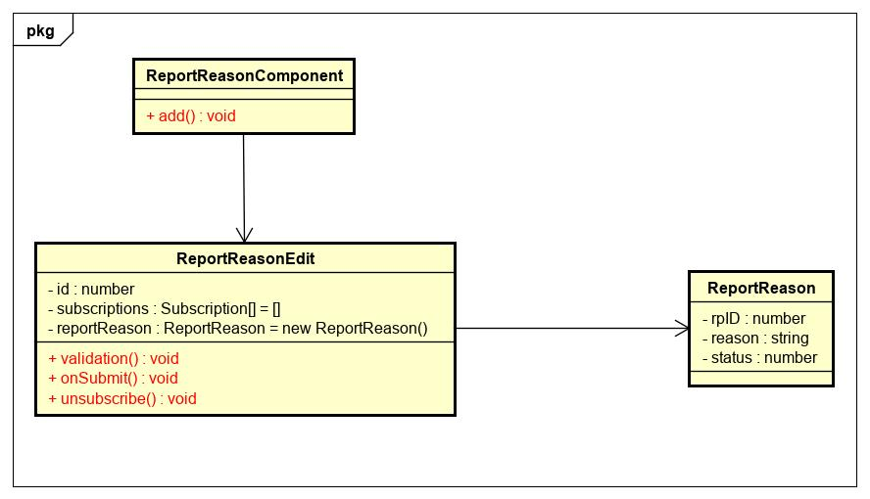

Figure 78 - Create report reason class diagram

|  |  |  |  |  |  |
| --- | --- | --- | --- | --- | --- |
| **Name** | ReportReasonComponent | | | **Type** | Class |
| **Description** | A class that represents a Report Reason component to be rendered on Website. | | | | |
|  | **Attributes** | | | | |
| **Name** | **Type** | **Visibility** | **Description** | | |
|  |  |  |  | | |
|  | **Operations** | | | | |
| **Name** | **Type** | **Visibility** | **Description** | | |
| add() | void | private | Display modal then add new report reason in website. | | |

|  |  |  |  |  |  |
| --- | --- | --- | --- | --- | --- |
| **Name** | ReportReasonEdit | | | **Type** | Class |
| **Description** | A class that contains content of report reason. | | | | |
|  | **Attributes** | | | | |
| **Name** | **Type** | **Visibility** | **Description** | | |
| id | number | private | Reason id | | |
| reportReason | object | private | Object of Report Reason class. | | |
| subscriptions | object | private | Manager all subscribe . | | |
|  | **Operations** | | | | |
| **Name** | **Type** | **Visibility** | **Description** | | |
| validation() | void | private | Display modal then add new report reason in website. | | |
| onSubmit() | void | private | Submit the data to be filled out in the modal. | | |
| unsubscribe() | void | private | End process of listening for results returned by API. | | |

|  |  |  |  |  |  |
| --- | --- | --- | --- | --- | --- |
| **Name** | ReportReason | | | **Type** | Class |
| **Description** | A class that contains model of report reason category. | | | | |
|  | **Attributes** | | | | |
| **Name** | **Type** | **Visibility** | **Description** | | |
| rpID | number | public | Id of report reason. | | |
| reason | string | public | Name of report reason. | | |
| status | number | public | Status of report reason. | | |
|  | **Operations** | | | | |
| **Name** | **Type** | **Visibility** | **Description** | | |

**\*Create report reason sequence diagram**

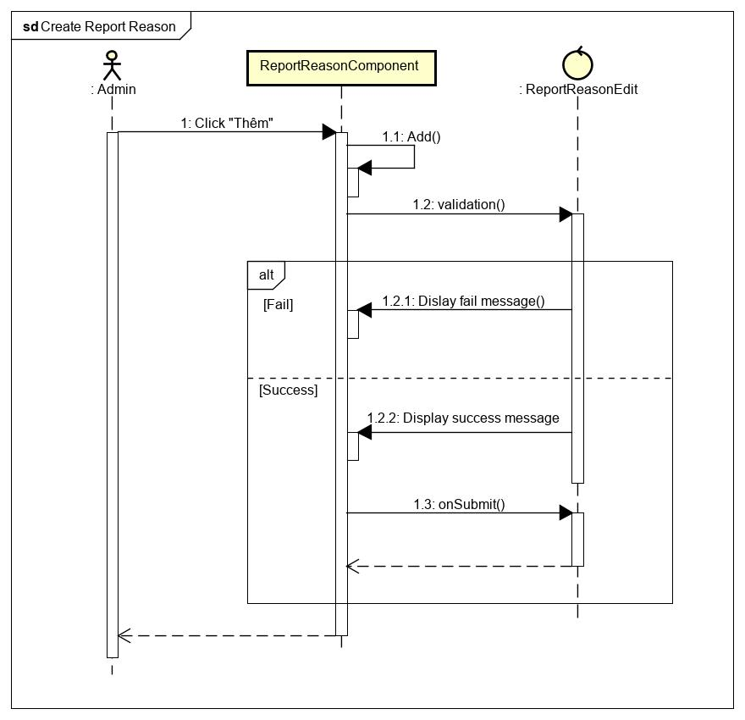

Figure 79 - Create report reason sequence diagram

### Manage Account

**\*View account class diagram**

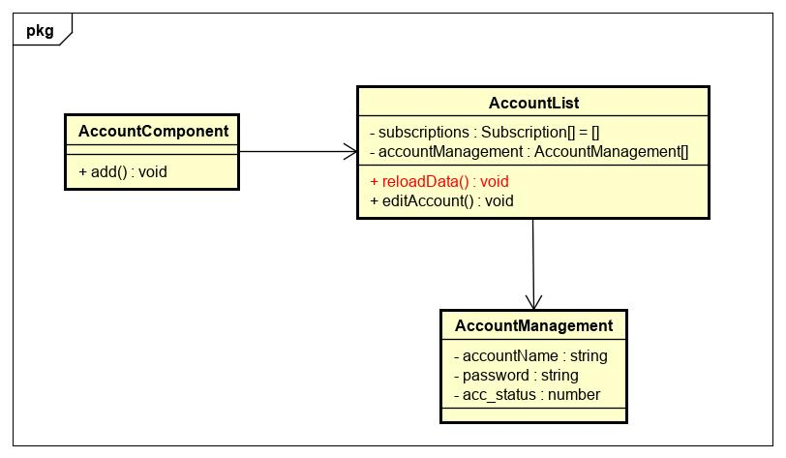

Figure 80 - View account class diagram

|  |  |  |  |  |  |
| --- | --- | --- | --- | --- | --- |
| **Name** | AccountList | | | **Type** | Class |
| **Description** | A class that contains content of Account category. | | | | |
|  | **Attributes** | | | | |
| **Name** | **Type** | **Visibility** | **Description** | | |
| account | object | private | Object of accountManagement class. | | |
| subscriptions | object | private | Manager all subscribe . | | |
|  | **Operations** | | | | |
| **Name** | **Type** | **Visibility** | **Description** | | |
| reloadData() | void | private | Get all account then display in table website. | | |

|  |  |  |  |  |  |
| --- | --- | --- | --- | --- | --- |
| **Name** | AccountManagement | | | **Type** | Class |
| **Description** | A class that contains model of account  category. | | | | |
|  | **Attributes** | | | | |
| **Name** | **Type** | **Visibility** | **Description** | | |
| accountName | string | public | Name of account. | | |
| password | string | public | Password of account. | | |
| acc_status | number | public | Status of account. | | |
|  | **Operations** | | | | |
| **Name** | **Type** | **Visibility** | **Description** | | |

**\*View account sequence diagram**

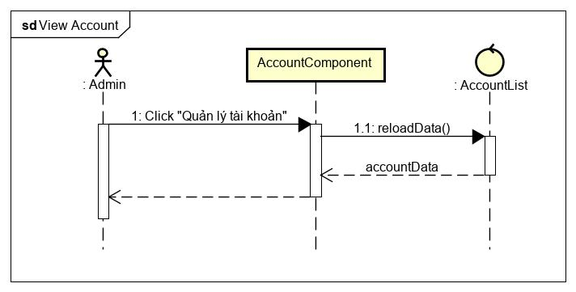

Figure 81 - View account sequence diagram

**\*Update account class diagram**

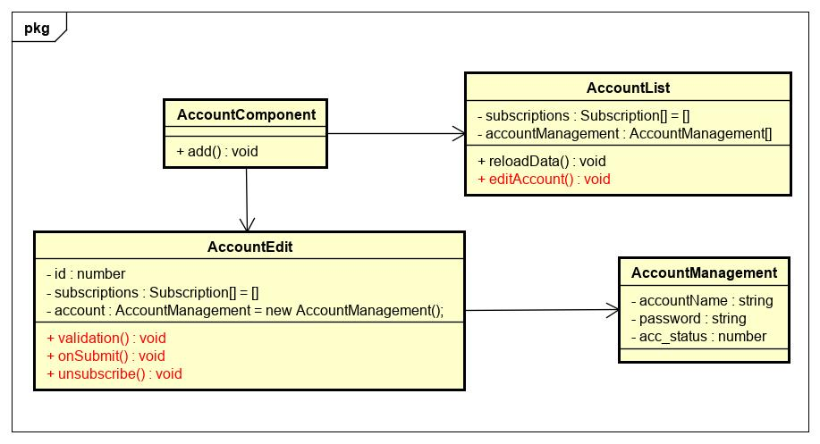

Figure 82 - Update account class diagram

|  |  |  |  |  |  |
| --- | --- | --- | --- | --- | --- |
| **Name** | AccountList | | | **Type** | Class |
| **Description** | A class that contains content of Account category. | | | | |
|  | **Attributes** | | | | |
| **Name** | **Type** | **Visibility** | **Description** | | |
| account | object | private | Object of accountManagement class. | | |
| subscriptions | object | private | Manager all subscribe . | | |
|  | **Operations** | | | | |
| **Name** | **Type** | **Visibility** | **Description** | | |
| editAccount() | void | private | Show modal edit account. | | |

|  |  |  |  |  |  |
| --- | --- | --- | --- | --- | --- |
| **Name** | AccountManagement | | | **Type** | Class |
| **Description** | A class that contains model of account  category. | | | | |
|  | **Attributes** | | | | |
| **Name** | **Type** | **Visibility** | **Description** | | |
| accountName | string | public | Name of account. | | |
| password | string | public | Password of account. | | |
| acc_status | number | public | Status of account. | | |
|  | **Operations** | | | | |
| **Name** | **Type** | **Visibility** | **Description** | | |

|  |  |  |  |  |  |
| --- | --- | --- | --- | --- | --- |
| **Name** | AccountEdit | | | **Type** | Class |
| **Description** | A class that contains content of account. | | | | |
|  | **Attributes** | | | | |
| **Name** | **Type** | **Visibility** | **Description** | | |
| account | object | private | Object of accountManagement class. | | |
| subscriptions | object | private | Manager all subscribe . | | |
|  | **Operations** | | | | |
| **Name** | **Type** | **Visibility** | **Description** | | |
| validation() | void | private | Display modal then add new account in website. | | |
| onSubmit() | void | private | Submit the data to be filled out in the modal. | | |
| unsubscribe() | void | private | End process of listening for results returned by API. | | |

**\*Update account sequence diagram**

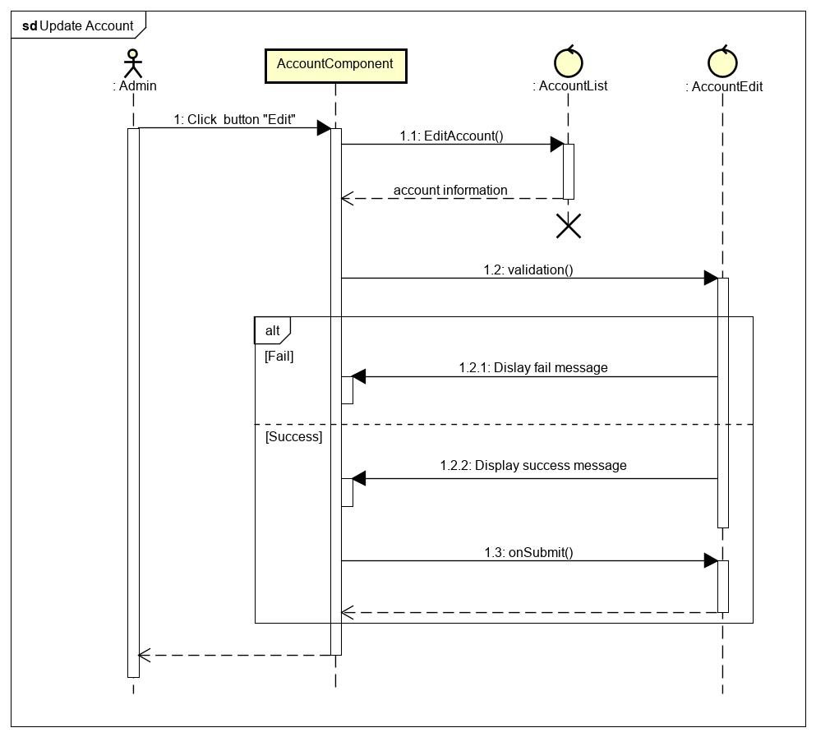

Figure 83 - Update account sequence diagram

**\*Create account class diagram**

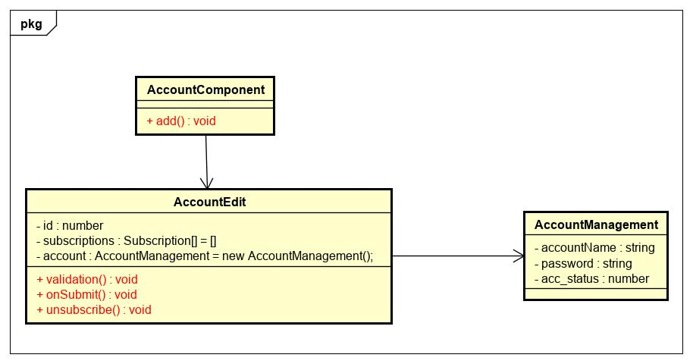

Figure 84 - Create account class diagram

|  |  |  |  |  |  |
| --- | --- | --- | --- | --- | --- |
| **Name** | AccountComponent | | | **Type** | Class |
| **Description** | A class that represents a Account component to be rendered on Website. | | | | |
|  | **Attributes** | | | | |
| **Name** | **Type** | **Visibility** | **Description** | | |
|  |  |  |  | | |
|  | **Operations** | | | | |
| **Name** | **Type** | **Visibility** | **Description** | | |
| add() | void | private | Display modal then add new account in website. | | |

|  |  |  |  |  |  |
| --- | --- | --- | --- | --- | --- |
| **Name** | AccountManagement | | | **Type** | Class |
| **Description** | A class that contains model of account  category. | | | | |
|  | **Attributes** | | | | |
| **Name** | **Type** | **Visibility** | **Description** | | |
| accountName | string | public | Name of account. | | |
| password | string | public | Password of account. | | |
| acc_status | number | public | Status of account. | | |
|  | **Operations** | | | | |
| **Name** | **Type** | **Visibility** | **Description** | | |

|  |  |  |  |  |  |
| --- | --- | --- | --- | --- | --- |
| **Name** | AccountEdit | | | **Type** | Class |
| **Description** | A class that contains content of account. | | | | |
|  | **Attributes** | | | | |
| **Name** | **Type** | **Visibility** | **Description** | | |
| account | object | private | Object of accountManagement class. | | |
| subscriptions | object | private | Manager all subscribe . | | |
|  | **Operations** | | | | |
| **Name** | **Type** | **Visibility** | **Description** | | |
| validation() | void | private | Display modal then add new account in website. | | |
| onSubmit() | void | private | Submit the data to be filled out in the modal. | | |
| unsubscribe() | void | private | End process of listening for results returned by API. | | |

**\*Create account sequence diagram**

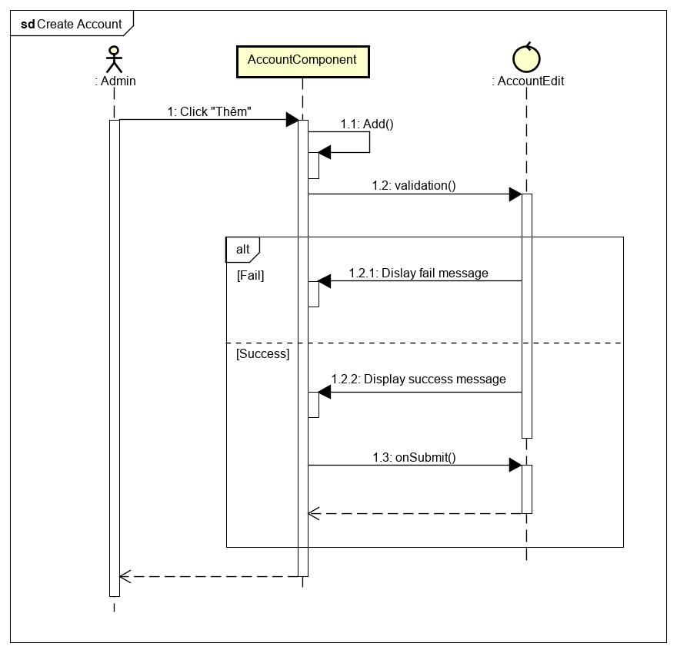

Figure 85 - Create account sequence diagram

**\*Change password class diagram**

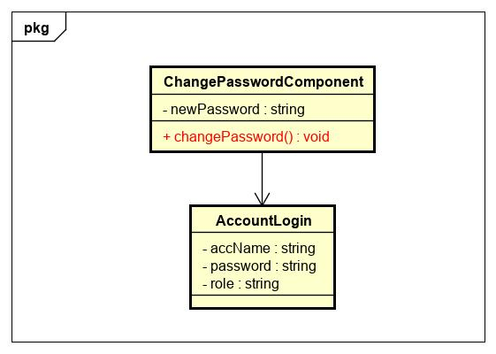

Figure 86 - Change password class diagram

|  |  |  |  |  |  |
| --- | --- | --- | --- | --- | --- |
| **Name** | ChangPasswordComponent | | | **Type** | Class |
| **Description** | A class that contains content of Change Password. | | | | |
|  | **Attributes** | | | | |
| **Name** | **Type** | **Visibility** | **Description** | | |
| newPassword | string | private | New password of account. | | |
|  | **Operations** | | | | |
| **Name** | **Type** | **Visibility** | **Description** | | |
| changePassword() | void | private | Change password when user click button. | | |

|  |  |  |  |  |  |
| --- | --- | --- | --- | --- | --- |
| **Name** | AccountLogin | | | **Type** | Class |
| **Description** | A class that contains model of account login. | | | | |
|  | **Attributes** | | | | |
| **Name** | **Type** | **Visibility** | **Description** | | |
| accName | string | public | Name of account. | | |
| password | string | public | Password of account. | | |
| role | string | public | Role of account. | | |
|  | **Operations** | | | | |
| **Name** | **Type** | **Visibility** | **Description** | | |

**\*Change password sequence diagram**

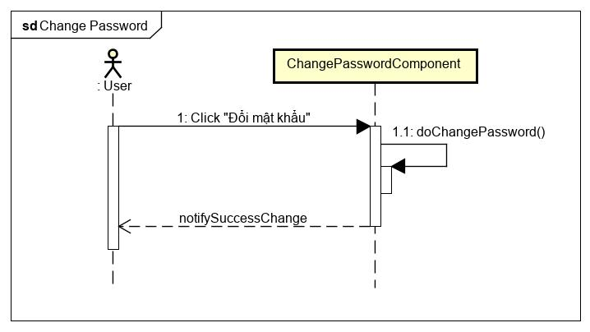

Figure 87 - Change password sequence diagram

### Verify Report

**\*Verify report class diagram**

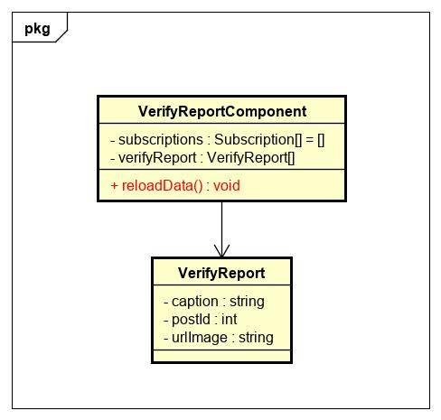

Figure 88 - Verify report class diagram

|  |  |  |  |  |  |
| --- | --- | --- | --- | --- | --- |
| **Name** | VerifyReportComponent | | | **Type** | Class |
| **Description** | A class that represents a Verify Report component to be rendered on Website. | | | | |
|  | **Attributes** | | | | |
| **Name** | **Type** | **Visibility** | **Description** | | |
| subscriptions | object | private | Object of Subscription class. | | |
| verifyReport | object | private | Object of VerifyReport class. | | |
|  | **Operations** | | | | |
| **Name** | **Type** | **Visibility** | **Description** | | |
| reloadData() | void | private | Get all verify report then display in table website. | | |

|  |  |  |  |  |  |
| --- | --- | --- | --- | --- | --- |
| **Name** | VerifyReport | | | **Type** | Class |
| **Description** | A class that contains model of verify report category. | | | | |
|  | **Attributes** | | | | |
| **Name** | **Type** | **Visibility** | **Description** | | |
| caption | string | public | Caption of verify report. | | |
| postId | string | public | PostId of verify report. | | |
| urlImage | string | public | urlImage of verify report. | | |
|  | **Operations** | | | | |
| **Name** | **Type** | **Visibility** | **Description** | | |

**\*Verify report sequence diagram**

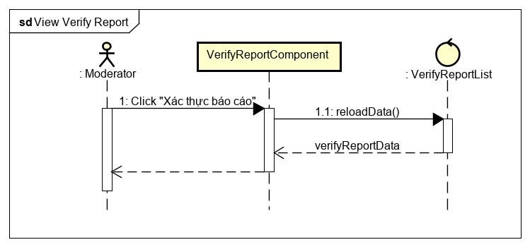

Figure 89 - Verify report sequence diagram

### Login With Account

**\*Login with account class diagram**

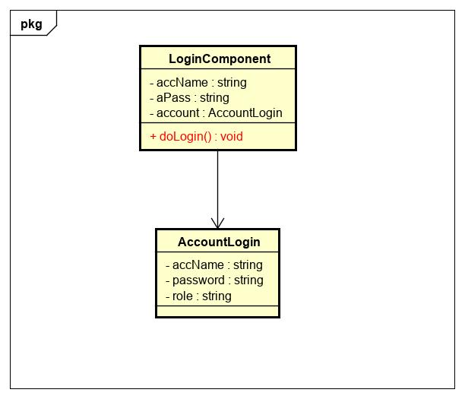

Figure 90 - Login with account class diagram

|  |  |  |  |  |  |
| --- | --- | --- | --- | --- | --- |
| **Name** | LoginComponent | | | **Type** | Class |
| **Description** | A class that represents a Login component to be rendered on Website. | | | | |
|  | **Attributes** | | | | |
| **Name** | **Type** | **Visibility** | **Description** | | |
| accName | string | private | Name of account. | | |
| aPass | string | private | Password of account. | | |
| account | object | private | Object of AccountLogin class. | | |
|  | **Operations** | | | | |
| **Name** | **Type** | **Visibility** | **Description** | | |
| doLogin() | void | private | Verify and Login to website. | | |

|  |  |  |  |  |  |
| --- | --- | --- | --- | --- | --- |
| **Name** | AccountLogin | | | **Type** | Class |
| **Description** | A class that contains model of account login. | | | | |
|  | **Attributes** | | | | |
| **Name** | **Type** | **Visibility** | **Description** | | |
| accName | string | public | Name of account. | | |
| password | string | public | Password of account. | | |
| role | string | public | Role of account. | | |
|  | **Operations** | | | | |
| **Name** | **Type** | **Visibility** | **Description** | | |

**\*Login with account sequence diagram**

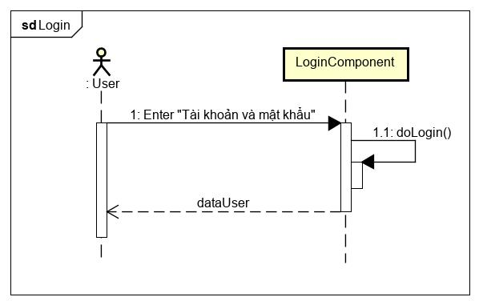

Figure 91 - Login with account sequence diagram

### Reset Password

**\*Reset password class diagram**

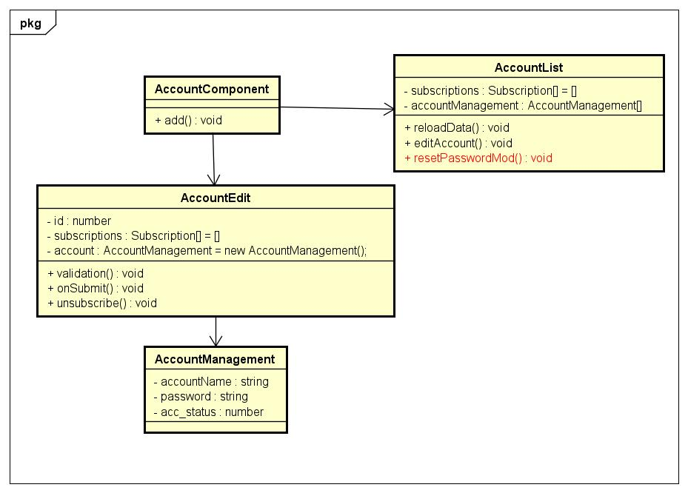

Figure 92 - Reset password class diagram

|  |  |  |  |  |  |
| --- | --- | --- | --- | --- | --- |
| **Name** | AccountList | | | **Type** | Class |
| **Description** | A class that contains content of Account category. | | | | |
|  | **Attributes** | | | | |
| **Name** | **Type** | **Visibility** | **Description** | | |
| account | object | private | Object of accountManagement class. | | |
| subscriptions | object | private | Manager all subscribe . | | |
|  | **Operations** | | | | |
| **Name** | **Type** | **Visibility** | **Description** | | |
| resetPasswordMod() | void | private | Reset password of moderator account. | | |

**\*Reset password sequence diagram**

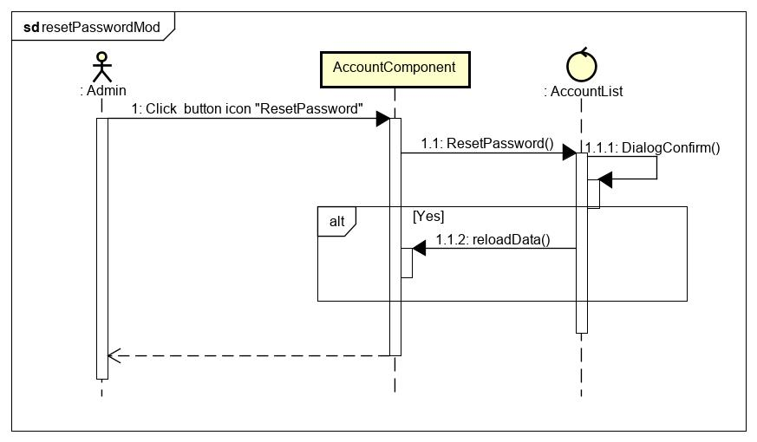

Figure 93 - Reset password sequence diagram

**CHAPTER 5: Software Testing Document**

5.1. Introduction

5.1.1. Purpose

The primary purpose of this chapter is to detect and prevent defects which may be created by developers while developing the software and this may lead to software failures. On the other hand, another objective of this chapter is to provide information about the level of quality and to make sure that the end result meets the business and user requirements. It contains the following sections:

* Scope of Testing
* Testing Tool and Environment
* Resources and responsibilities
* Test strategy: Test approach, test stage
* Test schedule
* Feature to be tested
* Feature not to be tested
* Defect Log
* Test report

5.1.2. Scope of testing

* Stages of testing:

There are 4 phases in Testing Process: Unit testing, Integration testing, System testing and Acceptance testing.

|  |  |  |
| --- | --- | --- |
| ID | Test Stages | Description |
| 1 | Unit testing | The main aim of this endeavor is to determine whether the application functions as designed. In this phase, a unit can refer to a function, individual program or even a procedure, and a White-box Testing method is usually used to get the job done. |
| 2 | Integration testing | Integration testing allows individuals the opportunity to combine all of the units within a program and test them as a group. This testing level is designed to find interface defects between the modules/functions. This is particularly beneficial because it determines how efficiently the units are running together. |
| 3 | System testing | System testing is the first level in which the complete application is tested as a whole. The goal at this level is to evaluate whether the system has complied with all of the outlined requirements and to see that it meets Quality Standards. |
| 4 | Acceptance testing | Acceptance testing (or User Acceptance Testing), is conducted to determine whether the system is ready for release. During this phase, the tester and some alpha test user will test the system to find out whether the application meets their business' needs. |

* Type of testing

The following type of testing is used in this project are:

* + GUI test
  + Function test
  + Regression test
  + Acceptance test include alpha test
  + Unit test

5.1.3. Range of testing

Team performs all functions defined in the SRS based on the approved version.

5.2. Test plan

5.2.1 Testing Tools and Environment

**5.2.1.1. Testing tools**

* **Front-end and Project Testing**
  + Chrome Developer Tool: To view logs.
  + Git: Manage bug.
  + Microsoft Excel: Manage testcase
* **API testing**
  + PostMan: to manage the list of all APIs and manually test APIs’ result
* **Unit test**
  + Jest: Unit test for JavaScripts
* **UI testing**
  + Expo client: View application when development

**5.2.1.2. Testing environment**

* **Device 1: Laptop Dell** 
  + CPU: i5 7300hq
  + Ram: 8gb
  + Gpu: gtx1050ti
* **Device 2: Laptop MSI**
  + CPU: i7 7700hq
  + Ram: 16gb
  + Gpu: gtx1050
* **Other device: Mobile phone**
  + HTC one M8
  + Xiaomi Redmi 4
  + Samsung a50
  + Nokia 8.1

5.2.2. Resources and Responsibilities

|  |  |  |
| --- | --- | --- |
| ID | Resources | Responsibilities |
| 1 | Project Manager | - Responsible for project schedule and overall success of the project  - Review test-case and report |
| 2 | Tester | - Preforming the actual system testing  - Manage test resource and assign test tasks  - Create test plan  - Create test cases  - Create test report  - Execute test  - Test log report |
| 3 | Developer | - Create unit test and integration test scripts  - Fix bugs |

5.2.3. Test Strategy

**5.2.3.1. Test Model**

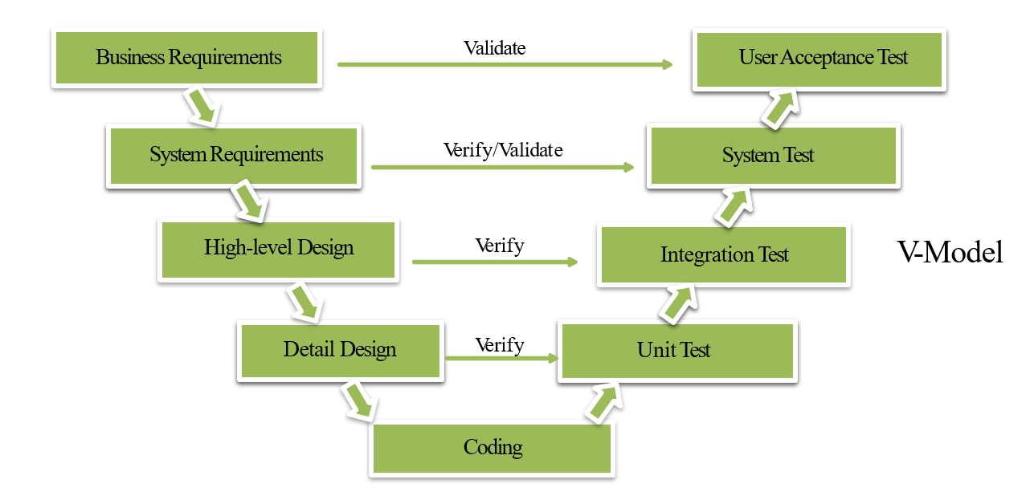

Figure 94 - V-model

V-Model (Rex Black, Dorothy Graham, Erik van Veenendaal. Foundations of Software Testing: ISTQB Certification. Google Books. 2012)

Overall, we choose V-Model to implement testing process. With V-Model, software development is separated into two appropriate phase’s groups: development and testing. In this model, the verification and validation will be done side by side. It emphasizes the strict process flow to develop a quality product. The errors occurred in any phase will be corrected in that phase. Proactive defect tracking defects, which are found at early stages even, may be in the development phase before application being tested.

Pet Dating API has 2 levels of test:

* Unit testing: Automation tests that cover logic of Models and Libraries
* API testing: Automation tests that involve testing APIs directly (in isolation) to determine whether APIs return the correct response (in the expected format) for a broad range of feasible requests, react properly to edge cases such as failures and unexpected/extreme inputs.
* Pet Dating Front-end works mostly with GUI instead of logic and it depends on Pet Dating API, so that Pet Dating Front-end apply system testing which coverage of whole Pet Dating system.

**5.2.3.2. Test types**

The following type of testing is used in this project are:

* + - Unit test:
* Testing all individual implemented methods, functions of model class or library class.
* Unit test also includes database testing to verify constraint, transaction, default value, data types, data format, and check null and junk characters which are mentioned in database design and software requirement.
* Test case will have to cover all logic branch that function or method could execute with difference data input. Another alternative logic branch should be covered if not, that logic branch should be detected at API testing level.
* Implemented function's error message and database error message will be included in this test.
  + - API test:
* Involves testing APIs directly to determine if they meet expectations for functionality, reliability, performance, and security. API testing will test all of individual implemented API of PetDating API.
* Test case will verify constraint of data which be mention in Business rule
* Basically, almost all API test cases are executed as automation test. After that all API with standard sample datasets will be saved and confirmation tests will be executed by using Postman with developer's local database.
  + - UI test:
* User Interface testing verifies a user's interaction with the software. The goal of GUI testing is to ensure that the GUI provides the user with an appropriate access and navigation through the functions of the target-of-test. In addition, GUI testing ensures that the objects within the GUI function as expected and conform to requirement
* GUI test will be performed fully on all screens.
* This test targets to cover the verification of the overall look and feel of the OCFU system including initial position, font, text size, color, focus, initial button, tab order, label, screen sizes and sentences width.
* Check all the GUI elements for size, position, width, length and acceptance of characters or numbers. For instance, it must be able to provide inputs to the input fields.
* Check if Error Messages are displayed correctly.
* Check if Font used in application is readable.
* Check if the alignment of the text is proper.
* Check if the Color of the font and warning messages is aesthetically pleasing.
* Check if images have good clarity.
* Check if images are properly aligned.
* Check the positioning of GUI elements for different screen resolution.
  + - Regression testing
      * The testing is to confirm that the bug was removed including the extent of the impact, when developer fix bug, developer and tester will confirm with each other what is the impact of fix bug modification, after that all impact unit or function will be retested by developer then tester after that
    - Acceptance testing
      * This test type will be executed by tester with designed test cases, acceptance test is a test type conducted to determine if the requirements of a specification or contract are met
      * It also includes alpha testing; alpha testing takes place at close relation user’s site and are free test to detect bug and strange behavior. By that, development team will improve UX and UI of system

**5.2.3.3. Test stage**

The table below describes the stages in which common tests are executed:

|  |  |  |  |  |
| --- | --- | --- | --- | --- |
| Type of test | Stage of test | | | |
| Unit test | Integration test | System test | Acceptance test |
| Unit tests | x | x | x |  |
| API tests | x | x |  |  |
| UI tests |  |  | x | x |
| Regression tests | x | x | x | x |
| Acceptance tests |  |  | x | x |

**5.2.3.4. Test schedule**

|  |  |  |  |
| --- | --- | --- | --- |
| Task | | Start date | End date |
| Phase 1 | Create test plan | 15/10/2019 | 17/10/2019 |
| Create and execute unit test | 18/10/2019 | 2/11/2019 |
| Create and execute integration test | 18/10/2019 | 2/11/2019 |
| Phase 2 | Create test plan | 5/11/2019 | 11/11/2019 |
| Create and execute unit test | 11/11/2019 | 2/12/2019 |
| Create and execute integration test | 15/11/2019 | 2/12/2019 |
| Phase 3 | Create test plan | 7/11/2019 | 7/11/2019 |
| Create and execute system test | 28/11/2019 | 12/12/2019 |
| Create and execute acceptance test | 30/11/2019 | 14/12/2019 |

**5.2.3.5. Deliverables**

|  |  |  |  |
| --- | --- | --- | --- |
| No | Deliverables | Responsibilities | Delivered date |
| 1 | Test plan | Test Leader | 10/11/2019 |
| 2 | Unit test | Developer | 2/12/2019 |
| 3 | Integration test | Tester + Developer | 2/12/2019 |
| 4 | System test | Tester + Developer + PM | 12/12/2019 |
| 5 | Acceptance test | All member | 14/12/2019 |
| 6 | Defect logs | All member | 15/12/2019 |
| 7 | Final test summary report | Test Leader | 17/12/2019 |

5.2.4. Features to be tested

* All features that are listed in Requirement that application have.
* GUI of the Mobile application.

5.3. Test case

5.3.1. UnitTest

Unit tests are done by the developers in order to test individual units, and approved by the test leader.

This is done to ensure that important functions, such as algorithms for verb conjugation and name conversion, return the correct values.

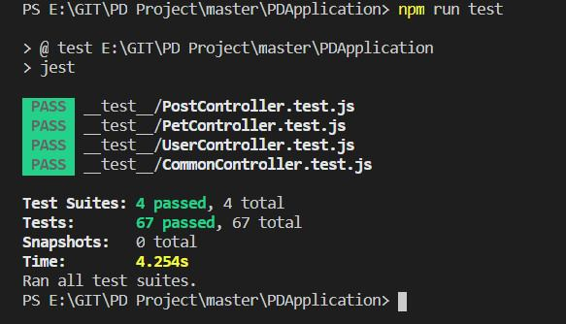

Figure 95 - Unit test with jest

5.3.2. System testing

Detail test cases will be described in **“PetDating_Final_TestCase.xlsx”** file.

5.3.3. Acceptance test

Acceptance Testing is a level of the software testing process where a system is tested for acceptability. The purpose of this test is to evaluate the system's compliance with the business requirements and assess whether it is acceptable for delivery. But our project will use the Check Lists as a substitute for Acceptance testing.

The content of the Checklist is shown in the table below

|  |  |  |  |
| --- | --- | --- | --- |
| No | Checklist | Yes | No |
| General | | | |
| 1 | Text does not have grammatical and spelling errors. | √ |  |
| 2 | All buttons are functional. | √ |  |
| 3 | All mandatory fields are validated and indicated by asterisk (*) symbol. | √ |  |
| 4 | All error messages are displayed using red color. | √ |  |
| 5 | All "Delete" functions ask for confirmation. | √ |  |
| GUI and usability | | | |
| 6 | Screen design follows the standard of the project. | √ |  |
| 7 | Waiting icon appear for waiting display data. | √ |  |
| 8 | Color red is used for all error messages. | √ |  |
| 9 | Project state is displayed and colored with appropriate state | √ |  |
| 10 | Design style is friendly and easy to use | √ |  |
| 11 | The text easy to understand. Don't use slang, acronyms, and abbreviations. | √ |  |
| 12 | The static text is clear, concise, and meaningful. | √ |  |
| 13 | The screen designed to fit with multiple screen size. | √ |  |

5.3.4. Defect Log

Excel and github are used to manage bugs of FCWB Processes:

* When a bug is found, testers change the status and assign for developer.
* Developers fix bugs and change status of bugs to resolve.
* If the bug is fixed then tester change the status to close, otherwise will be re-open again to fix.

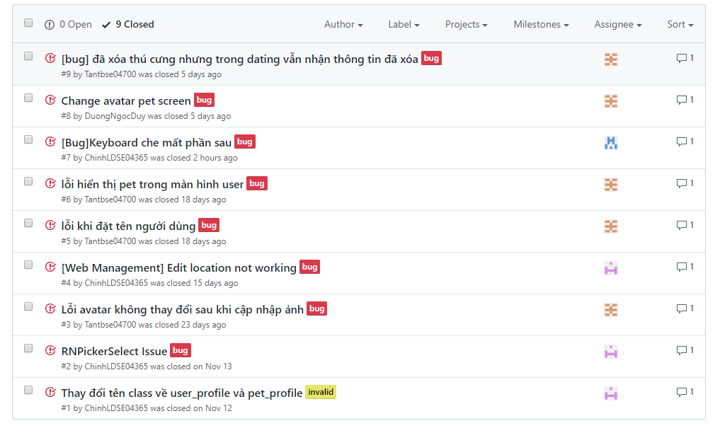

Figure 96 - Defect logs with Github

5.4. Test Report



### Unit test

|  |  |  |  |  |
| --- | --- | --- | --- | --- |
|  | Function Name | Number of test case (Estimate) | Pass | Fail |
| 1 | dateFormat | 10 | 10 | 0 |
| 2 | reversDF | 4 | 4 | 0 |
| 3 | getAge | 6 | 6 | 0 |
| 4 | timeFormat | 5 | 5 | 0 |
| 5 | petValidation | 10 | 10 | 0 |
| 6 | captionValidation | 6 | 6 | 0 |
| 7 | userValidation | 12 | 12 | 0 |
| 8 | phoneValidation | 14 | 14 | 0 |
| Total | | 67 | 67 | 0 |

### Integration and system tests

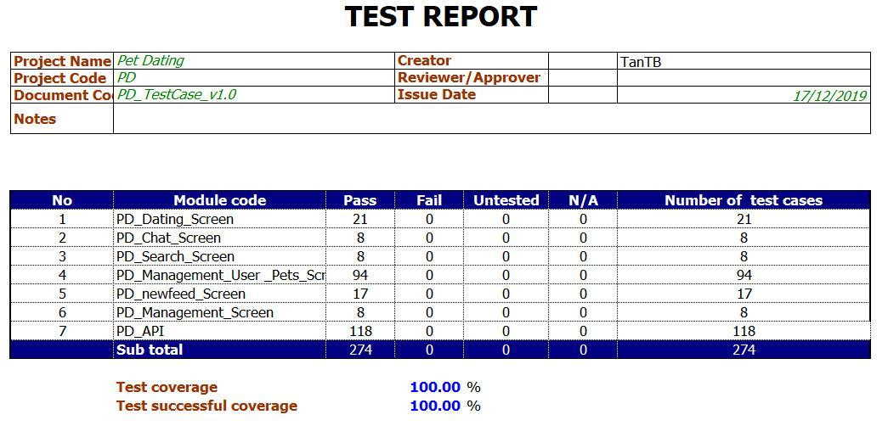

Figure 97 - Integration and system test report

# **CHAPTER 6: USER MANUAL**



## Development and deployment guidelines



### Development guideline

#### Environment for development

☞ Laptop MSI CX61 with Windows OS 10 Education version 1909

⮚ Integrated development environment:

• Visual Studio Code version 1.41.0

⮚ Node.js version 10.16.3 LTS

⮚ XAMPP 7.3.12

⮚ Expo-cli version 3.9.1

☞ Android Phone with Andorid 7.0

Expo client app

#### Setup development environment

##### *Install Visual Studio Code*

• Go to URL: <https://code.visualstudio.com/>, click on “Download” button, the Download page appears, choose the Windows package ( 32 bit or 64 bit, depends on the system ), the Save pop-up appears, click Save button to start download the installation file

Double click the file **“VSCodeUserSetup-x64-1.41.0.exe”** to start install Visual Studio Code



Figure 98 - Interface of Visual Studio Code

• Start using Visual Studio Code by opening it from Desktop

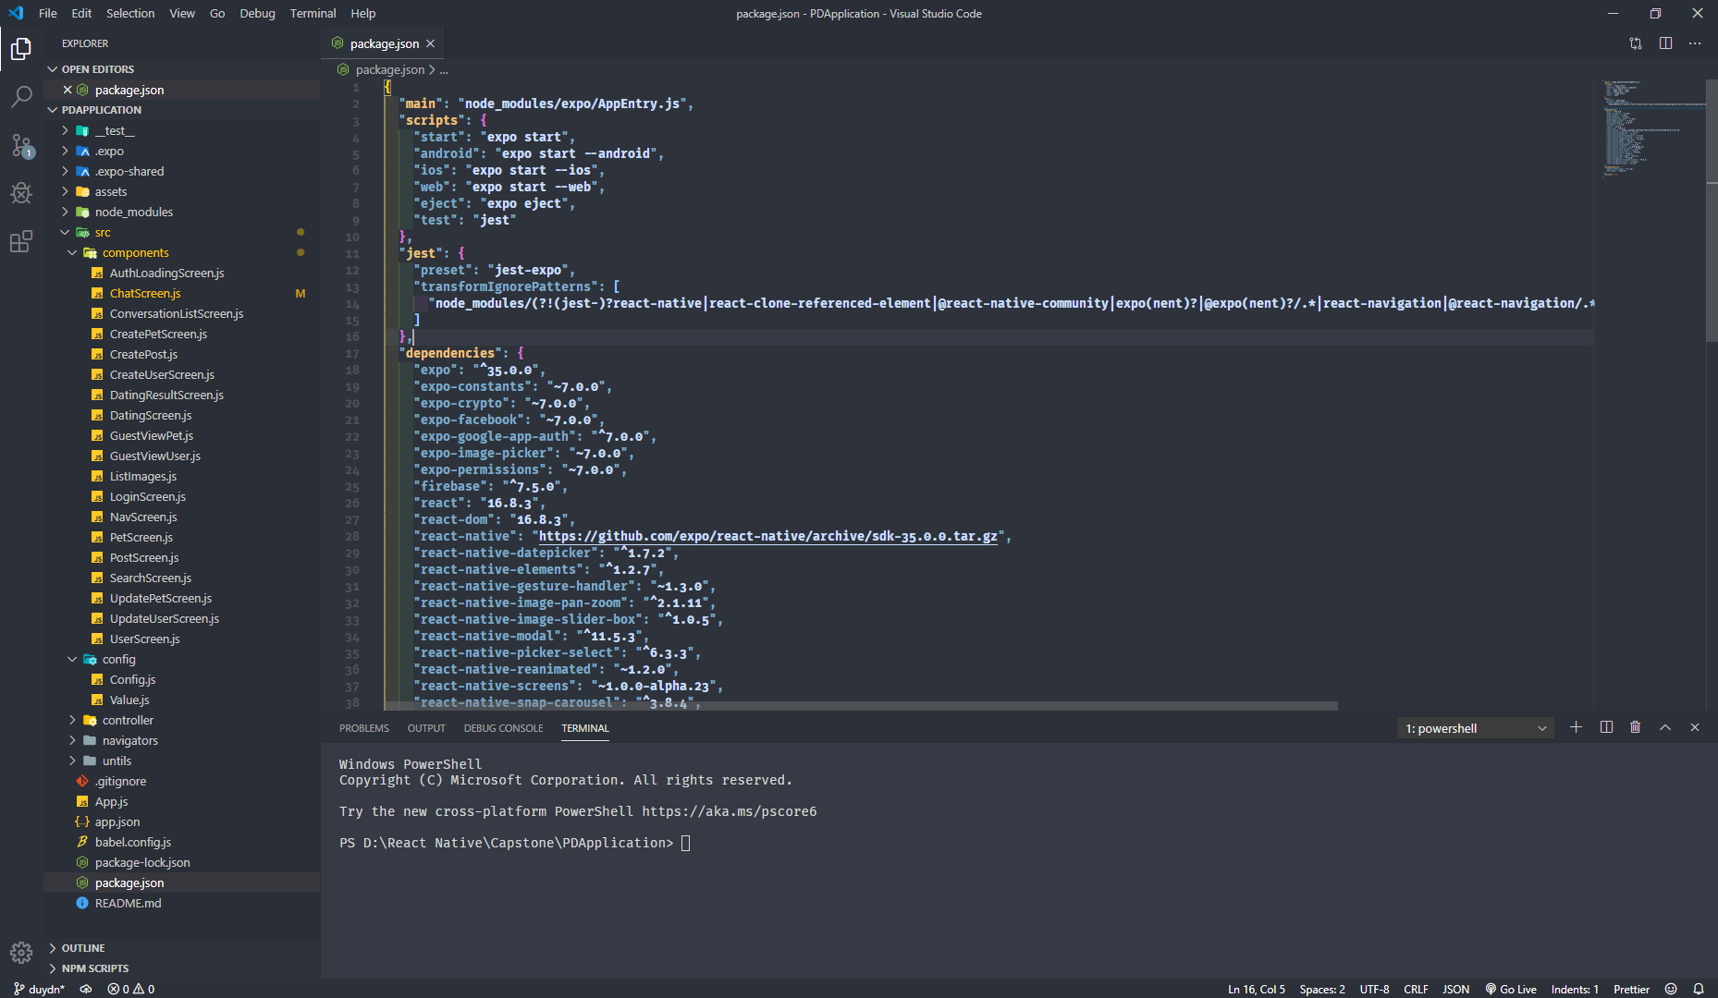

Figure 99 - Interface of Visual Studio Code

##### *Install Node.js version 10.16.3 LTS*

• Go to URL:<https://nodejs.org/en/download/releases/>, choose the 10.16.3 version and click Download, the Index page of the corresponding version appears, choose the [node-v10.16.3-win-x64.zip](https://nodejs.org/download/release/v10.16.3/node-v10.16.3-win-x64.zip) hyperlink, the Save pop-up appears, click Save button to start download the installation folder.



Figure 100 - Nodejs setup folder

Extract the folder **“node-v10.16.3-win-x64.zip”**

• Open the folder, double click the file **“node.exe”** to start install Nodejs.

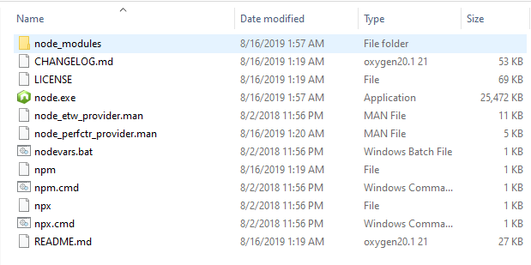

Figure 101 - Nodejs setup folder after extracting

• After the setup file running completely, check if Nodejs was installed successfully by opening Command Prompt and running the command “node -v”

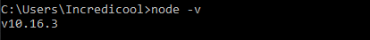

Figure 102 - Nodejs was installed succesfully

##### *Install XAMPP 7.3.12*

• Go to URL: https://www.apachefriends.org/index.html, click the XAMPP for Windows package, the Save pop-up appears, click Save button to start download the installation file

• Double click the file **“xampp-windows-x64-7.3.12-0-VC15-installer.exe”** to start install XAMPP



Figure 103 - XAMPP setup file

• Start XAMPP Control Panel by opening it from **C:\xampp** folder

• Click “Start” button of Apache and MySQL module

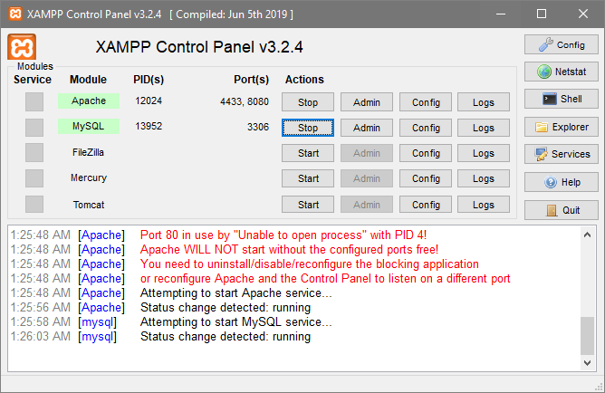

Figure 104 - XAMPP Control Panel interface

##### *Install expo-cli version 3.9.1*

• Open Command Prompt and running the command “*npm install -g expo-cli*”



Figure 105 - Command for installing expo-cli

• After the command running succesfully, check if expo-cli was installed successfully by running the command “*expo -V*”

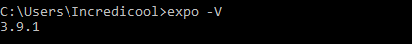

Figure 106 - expo-cli was installed succesfully

##### *Install Expo client app for android*

• Search for Expo app on Google Play Store

• Press Install

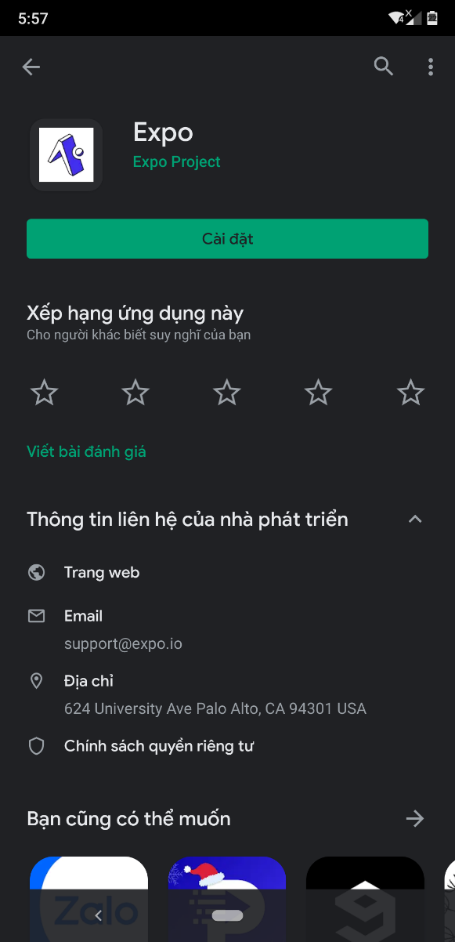

Figure 107 - Expo app on Google Play Store

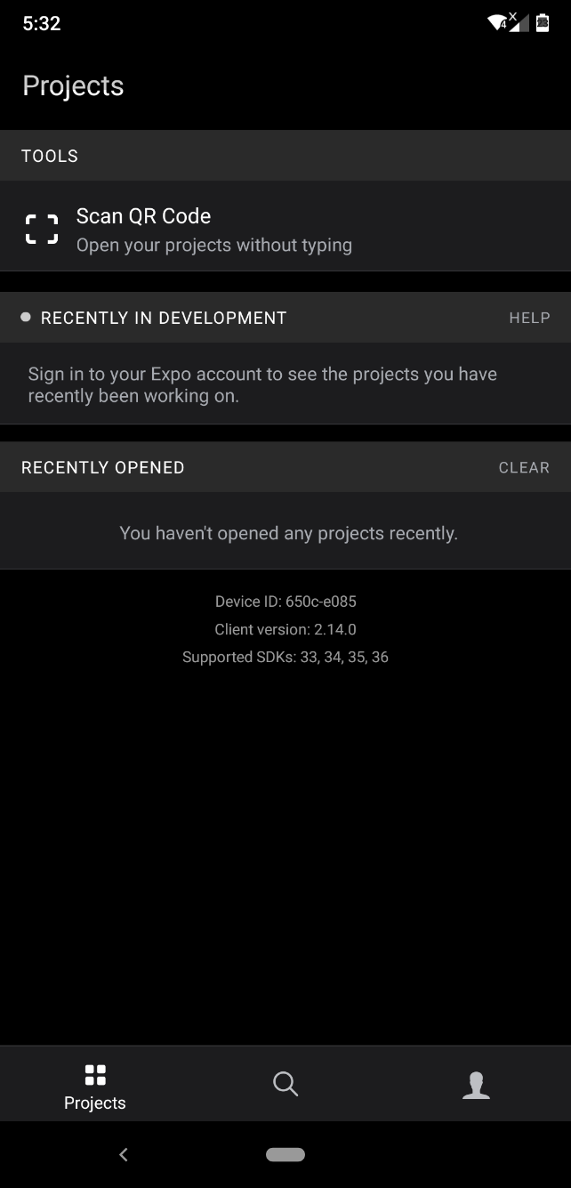

Figure 108 - Expo Client app interface

### Deployment guideline

#### Environment for deployment

☞ Hawk Host

☞ Google Firebase with following services:

⮚ Storage

⮚ Realtime Database

#### Setup deployment

##### *Set up hosting on Hawk Host*

• Go to <https://my.hawkhost.com/register.php> to create an account

• Create application with cPanel on Hawk Host

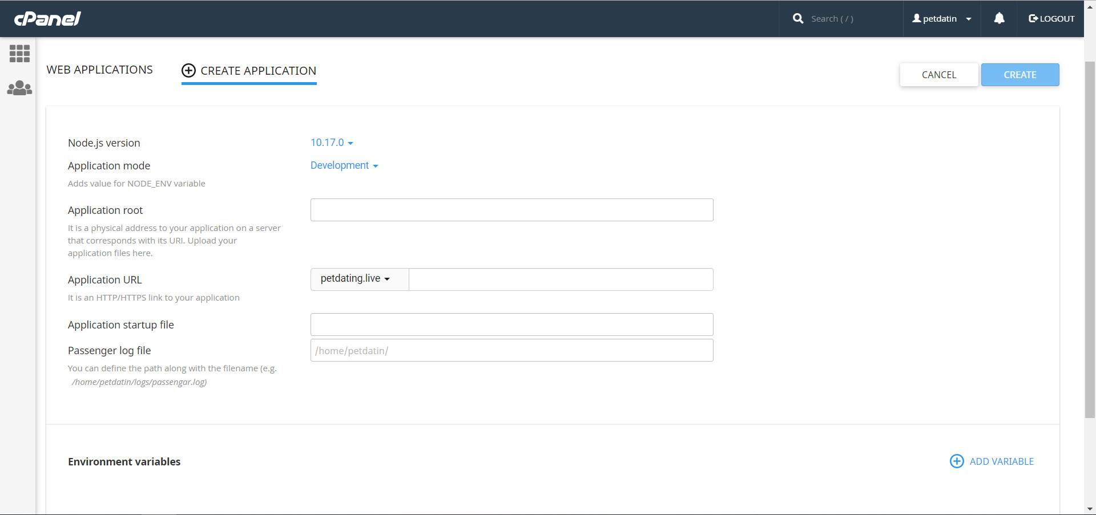

Figure 109 - Create application interface on Hawk Host

• Upload the backend and api code files to File Manager to deploy the server

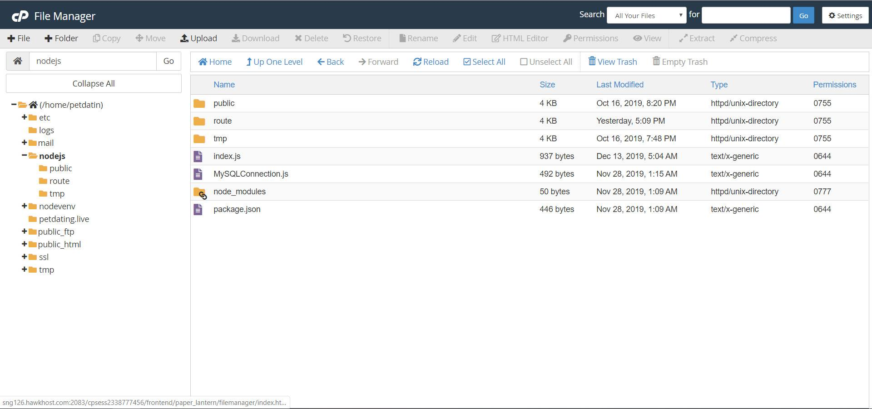

Figure 110 - File Manager interface

##### *Set up services of Google Firebase*

• Go to <https://console.firebase.google.com/u/0/> and signing in with Google account

• Click Add project to create a project with Firebase console

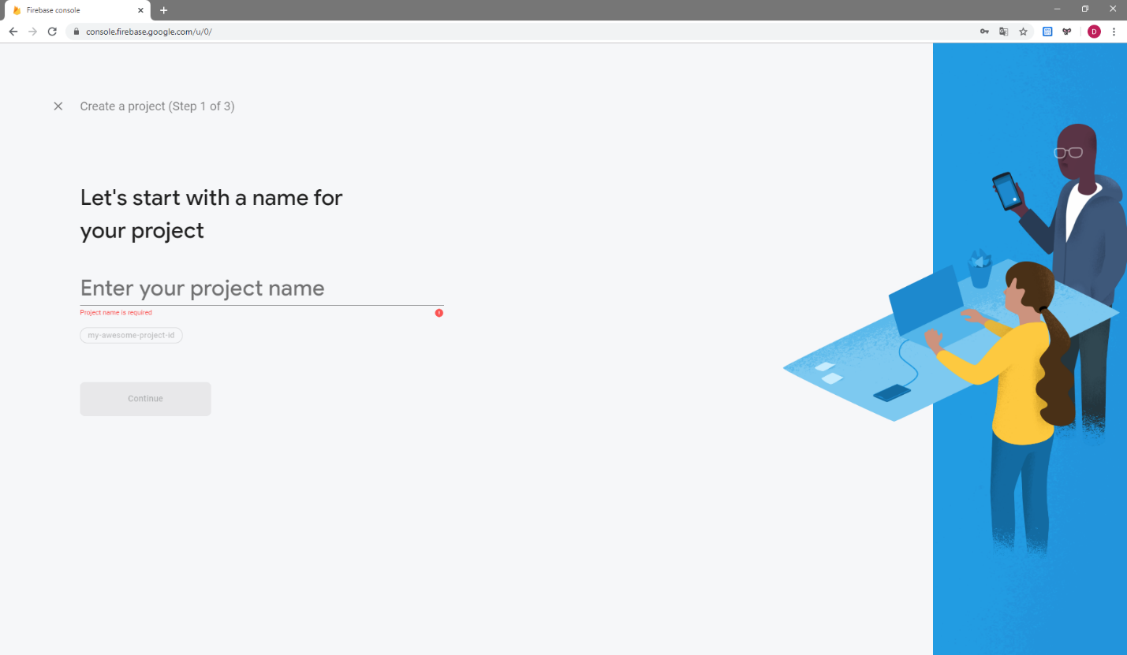

Figure 111 - Create project interface

• From the sidebar menu, click Authentication

• Switch to Sign-in method tab, in the Sign-in providers section, turn Anonymous from Disabled to Enabled

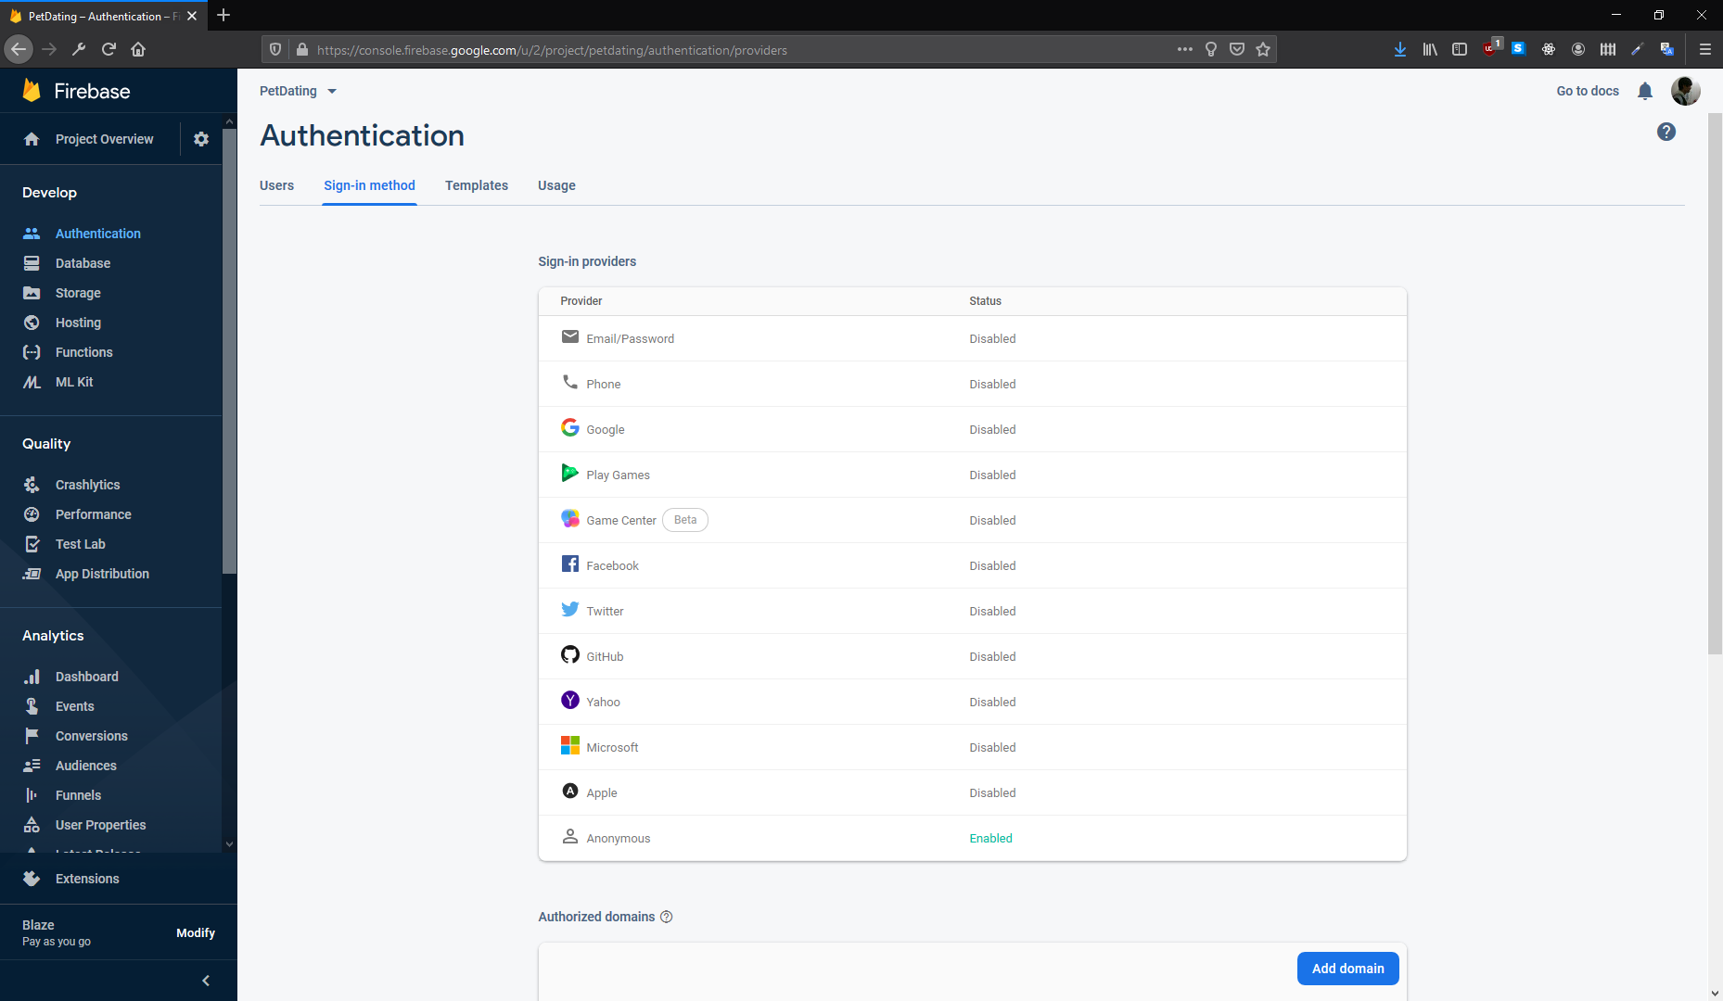

Figure 112 - Sign-in method set up interface for database

• From the sidebar menu, click Database

• Go to Realtime Database section and click Create database button

• Choose option “Start in locked mode”, then click Enable button

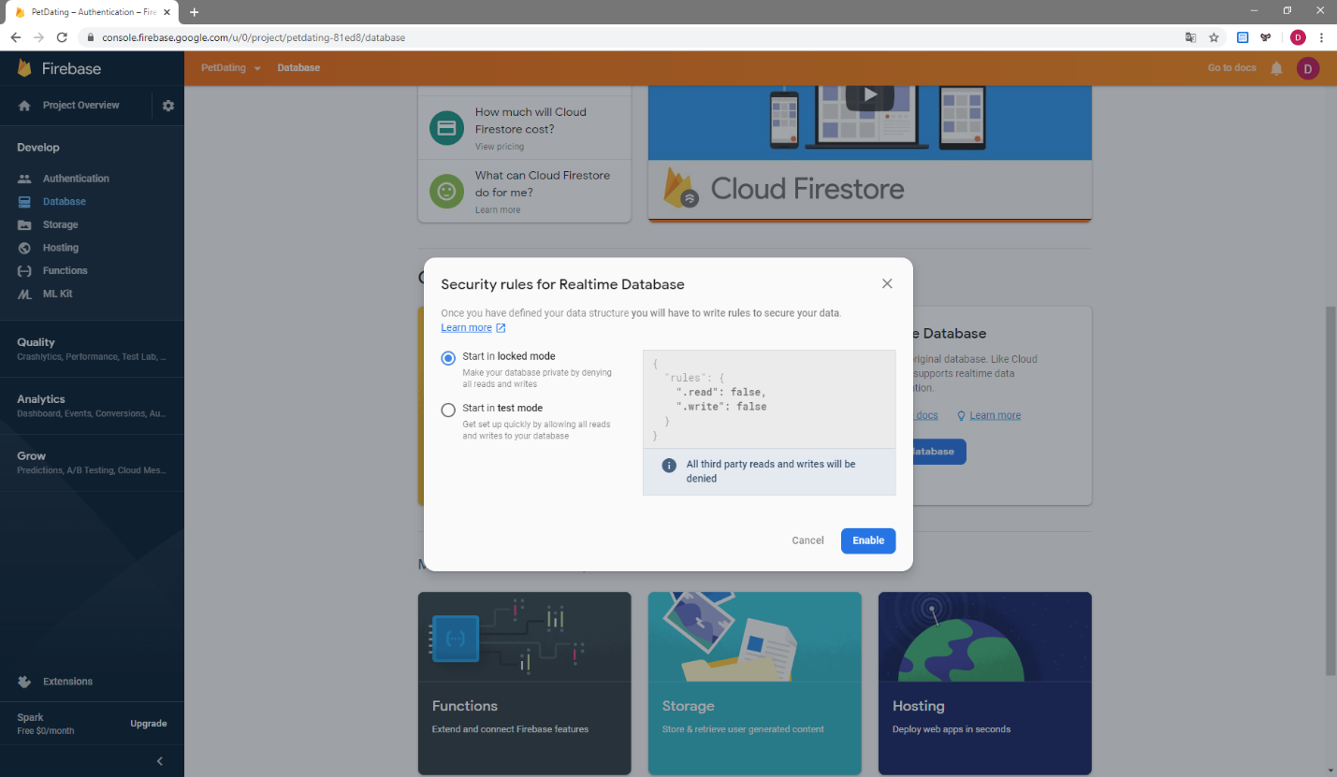

Figure 113 - Create database interface

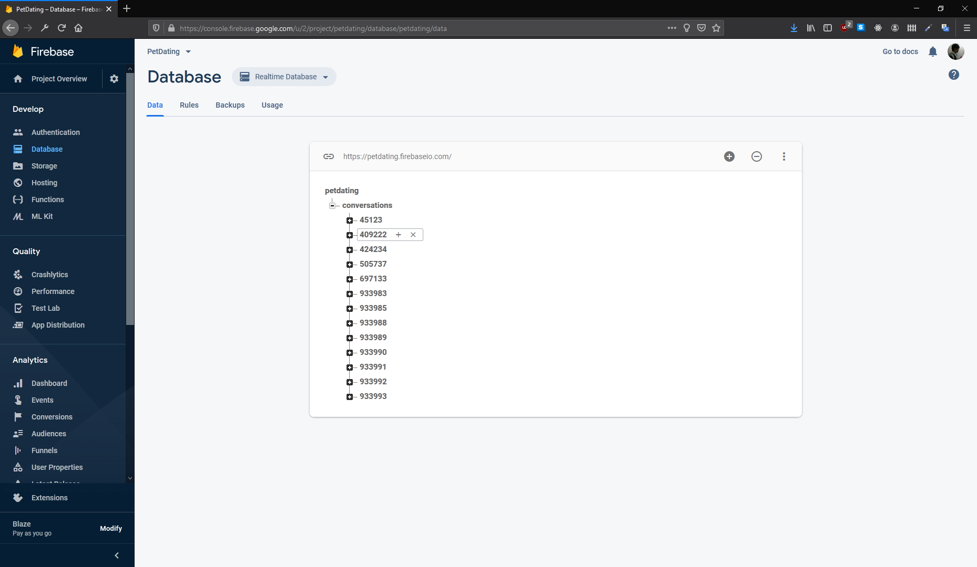

Figure 114 - Realtime Database interface

• From the sidebar menu, click Storage

• Click Get Started button

• Set up rules and location for Storage

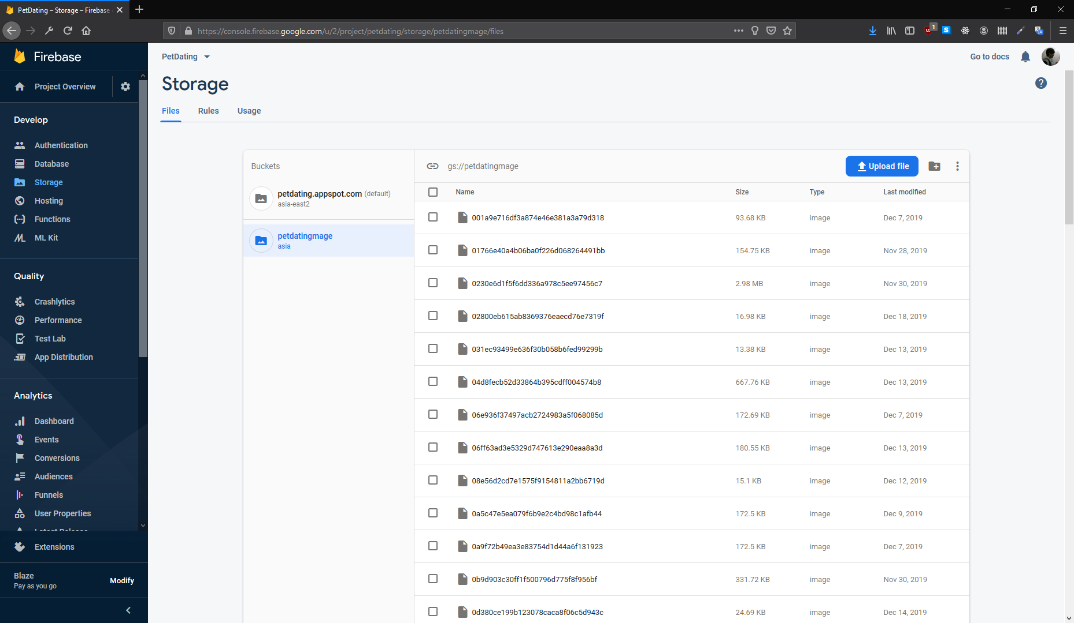

Figure 115 - Storage bucket interface

## User guideline



### Login, Logout

#### Login

• Open app

• Choose “Đăng nhập bằng FACEBOOK” or “Đăng nhập bằng GOOGLE”

• Fill in with Google or Facebook information

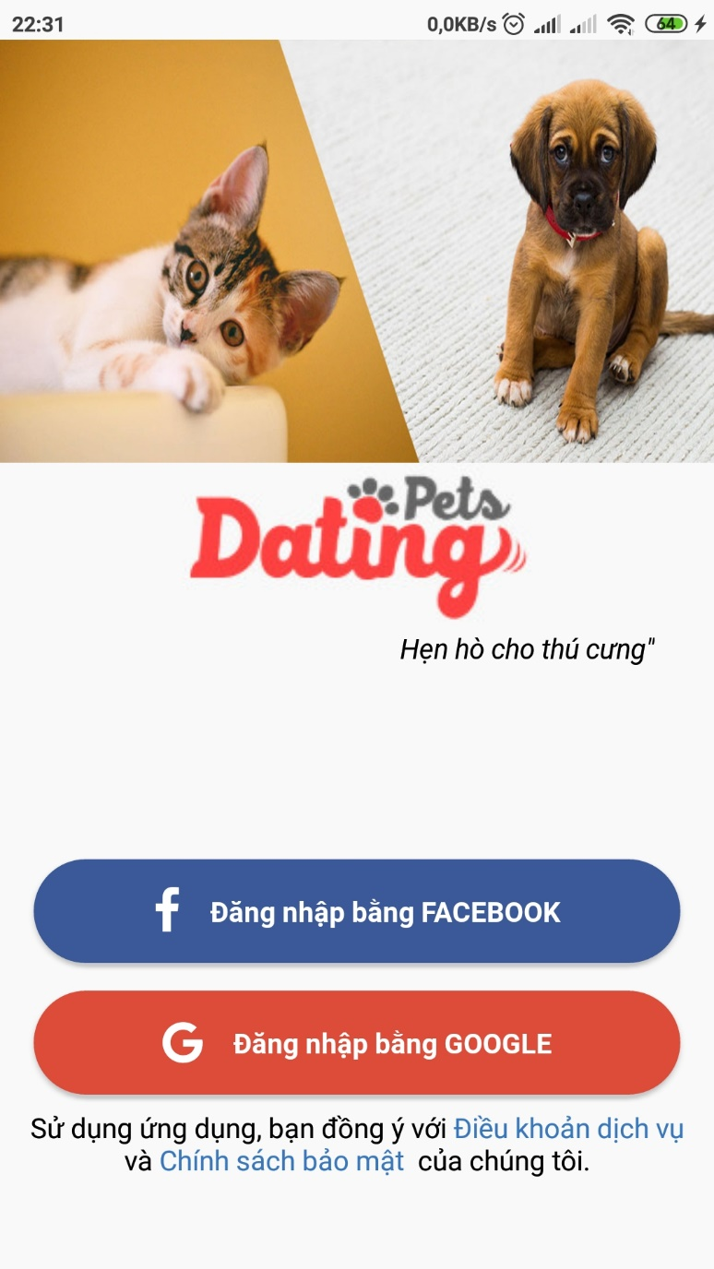

Figure 116 - Login interface

#### Logout

• Switch to Option tab

• Press “Đăng xuất”

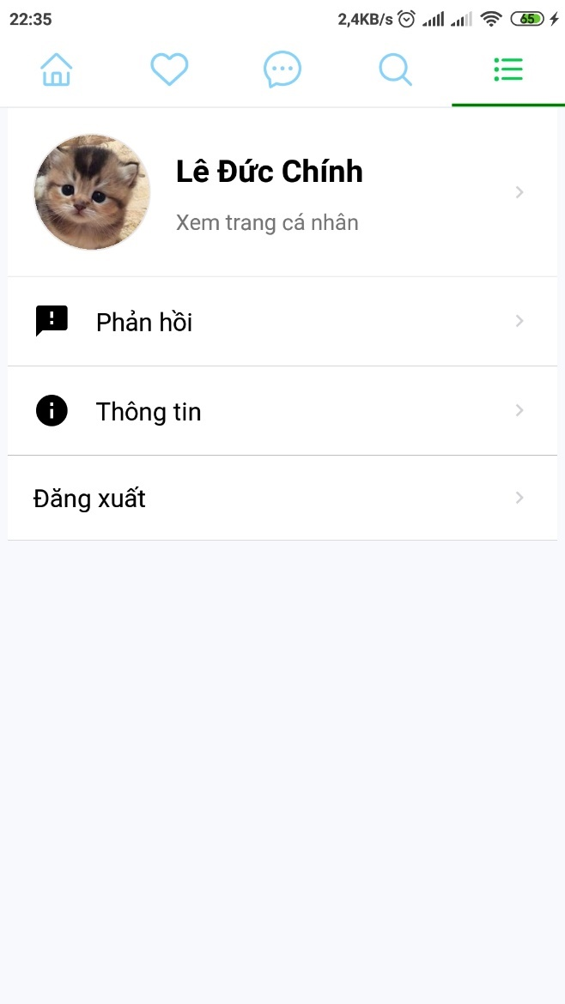

Figure 117 - Logout option in Option tab

### Create profile

• After logging in, create profile screen will appear

• Choose image from phone to set as avatar

• Fill all needed information, and press “THAM GIA PETDATING”

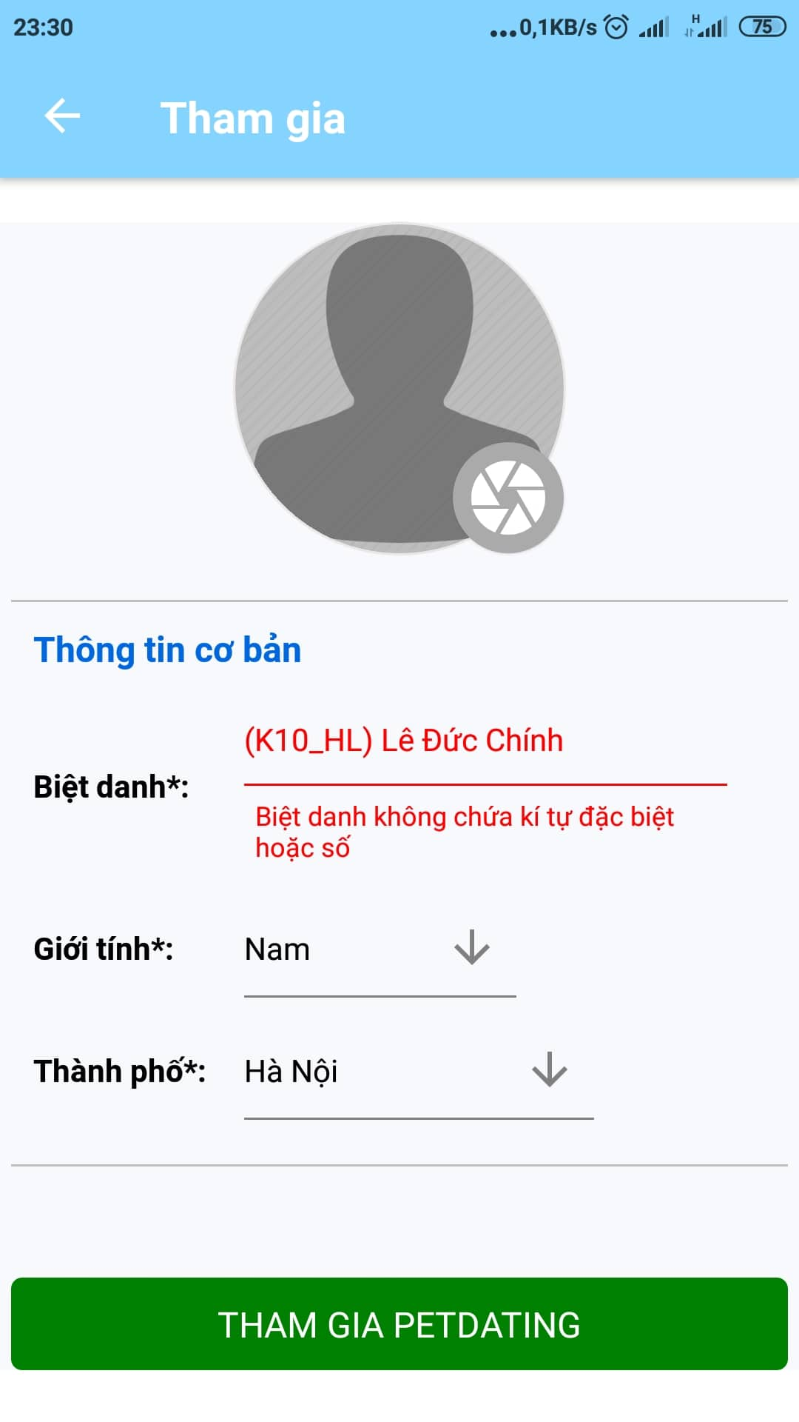

Figure 118 - Create user profile interface

### Newsfeed

• Swith to Newfeed tab to see contents posted by others users

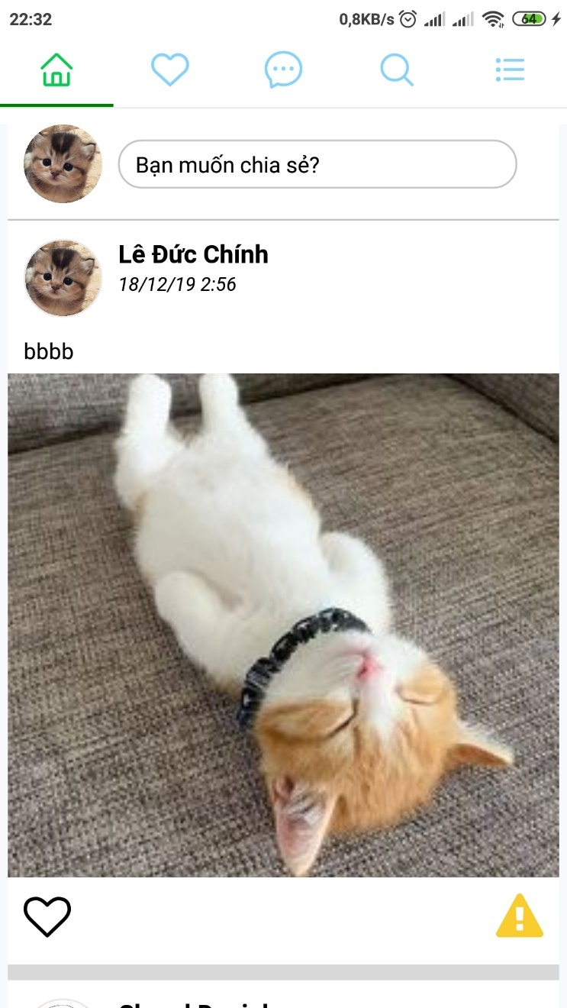

Figure 119 - Newsfeed interface

### Create new post

• Press “Bạn muốn chia sẻ” in Newfeed tab

• Choose images from phone to add by pressing “THÊM ẢNH”

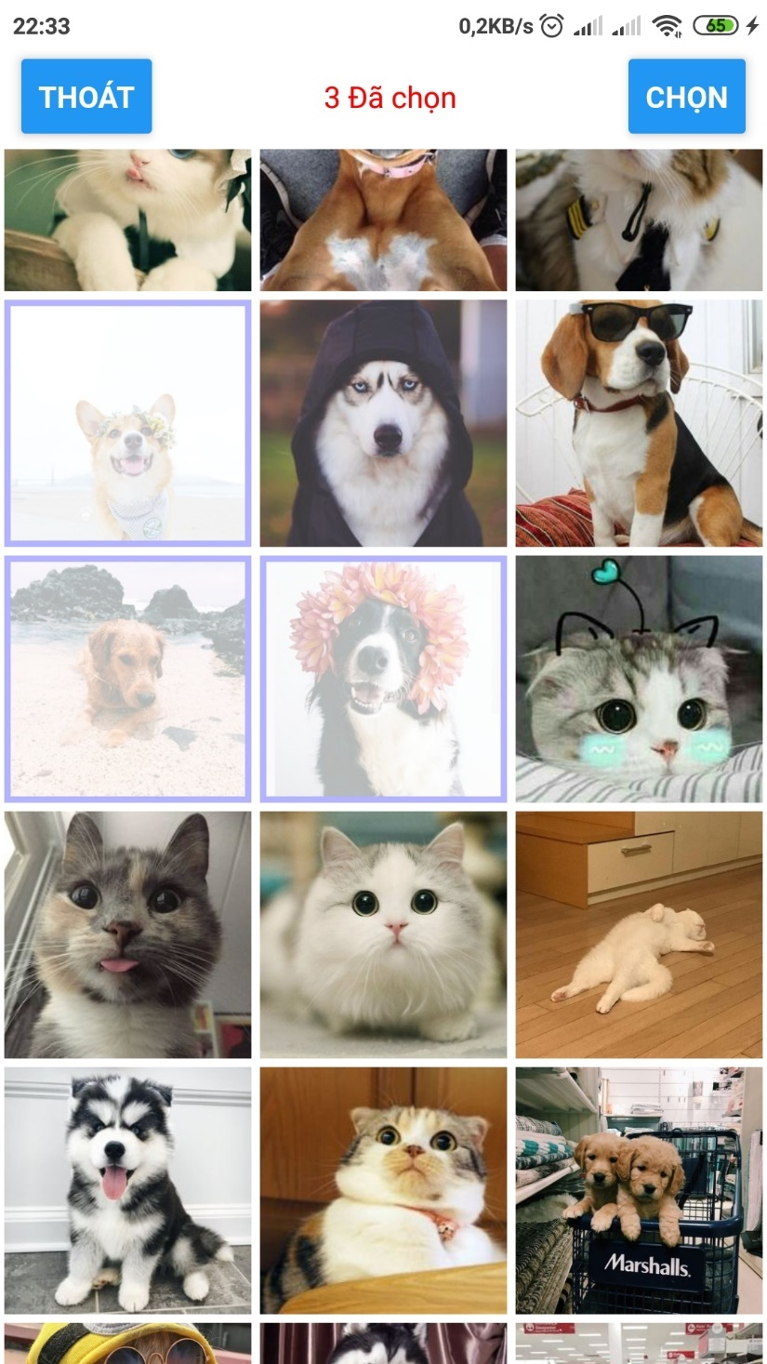

Figure 120 - Choose images interface

• Write status

• Press “Đăng”

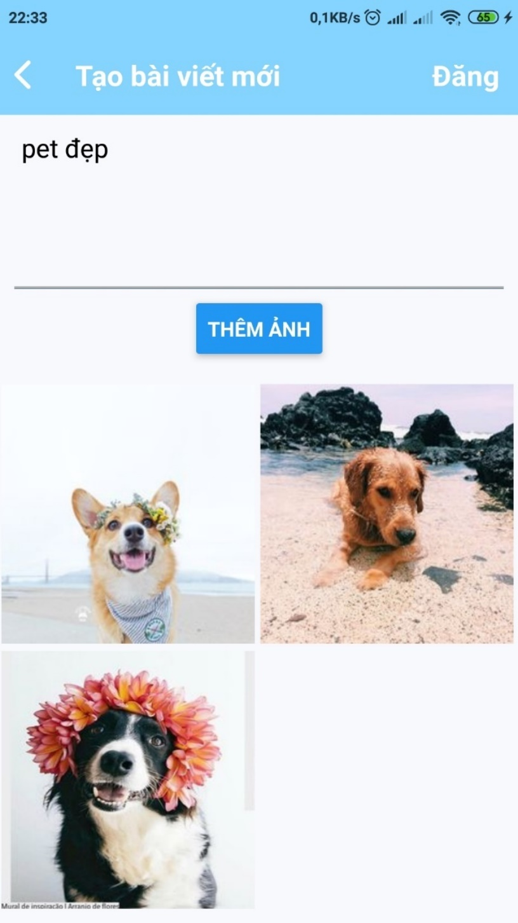

Figure 121 - Create new post interface

### Dating – Automation mode, Manual mode and Result

• Switch to Dating tab

• Choose which pet you want to find mate for in the combobox next to “Chọn pet”

• Choose mode in the combobox next to “Chế độ”, there are 2 modes:

⮱ Automation mode which is represented by option “Tự động”

⮱ Manual mode which is represented by op tin “Thủ công”

#### Automation mode

After choosing all needed information, press “Kết nối”

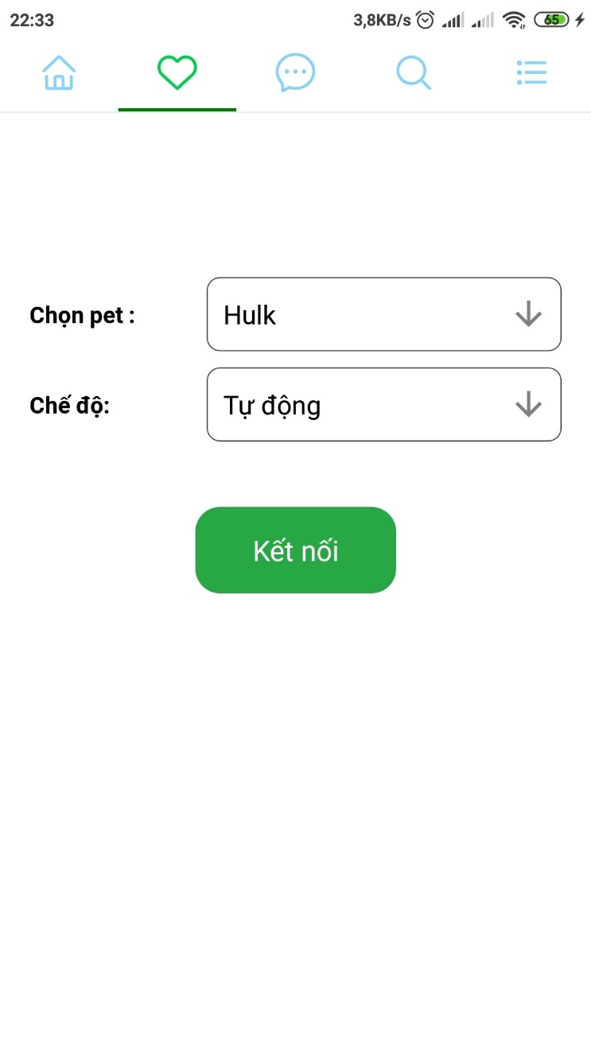

Figure 122 - Find mate interface (Automation mode)

#### Manual mode

• Choose option “Thủ công”, more comboboxs will appear to choose informations manually

• After choosing all need information, press “Kết nối”

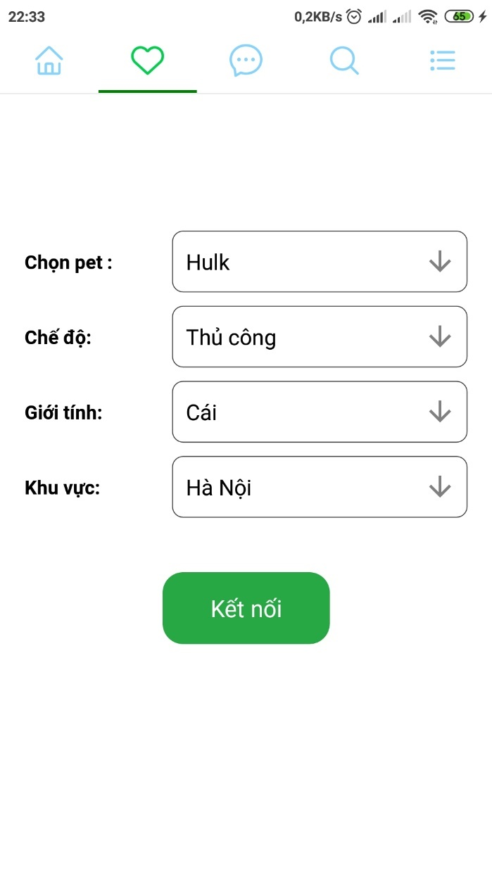

Figure 123 - Find mate interface (Manual mode)

#### Result

• All the pet that match your information entered will be shown

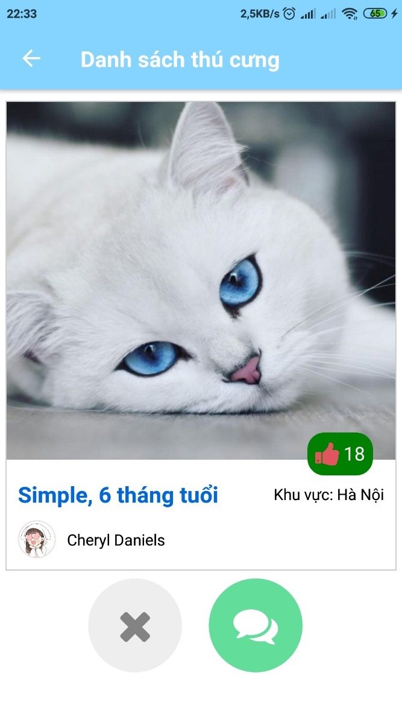

Figure 124 - Find mate result

• Give this pet a like by presssing the “Thumbup” icon

• Ignore this pet by pressing “X” icon

• Chat with the owner of this pet by pressing “Conversation” icon

### Chat

• Switch to Chat tab

• All the conversation that you took part in will be shown here

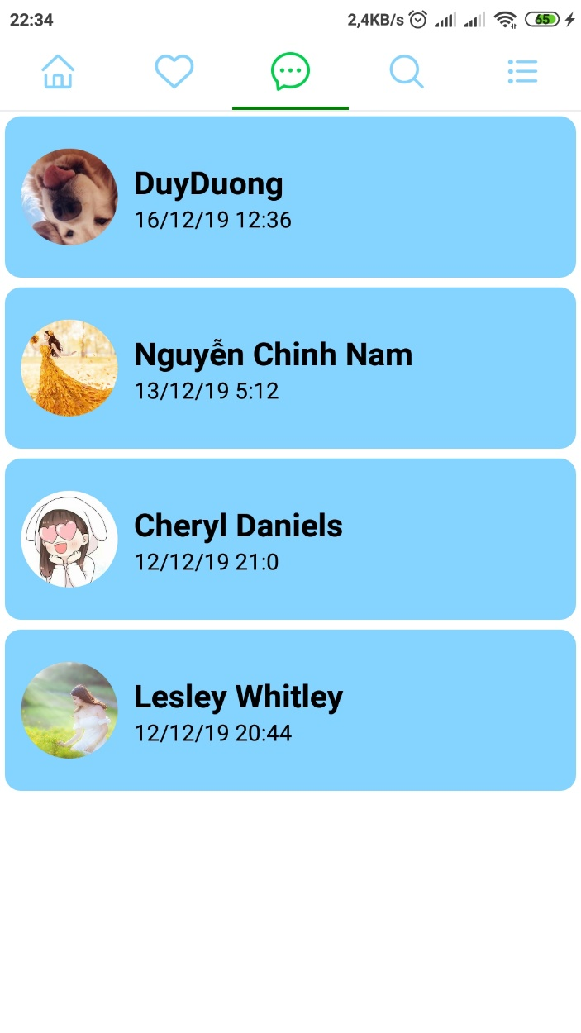

Figure 125 - List of conversation interface

• Choose a conversation

• Type the message in the text inout

• Press “Send” icon to send the message

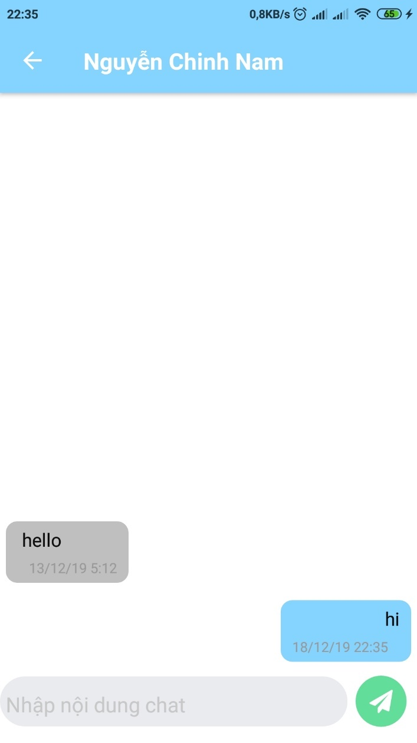

Figure 126 - Chat interface

### Search and view others user’s profile

#### Search

• Switch to Search tab

• Type user name you want to search in the text input

• Press “Search” icon

• All results that match the information will be shown below

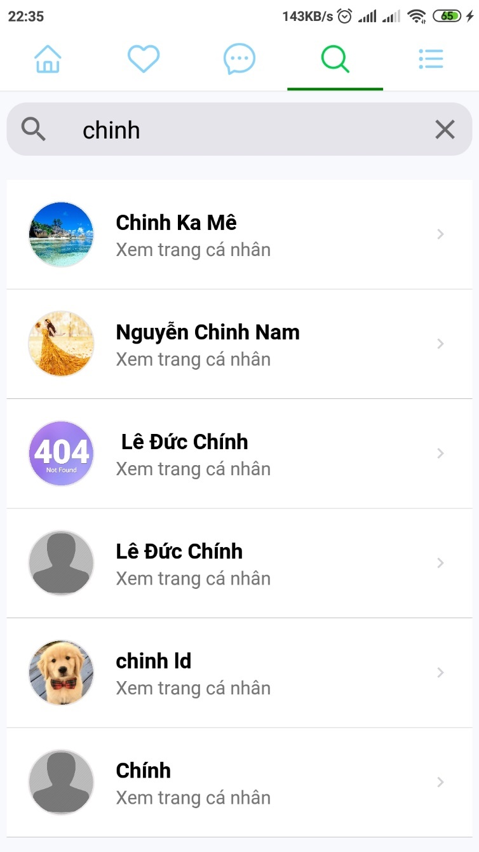

Figure 127 - Search and search result interface

#### **View others user’s profile**

• Press a search result in the list

• Profile and all information, images and pet of this user will be shown

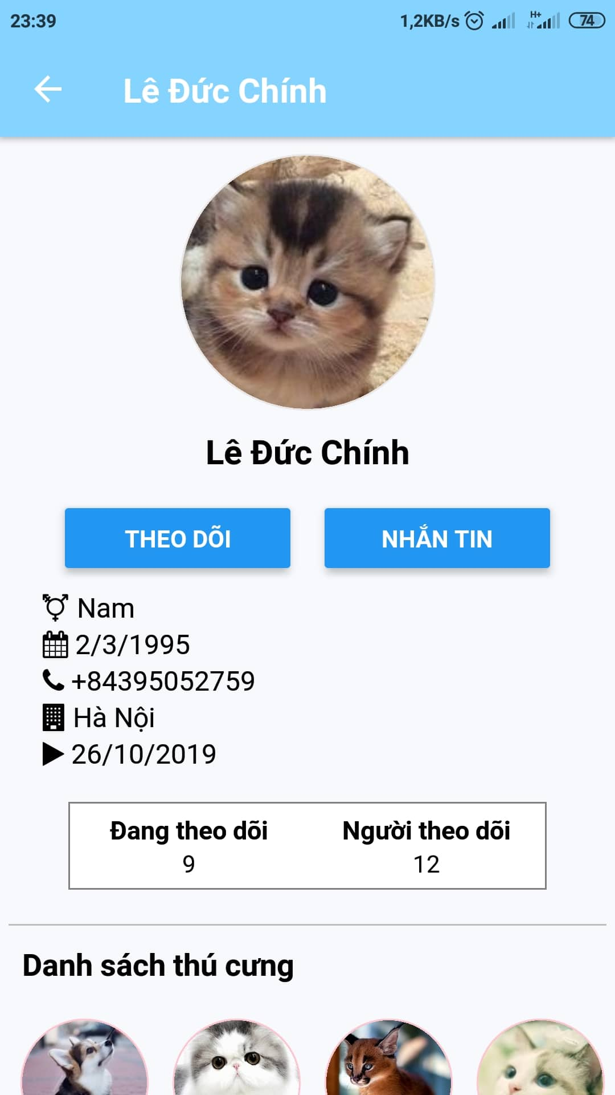

Figure 128 - Others users profile interface

• Press “THEO DÕI” button to follow this user

• Press “NHẮN TIN” button to chat with this user

• Press a pet profile that you want to see

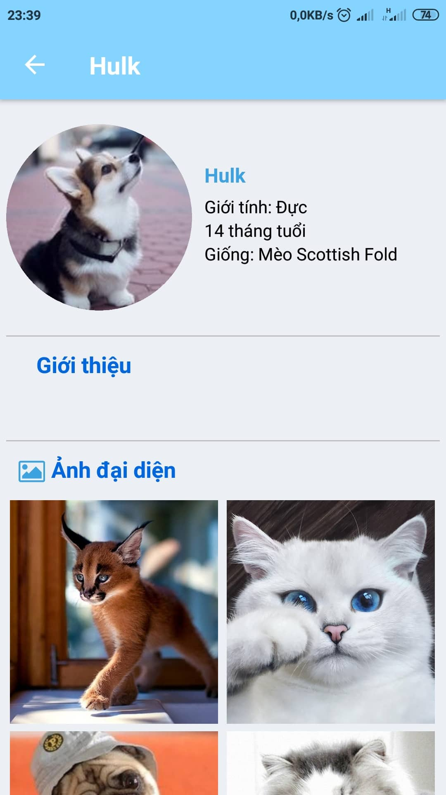

Figure 129 - Others users pet profile interface

### View and update user profile

#### View profile

• Switch to Option tab

• Press “Xem trang cá nhân ”

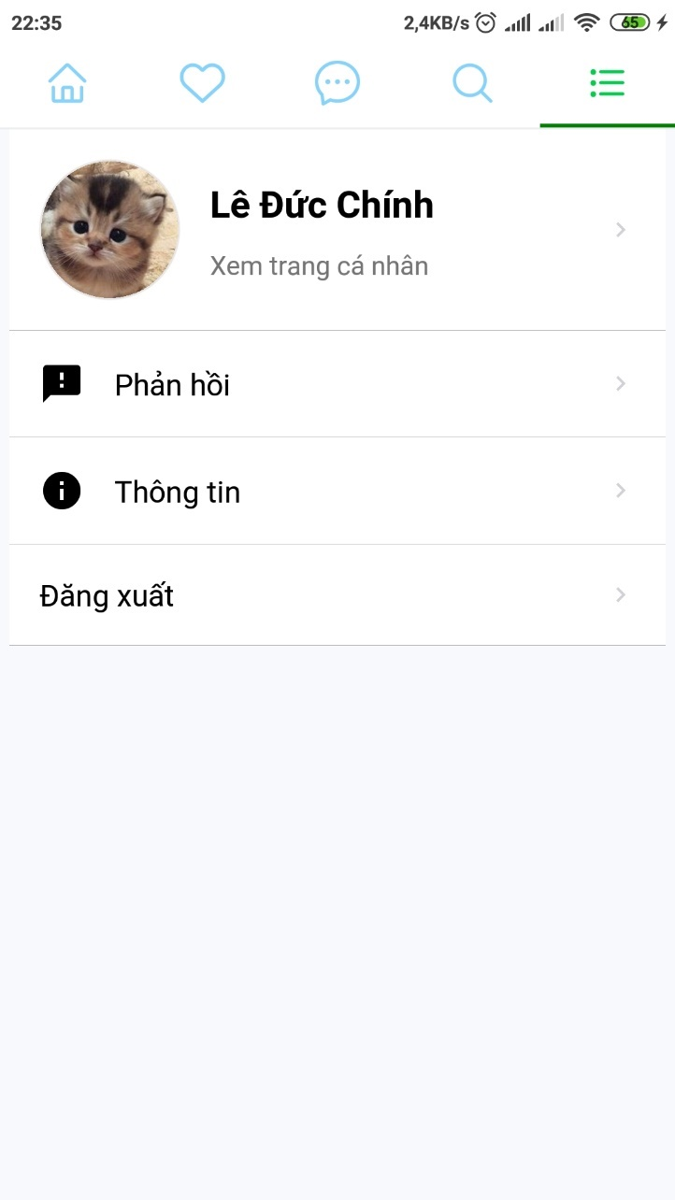

Figure 130 - Option tab interface

• The profile with all information and images uploaded, all pet profile will be shown here

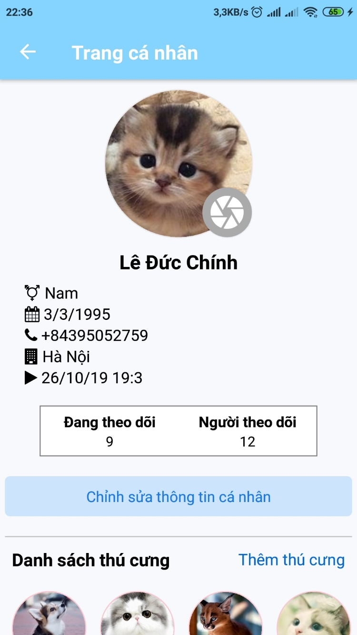

Figure 131 - User profile interface

#### **Update profile**

• Press “Chỉnh sửa thông tin cá nhân” button to update profile information

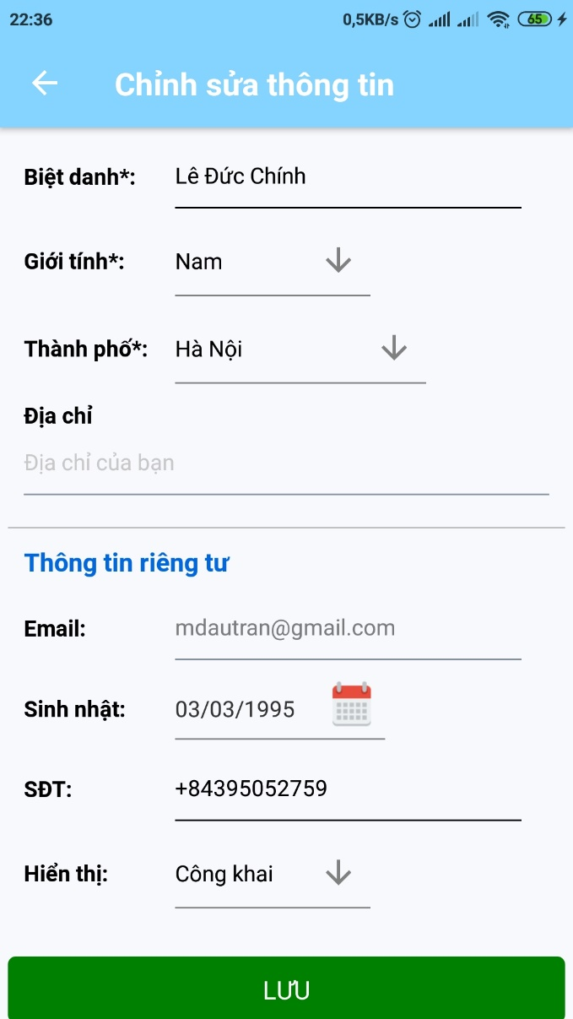

Figure 132 - Profile editing interface

• Fill in all information, then press “Lưu” to update profile



### Create, view and update pet profile

#### Create pet profile

• In the profile screen, press “Thêm thú cưng”



• Choose image and fill in all information, press “Tạo”

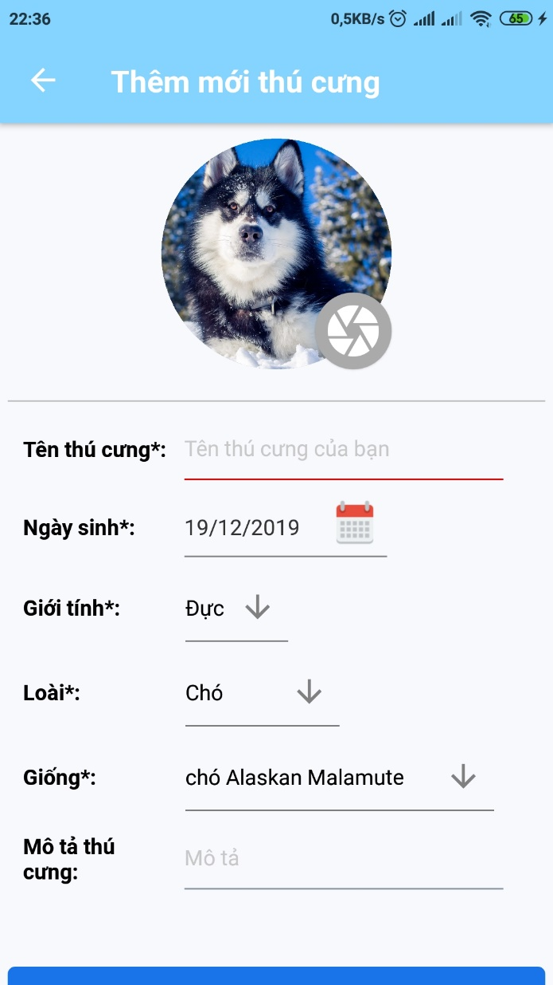

Figure 133 - Pet profile editing interface

#### **View pet profile**

• Press a pet profile in user profile screen

• Profile of the corresponding pet will be shown

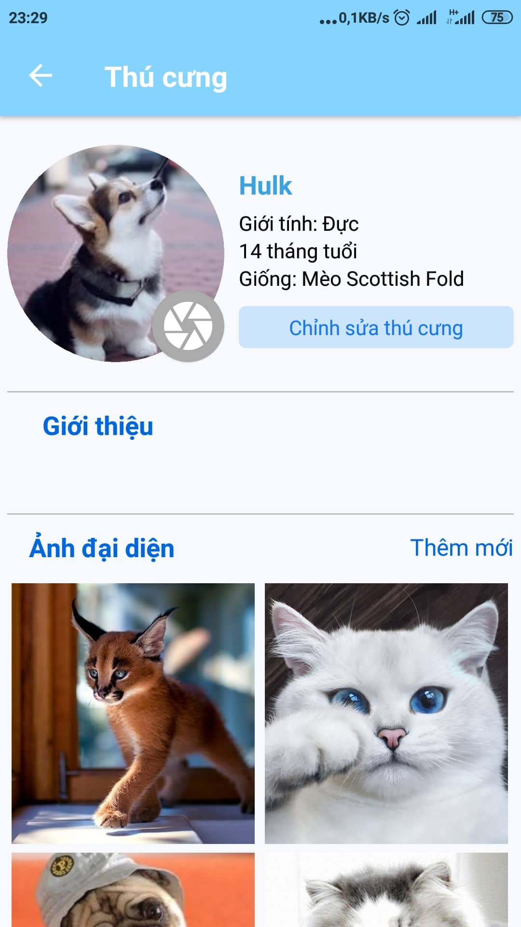

Figure 134 - Pet profile interface

#### **Update pet profile**

• Press “Chỉnh sửa thú cưng” in pet profile

• Fill in all information that you want to update, then press “LƯU”

• Press “XÓA THÚ CƯNG” if you want to delete this pet profile

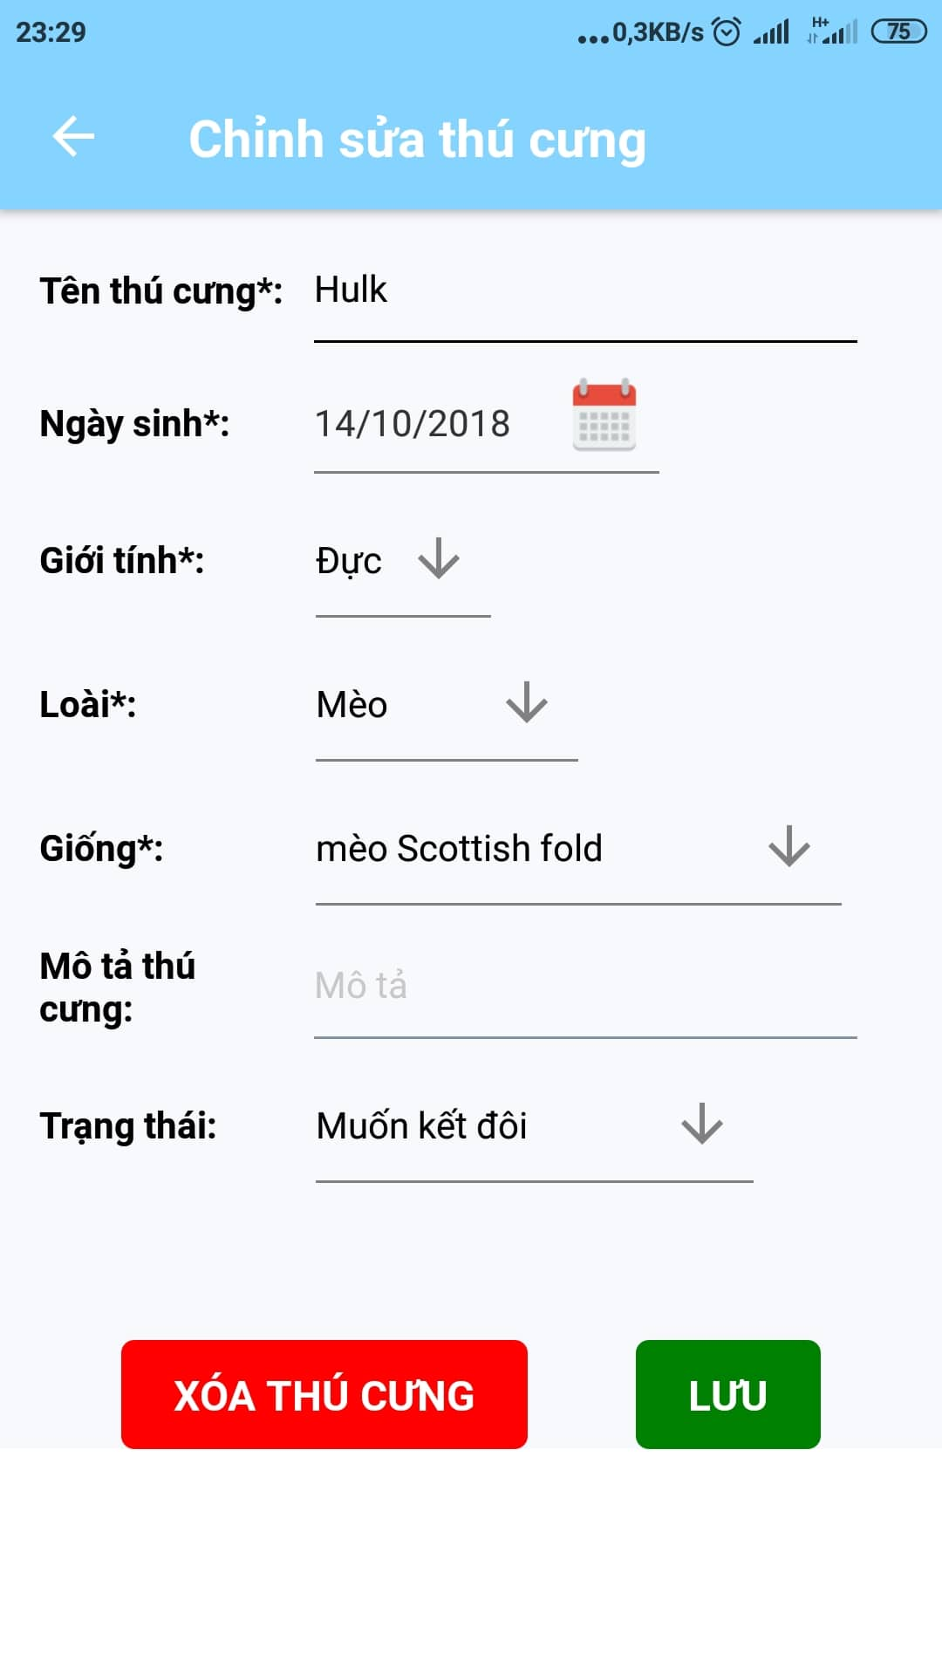

Figure 135 - Pet profile editing interface

### Feedback

• Switch to Option tab

• Press “Phản hồi”

• Choose one way to feedback

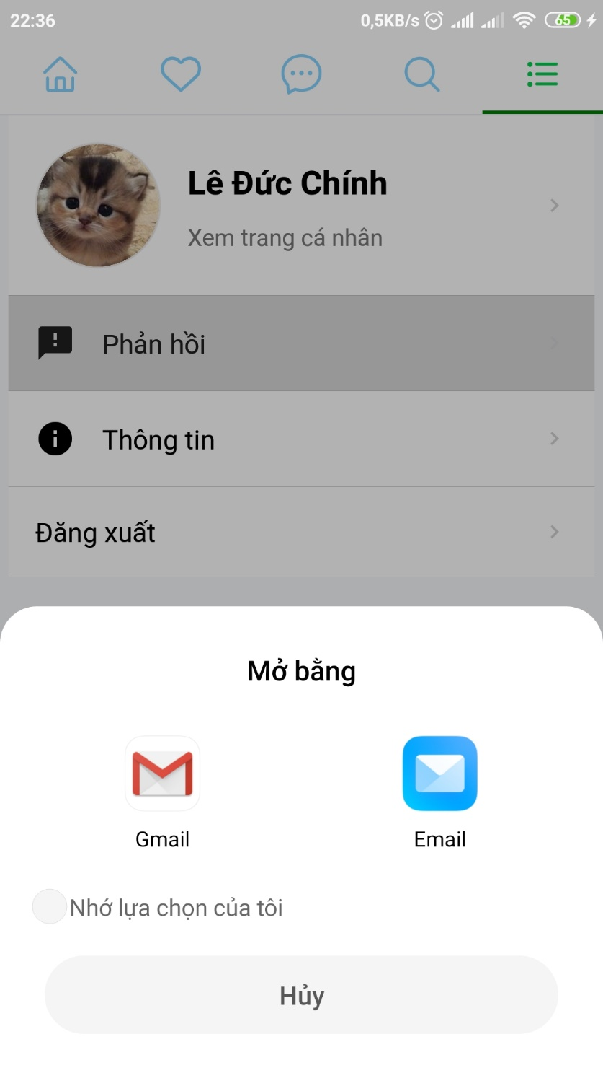

Figure 136 - Feedback interface